






Audit financial procedures
D1.HFI.CL8.01
D1.HFA.CL7.05
D2.TFA.CL7.01
Trainer Guide

Audit financial procedures
D1.HFI.CL8.01
D1.HFA.CL7.05
D2.TFA.CL7.01
Trainer Guide





Project Base
William Angliss Institute of TAFE
555 La Trobe Street
Melbourne 3000 Victoria
Telephone: | (03) 9606 2111
Facsimile: | (03) 9670 1330
Acknowledgements
Project Director: | Wayne Crosbie
Project Manager | Jim Irwin
Chief Writer: | Alan Hickman
Subject Writer: | Nick Hyland and Dianne Whelan
Editor: | Jim Irwin
DTP/Production: | Daniel Chee, Mai Vu, Cindy Curran

The Association of Southeast Asian Nations (ASEAN) was established on 8 August 1967. The Member States of the Association are Brunei Darussalam, Cambodia, Indonesia, Lao PDR, Malaysia, Myanmar, Philippines, Singapore, Thailand and Viet Nam.
The ASEAN Secretariat is based in Jakarta, Indonesia.
General Information on ASEAN appears online at the ASEAN Website: www.asean.org.
All text is produced by William Angliss Institute of TAFE for the ASEAN Project on “Toolbox Development for Tourism Labour Divisions for Travel Agencies and Tour Operations”.
This publication is supported by the Australian Government’s aid program through the ASEAN-Australia Development Cooperation Program Phase II (AADCP II).
Copyright: Association of Southeast Asian Nations (ASEAN) 2015.
All rights reserved.
Disclaimer
Every effort has been made to ensure that this publication is free from errors or omissions. However, you should conduct your own enquiries and seek professional advice before relying on any fact, statement or matter contained in this book. The ASEAN Secretariat and William Angliss Institute of TAFE are not responsible for any injury, loss or damage as a result of material included or omitted from this course. Information in this module is current at the time of publication. Time of publication is indicated in the date stamp at the bottom of each page.
Some images appearing in this resource have been purchased from stock photography suppliers Shutterstock and iStockphoto and other third party copyright owners and as such are non-transferable and non-exclusive. Clip arts, font images and illustrations used are from the Microsoft Office Clip Art and Media Library. Some images have been provided by and are the property of William Angliss Institute.
Additional images have been sourced from Flickr and SXC and are used under Creative Commons licence: http://creativecommons.org/licenses/by/2.0/deed.en
File name: TG_Audit financial procedures_270715





Table of contents
Competency Based Training (CBT) and assessment – An introduction for trainers 1
Competency standard 11
Notes and PowerPoint slides 19
Activities 87
Recommended training equipment 127
Instructions for Trainers for using PowerPoint – Presenter View 129
Appendix – ASEAN acronyms 131

Competency Based Training (CBT) and assessment – An introduction for trainers

Competency
Competency refers to the ability to perform particular tasks and duties to the standard of performance expected in the workplace.
Competency requires the application of specified knowledge, skills and attitudes relevant to effective participation, consistently over time and in the workplace environment.
The essential skills and knowledge are either identified separately or combined.
Knowledge identifies what a person needs to know to perform the work in an informed and effective manner.
Skills describe the application of knowledge to situations where understanding is converted into a workplace outcome.
Attitude describes the founding reasons behind the need for certain knowledge or why skills are performed in a specified manner.
Competency covers all aspects of workplace performance and involves:
- Performing individual tasks
- Managing a range of different tasks
- Responding to contingencies or breakdowns
- Dealing with the responsibilities of the workplace
- Working with others.

Unit of competency
Like with any training qualification or program, a range of subject topics are identified that focus on the ability in a certain work area, responsibility or function.
Each manual focuses on a specific unit of competency that applies in the hospitality workplace.
In this manual a unit of competency is identified as a ‘unit’.
Each unit of competency identifies a discrete workplace requirement and includes:
- Knowledge and skills that underpin competency
- Language, literacy and numeracy
- Occupational safety and health requirements.
Each unit of competency must be adhered to in training and assessment to ensure consistency of outcomes.

Element of competency
An element of competency describes the essential outcomes within a unit of competency.
The elements of competency are the basic building blocks of the unit of competency. They describe in terms of outcomes the significant functions and tasks that make up the competency.
In this manual elements of competency are identified as an ‘element’.

Performance criteria
Performance criteria indicate the standard of performance that is required to demonstrate achievement within an element of competency. The standards reflect identified industry skill needs.
Performance criteria will be made up of certain specified skills, knowledge and attitudes.

Learning
For the purpose of this manual learning incorporates two key activities:
- Training
- Assessment.
Both of these activities will be discussed in detail in this introduction.
Today training and assessment can be delivered in a variety of ways. It may be provided to participants:
- On-the-job – in the workplace
- Off-the-job – at an educational institution or dedicated training environment
- As a combination of these two options.
No longer is it necessary for learners to be absent from the workplace for long periods of time in order to obtain recognised and accredited qualifications.

Learning approaches
This manual will identify two avenues to facilitate learning:
Competency Based Training (CBT)
This is the strategy of developing a participant’s competency.
Educational institutions utilise a range of training strategies to ensure that participants are able to gain the knowledge and skills required for successful:
- Completion of the training program or qualification
- Implementation in the workplace.
The strategies selected should be chosen based on suitability and the learning styles of participants.

Competency Based Assessment (CBA)
This is the strategy of assessing competency of a participant.
Educational institutions utilise a range of assessment strategies to ensure that participants are assessed in a manner that demonstrates validity, fairness, reliability, flexibility and fairness of assessment processes.

Flexibility in learning
It is important to note that flexibility in training and assessment strategies is required to meet the needs of participants who may have learning difficulties. The strategies used will vary, taking into account the needs of individual participants with learning difficulties. However they will be applied in a manner which does not discriminate against the participant or the participant body as a whole.
Catering for participant diversity
Participants have diverse backgrounds, needs and interests. When planning training and assessment activities to cater for individual differences, trainers and assessors should:
- Consider individuals’ experiences, learning styles and interests
- Develop questions and activities that are aimed at different levels of ability
- Modify the expectations for some participants
- Provide opportunities for a variety of forms of participation, such as individual, pair and small group activities
- Assess participants based on individual progress and outcomes.
The diversity among participants also provides a good reason for building up a learning community in which participants support each other’s learning.
Participant centred learning
This involves taking into account structuring training and assessment that:
- Builds on strengths – Training environments need to demonstrate the many positive features of local participants (such as the attribution of academic success to effort, and the social nature of achievement motivation) and of their trainers (such as a strong emphasis on subject disciplines and moral responsibility). These strengths and uniqueness of local participants and trainers should be acknowledged and treasured
- Acknowledges prior knowledge and experience – The learning activities should be planned with participants’ prior knowledge and experience in mind
- Understands learning objectives – Each learning activity should have clear learning objectives and participants should be informed of them at the outset. Trainers should also be clear about the purpose of assignments and explain their significance to participants
- Teaches for understanding – The pedagogies chosen should aim at enabling participants to act and think flexibly with what they know
- Teaches for independent learning – Generic skills and reflection should be nurtured through learning activities in appropriate contexts of the curriculum. Participants should be encouraged to take responsibility for their own learning
- Enhances motivation – Learning is most effective when participants are motivated. Various strategies should be used to arouse the interest of participants
- Makes effective use of resources – A variety of teaching resources can be employed as tools for learning
- Maximises engagement – In conducting learning activities, it is important for the minds of participants to be actively engaged
- Aligns assessment with learning and teaching – Feedback and assessment should be an integral part of learning and teaching
- Caters for learner diversity – Trainers should be aware that participants have different characteristics and strengths and try to nurture these rather than impose a standard set of expectations.
Active learning
The goal of nurturing independent learning in participants does not imply that they always have to work in isolation or solely in a classroom. On the contrary, the construction of knowledge in tourism and hospitality studies can often best be carried out in collaboration with others in the field. Sharing experiences, insights and views on issues of common concern, and working together to collect information through conducting investigative studies in the field (active learning) can contribute a lot to their eventual success.
Active learning has an important part to play in fostering a sense of community in the class. First, to operate successfully, a learning community requires an ethos of acceptance and a sense of trust among participants, and between them and their trainers. Trainers can help to foster acceptance and trust through encouragement and personal example, and by allowing participants to take risks as they explore and articulate their views, however immature these may appear to be. Participants also come to realise that their classmates (and their trainers) are partners in learning and solving.
Trainers can also encourage cooperative learning by designing appropriate group learning tasks, which include, for example, collecting background information, conducting small-scale surveys, or producing media presentations on certain issues and themes. Participants need to be reminded that, while they should work towards successful completion of the field tasks, developing positive peer relationships in the process is an important objective of all group work.

Competency Based Training (CBT)
Principle of Competency Based Training
Competency based training is aimed at developing the knowledge, skills and attitudes of participants, through a variety of training tools.
Training strategies
The aims of this curriculum are to enable participants to:
- Undertake a variety of subject courses that are relevant to industry in the current environment
- Learn current industry skills, information and trends relevant to industry
- Learn through a range of practical and theoretical approaches
- Be able to identify, explore and solve issues in a productive manner
- Be able to become confident, equipped and flexible managers of the future
- Be ‘job ready’ and a valuable employee in the industry upon graduation of any qualification level.
To ensure participants are able to gain the knowledge and skills required to meet competency in each unit of competency in the qualification, a range of training delivery modes are used.
Types of training
In choosing learning and teaching strategies, trainers should take into account the practical, complex and multi-disciplinary nature of the subject area, as well as their participant’s prior knowledge, learning styles and abilities.
Training outcomes can be attained by utilising one or more delivery methods:
Lecture/tutorial
This is a common method of training involving transfer of information from the trainer to the participants. It is an effective approach to introduce new concepts or information to the learners and also to build upon the existing knowledge. The listener is expected to reflect on the subject and seek clarifications on the doubts.
Demonstration
Demonstration is a very effective training method that involves a trainer showing a participant how to perform a task or activity. Through a visual demonstration, trainers may also explain reasoning behind certain actions or provide supplementary information to help facilitate understanding.
Group discussions
Brainstorming in which all the members in a group express their ideas, views and opinions on a given topic. It is a free flow and exchange of knowledge among the participants and the trainer. The discussion is carried out by the group on the basis of their own experience, perceptions and values. This will facilitate acquiring new knowledge. When everybody is expected to participate in the group discussion, even the introverted persons will also get stimulated and try to articulate their feelings.
The ideas that emerge in the discussions should be noted down and presentations are to be made by the groups. Sometimes consensus needs to be arrived at on a given topic. Group discussions are to be held under the moderation of a leader guided by the trainer. Group discussion technique triggers thinking process, encourages interactions and enhances communication skills.
Role play
This is a common and very effective method of bringing into the classroom real life situations, which may not otherwise be possible. Participants are made to enact a particular role so as to give a real feel of the roles they may be called upon to play. This enables participants to understand the behaviour of others as well as their own emotions and feelings. The instructor must brief the role players on what is expected of them. The role player may either be given a ready-made script, which they can memorise and enact, or they may be required to develop their own scripts around a given situation. This technique is extremely useful in understanding creative selling techniques and human relations. It can be entertaining and energising and it helps the reserved and less literate to express their feelings.

Simulation games
When trainees need to become aware of something that they have not been conscious of, simulations can be a useful mechanism. Simulation games are a method based on "here and now" experience shared by all the participants. The games focus on the participation of the trainees and their willingness to share their ideas with others. A "near real life" situation is created providing an opportunity to which they apply themselves by adopting certain behaviour. They then experience the impact of their behaviour on the situation. It is carried out to generate responses and reactions based on the real feelings of the participants, which are subsequently analysed by the trainer.
While use of simulation games can result in very effective learning, it needs considerable trainer competence to analyse the situations.
Individual /group exercises
Exercises are often introduced to find out how much the participant has assimilated. This method involves imparting instructions to participants on a particular subject through use of written exercises. In the group exercises, the entire class is divided into small groups, and members are asked to collaborate to arrive at a consensus or solution to a problem.
Case study
This is a training method that enables the trainer and the participant to experience a real life situation. It may be on account of events in the past or situations in the present, in which there may be one or more problems to be solved and decisions to be taken. The basic objective of a case study is to help participants diagnose, analyse and/or solve a particular problem and to make them internalise the critical inputs delivered in the training. Questions are generally given at the end of the case study to direct the participants and to stimulate their thinking towards possible solutions. Studies may be presented in written or verbal form.
Field visit
This involves a carefully planned visit or tour to a place of learning or interest. The idea is to give first-hand knowledge by personal observation of field situations, and to relate theory with practice. The emphasis is on observing, exploring, asking questions and understanding. The trainer should remember to brief the participants about what they should observe and about the customs and norms that need to be respected.
Group presentation
The participants are asked to work in groups and produce the results and findings of their group work to the members of another sub-group. By this method participants get a good picture of each other's views and perceptions on the topic and they are able to compare them with their own point of view. The pooling and sharing of findings enriches the discussion and learning process.
Practice sessions
This method is of paramount importance for skills training. Participants are provided with an opportunity to practice in a controlled situation what they have learnt. It could be real life or through a make-believe situation.

Games
This is a group process and includes those methods that involve usually fun-based activity, aimed at conveying feelings and experiences, which are everyday in nature, and applying them within the game being played. A game has set rules and regulations, and may or may not include a competitive element. After the game is played, it is essential that the participants be debriefed and their lessons and experiences consolidated by the trainer.
Research
Trainers may require learners to undertake research activities, including online research, to gather information or further understanding about a specific subject area.

Competency Based Assessment (CBA)
Principle of Competency Based Assessment
Competency based assessment is aimed at compiling a list of evidence that shows that a person is competent in a particular unit of competency.
Competencies are gained through a multitude of ways including:
- Training and development programs
- Formal education
- Life experience
- Apprenticeships
- On-the-job experience
- Self-help programs.
All of these together contribute to job competence in a person. Ultimately, assessors and participants work together, through the ‘collection of evidence’ in determining overall competence.
This evidence can be collected:
- Using different formats
- Using different people
- Collected over a period of time.
The assessor, who is ideally someone with considerable experience in the area being assessed, reviews the evidence and verifies the person as being competent or not.
Flexibility in assessment
Whilst allocated assessment tools have been identified for this subject, all attempts are made to determine competency and suitable alternate assessment tools may be used, according to the requirements of the participant.
The assessment needs to be equitable for all participants, taking into account their cultural and linguistic needs.
Competency must be proven regardless of:
- Language
- Delivery Method
- Assessment Method.
Assessment objectives
The assessment tools used for subjects are designed to determine competency against the ‘elements of competency’ and their associated ‘performance criteria’.
The assessment tools are used to identify sufficient:
- Knowledge, including underpinning knowledge
- Skills
- Attitudes
Assessment tools are activities that trainees are required to undertake to prove participant competency in this subject.
All assessments must be completed satisfactorily for participants to obtain competence in this subject. There are no exceptions to this requirement, however, it is possible that in some cases several assessment items may be combined and assessed together.
Types of assessment
Allocated Assessment Tools
There are a number of assessment tools that are used to determine competency in this subject:
- Work projects
- Written questions
- Oral questions
- Third Party Report
- Observation Checklist.
Instructions on how assessors should conduct these assessment methods are explained in the Assessment Manuals.
Alternative assessment tools
Whilst this subject has identified assessment tools, as indicated above, this does not restrict the assessor from using different assessment methods to measure the competency of a participant.
Evidence is simply proof that the assessor gathers to show participants can actually do what they are required to do.
Whilst there is a distinct requirement for participants to demonstrate competency, there are many and diverse sources of evidence available to the assessor.
Ongoing performance at work, as verified by a supervisor or physical evidence, can count towards assessment. Additionally, the assessor can talk to customers or work colleagues to gather evidence about performance.
A range of assessment methods to assess competency include:
- Practical demonstrations
- Practical demonstrations in simulated work conditions
- Problem solving
- Portfolios of evidence
- Critical incident reports
- Journals
- Oral presentations
- Interviews
- Videos
- Visuals: slides, audio tapes
- Case studies
- Log books
- Projects
- Role plays
- Group projects
- Group discussions
- Examinations.
Recognition of Prior Learning
Recognition of Prior Learning is the process that gives current industry professionals who do not have a formal qualification, the opportunity to benchmark their extensive skills and experience against the standards set out in each unit of competency/subject.
Also known as a Skills Recognition Audit (SRA), this process is a learning and assessment pathway which encompasses:
- Recognition of Current Competencies (RCC)
- Skills auditing
- Gap analysis and training
- Credit transfer.
Assessing competency
As mentioned, assessment is the process of identifying a participant’s current knowledge, skills and attitudes sets against all elements of competency within a unit of competency. Traditionally in education, grades or marks were given to participants, dependent on how many questions the participant successfully answered in an assessment tool.
Competency based assessment does not award grades, but simply identifies if the participant has the knowledge, skills and attitudes to undertake the required task to the specified standard.
Therefore, when assessing competency, an assessor has two possible results that can be awarded:
- Pass Competent (PC)
- Not Yet Competent (NYC).
Pass Competent (PC)
If the participant is able to successfully answer or demonstrate what is required, to the expected standards of the performance criteria, they will be deemed as ‘Pass Competent’ (PC).
The assessor will award a ‘Pass Competent’ (PC) if they feel the participant has the necessary knowledge, skills and attitudes in all assessment tasks for a unit.
Not Yet Competent’ (NYC)
If the participant is unable to answer or demonstrate competency to the desired standard, they will be deemed to be ‘Not Yet Competent’ (NYC).
This does not mean the participant will need to complete all the assessment tasks again. The focus will be on the specific assessment tasks that were not performed to the expected standards.
The participant may be required to:
a) Undertake further training or instruction
b) Undertake the assessment task again until they are deemed to be ‘Pass Competent’.

Competency standard
UNIT TITLE: AUDIT FINANCIAL PROCEDURES |  |  |  | NOMINAL HOURS: 60
UNIT NUMBER: D1.HFI.CL8.01 D1.HFA.CL7.05 D2.TFA.CL7.01
UNIT DESCRIPTOR: This unit deals with the skills and knowledge required to audit financial procedures in a range of settings within the labour divisions of the hotel and travel industries.
ELEMENTS AND PERFORMANCE CRITERIA | UNIT VARIABLE AND ASSESSMENT GUIDE
Element 1. Monitor financial procedures  1.1 Check transactions accord with enterprise procedures  1.2 Balance transactions accurately  1.3 Check balances prepared by others are in accordance with enterprise procedures  1.4 Implement and control financial systems in accordance with enterprise procedures  1.5 Monitor financial systems and provide input on possible improvements to appropriate personnel  1.6 Identify and resolve discrepancies or errors according to level of responsibility and in consultation with designated persons | Unit Variables  The Unit Variables provide advice to interpret the scope and context of this unit of competence, allowing for differences between enterprises and workplaces. It relates to the unit as a whole and facilitates holistic assessment.  This unit applies to audit financial procedures within the labour divisions of the hotel and travel industries and may include:  - Front Office  - Housekeeping  - Food and Beverage Service  - Food Production  - Travel Agencies  - Tour Operation  Transactions may include:  - Purchasing of a fixed asset on credit  - Selling of a fixed asset on credit
Element 2. Complete financial reports  2.1 Accurately complete routine financial/statistical reports within designated timelines  2.2 Forward financial/statistical reports promptly to the appropriate person/department | - Correcting posting errors  - Writing-off a bad debt  - Incurring interest expense  - Incurring interest receivable  - Commencing business entries  - Withdrawing of stock/assets by owner  - Making non-cash transactions, e.g. Writing off depreciation, stock losses  - Working in foreign currency amounts.  Check balances may include:  - Checking accuracy of debtor account balances, e.g. Cash receipts journal, sales return journal, general journal  - Checking accuracy of creditor account balances, e.g. Cash payments journal, purchases journal, purchases returns journal, general journal  - Checking the total of the debtor's schedule equals the balance of the debtor's control account  - Checking the total of the creditor's schedule equals the balance of the creditor's control account.
Financial systems should relate to:
- Sales and sales returns
- Purchases and purchase returns
- Cash receipts
- Cash payments
- Asset acquisition
- Stock control
- Debtor control
- Creditor control
- Petty cash
- Banking procedures
- Cash control, e.g. Security, floats.
Discrepancies or errors may relate to:
- Data entry errors
- Sales that should have had an invoice raised but by error did not
- Goods not delivered but charged for
- Posting errors, including:
- Posting of the wrong amount
- Omitting a posting
- Posting in the wrong column
- Posting more than once.
Designated persons may include:
- Supervisor
- Bank personnel
- Authorised department persons
- Line management
- Statutory body personnel.
Financial/statistical reports may relate to:
- Daily, weekly, monthly transactions and reports
- Break up by department
- Occupancy
- Sales performance
- Commission earnings
- Sales returns
- Commercial account activity
- Foreign currency activities
- All types of payment.
Designated timelines may relate to:
- Within agreed period
- Monthly
- By month end
- Within organisational deadline.
Assessment Guide
The following skills and knowledge must be assessed as part of this unit:
- Understanding of the processes to identify and respond to discrepancies and errors
- Understanding of the processes to identify and comply with organisational requirements
- Understanding of the principles of double entry bookkeeping and accrual accounting.
Linkages To Other Units
- Develop and implement business plans
- Develop and implement operational plans
- Plan and establish systems and procedures
- Prepare business documents
- Maintain financial performance within a budget
- Maintain financial standards and records
- Manage legal requirements for business compliance
- Manage physical assets and infrastructure
- Lead and manage people.
Critical Aspects of Assessment
Evidence of the following is essential:
- Demonstrated ability to audit financial procedures within a travel and hotel industry context
- Consistency of performance across a range of situations that demonstrates knowledge, understanding and skill in implementing the principles double entry bookkeeping and accrual accounting in order to audit financial procedures.
Context of Assessment
This unit may be assessed on or off the job:
- Assessment should include practical demonstration of the ability to maintain financial standards and records in the workplace or through a simulation activity, supported by a range of methods to assess underpinning knowledge
- Assessment must relate to the individual’s work area, job role and area of responsibility
- Assessment must include project or work activities that allow the candidate to respond to multiple and varying workplace issues relevant to work area, job role and area of responsibility that allow the candidate to demonstrate knowledge and awareness of auditing financial procedures.
Resource Implications
Training and assessment to include access to a real or simulated commercial workplace environment in which financial procedures can be audited; and access to workplace standards, procedures, policies, guidelines, tools and equipment.
Assessment Methods
The following methods may be used to assess competency for this unit:
- Case studies
- Observation of practical candidate performance
- Oral and written questions
- Portfolio evidence
- Problem solving
- Role plays
- Third party reports completed by a supervisor
- Project and assignment work.
Key Competencies in this Unit
Level 1 = competence to undertake tasks effectively
Level 2 = competence to manage tasks
Level 3 = competence to use concepts for evaluating
 | Key Competencies | Level | Examples
 | Collecting, organising and analysing information | 3 | Analyse financial information to audit financial procedures
 | Communicating ideas and information | 3 | Express complex strategies in a clear and concise format
 | Planning and organising activities | 3 | Perform activities in line with business requirements
 | Working with others and in teams | 3 | Devise strategies to ensure team commitment to budget control
 | Using mathematical ideas and techniques | 2 | Calculate deviations and reverse errors
 | Solving problems | 3 | Identify discrepancies and errors
 | Using technology | 2 | Identify and analyse the optimum use of technology to achieve business objectives; use accounting software

Notes and PowerPoint slides
Slide
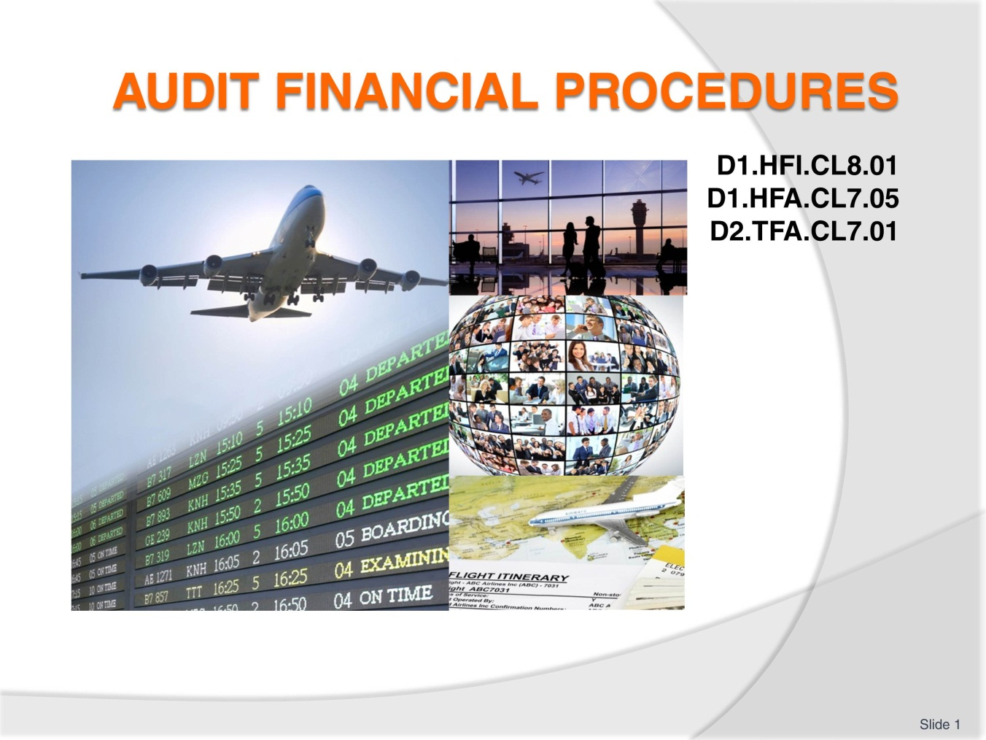
Slide No | Trainer Notes
- Trainer welcomes students to class
- Discuss housekeeping issues such as times of attendance, expected classroom behaviour, contact details, any resources required such as a calculator
- Explain that the trainees will be assessed and the requirements of those assessments.

Slide
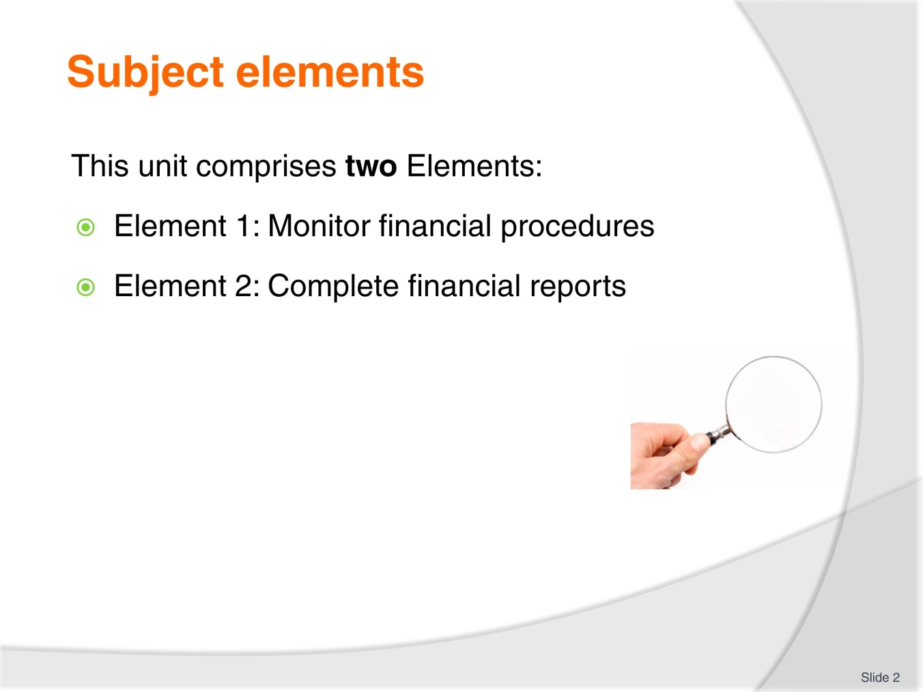
Slide No | Trainer Notes
Trainer advises this Unit comprises two Elements, as listed on the slide explaining:
- Each Element comprises a number of Performance Criteria which will be identified throughout the class and explained in detail
- Trainees can obtain more detail from their Trainee Manual(TM)
- At times the course presents advice and information about various protocols but where their workplace requirements differ to what is presented, the workplace practices and standards, as well as policies and procedures must be observed.

Slide
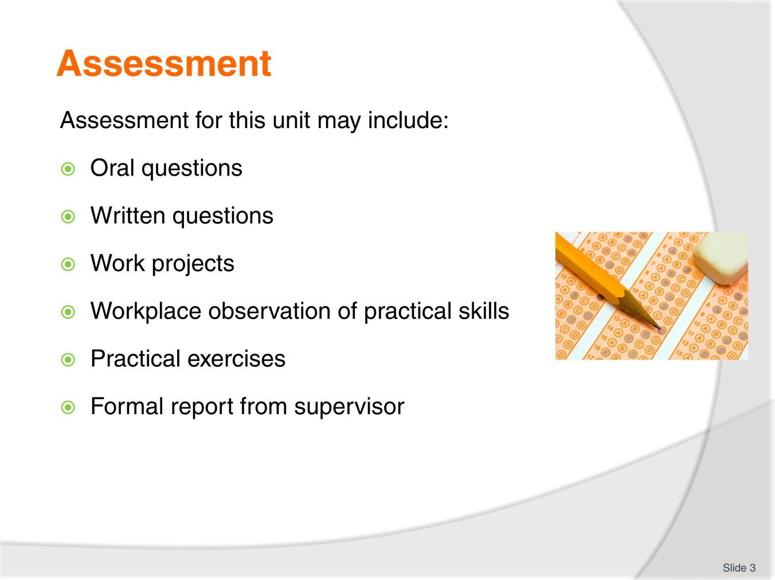
Slide No | Trainer Notes
- Trainer advises that assessment for this Unit may take several forms all of which are aimed at verifying they have achieved competency for the Unit as required
- Trainer indicates the methods of assessment that will be applied to them for this Unit.

Slide
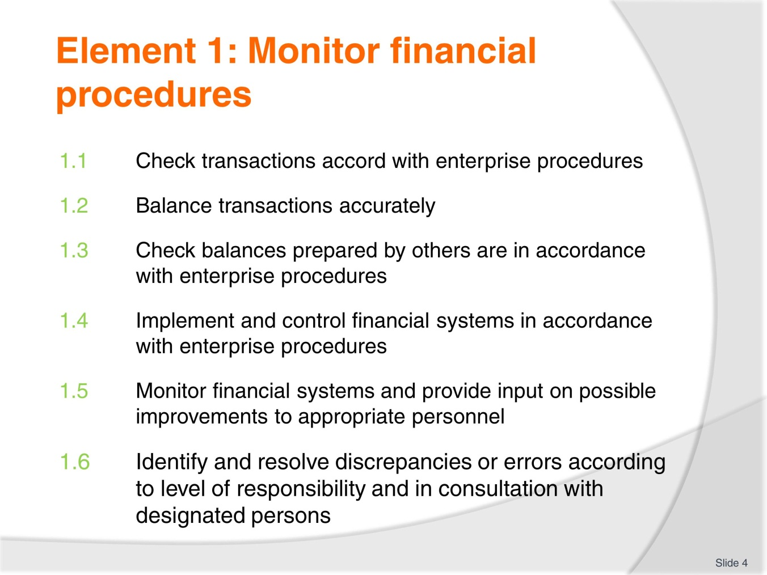
Slide No | Trainer Notes
- Trainer advises trainees this Element is comprised of six Performance Criteria which will be identified throughout the class and explained in detail
- Trainees can obtain more detail from their Trainee Manual.

Slide
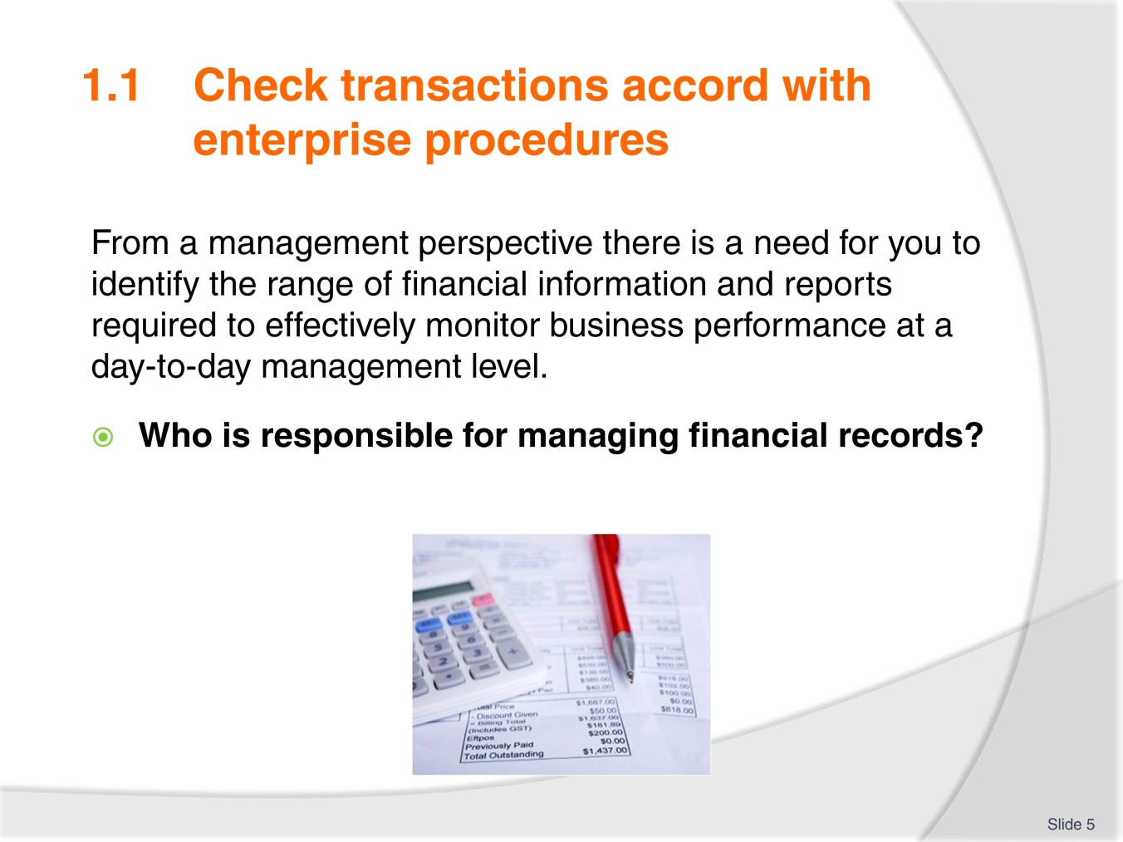
Slide No | Trainer Notes
 | Discuss this topic and brainstorm ideas completing Activity 1 as the summary.

Slide
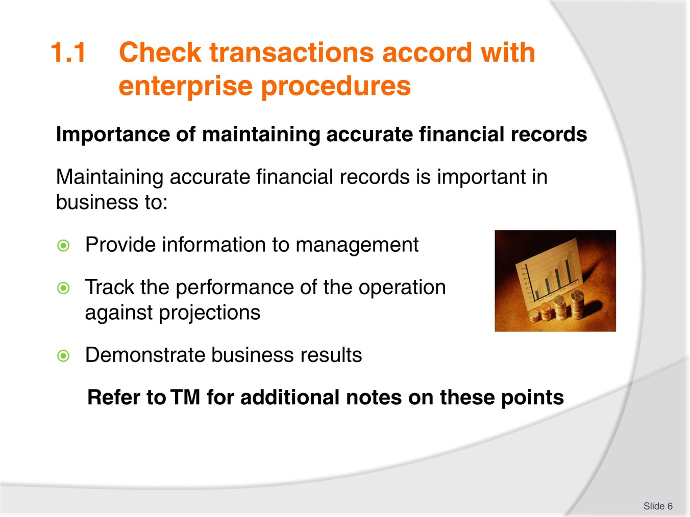
Slide No | Trainer Notes
 | Discuss and clarify as necessary.

Slide
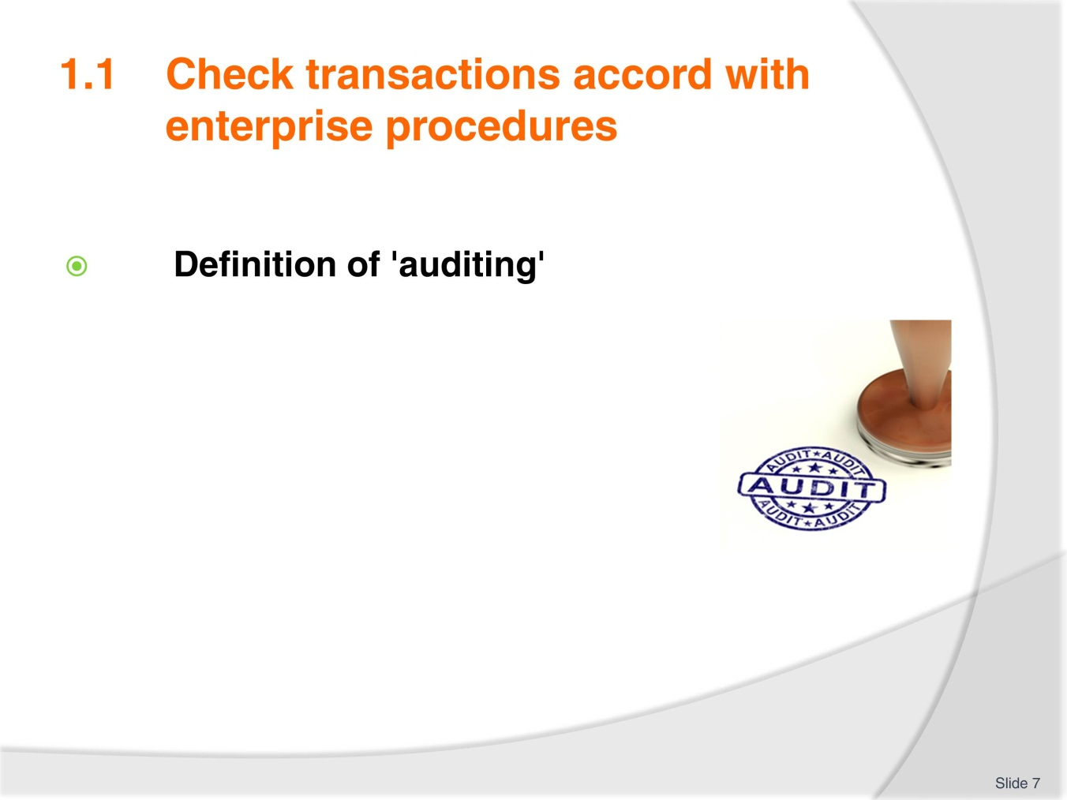
Slide No | Trainer Notes
- Ask trainees to close their manuals
- Ask each trainee to write a definition on their understanding of auditing
- Quickly have each person read their definition
- Brainstorm auditing and its purpose
- When complete, highlight key points in TM including auditing definition
- Review the bullet points and compare against what was brainstormed.

Slide
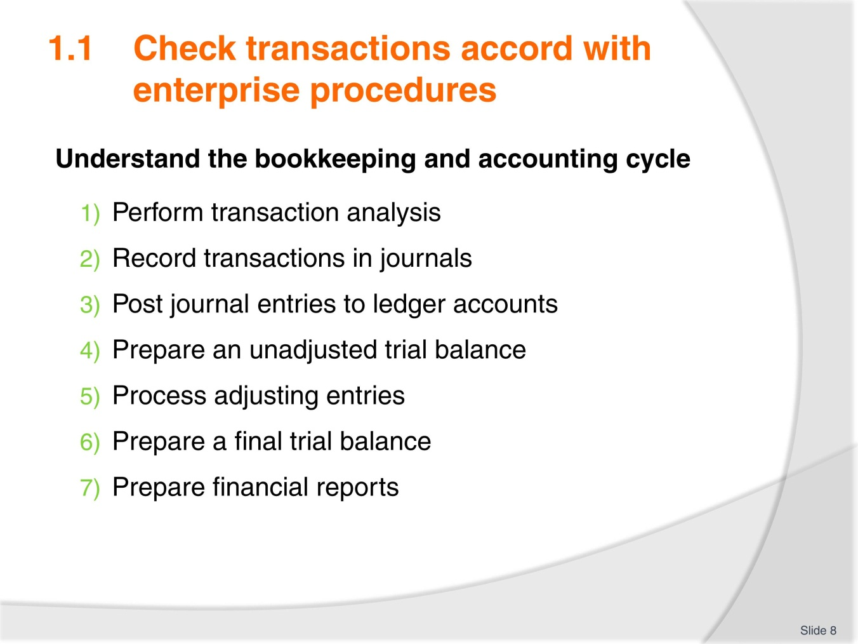
Slide No | Trainer Notes
- Discuss each point explaining with some detail what activities are involved and its importance in the cycle
- Have a sample, ledger, journal and financial report as examples for trainees to view.

Slide
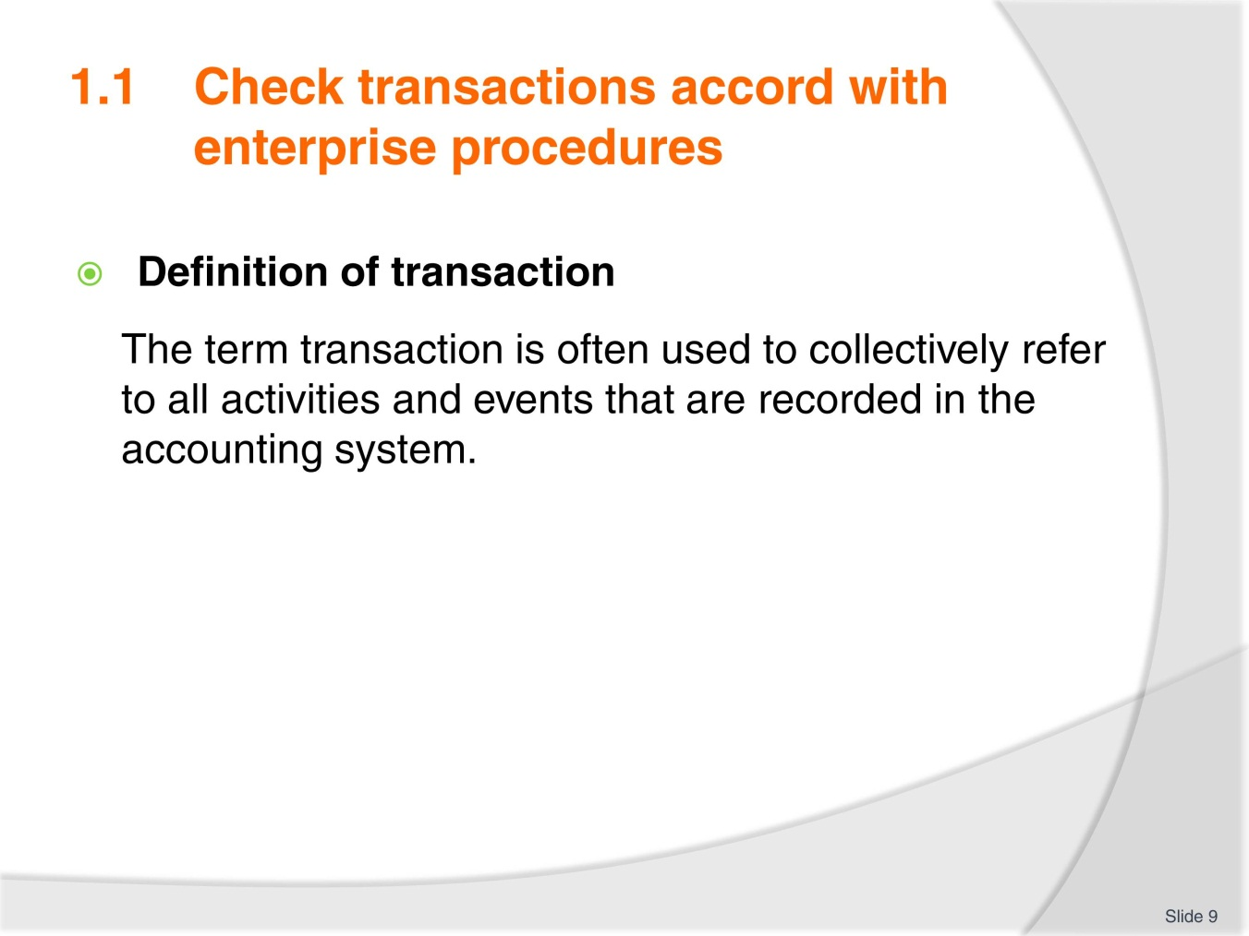
Slide No | Trainer Notes
 | Remind trainees that the exchange of money or credit cards is not always involved.

Slide
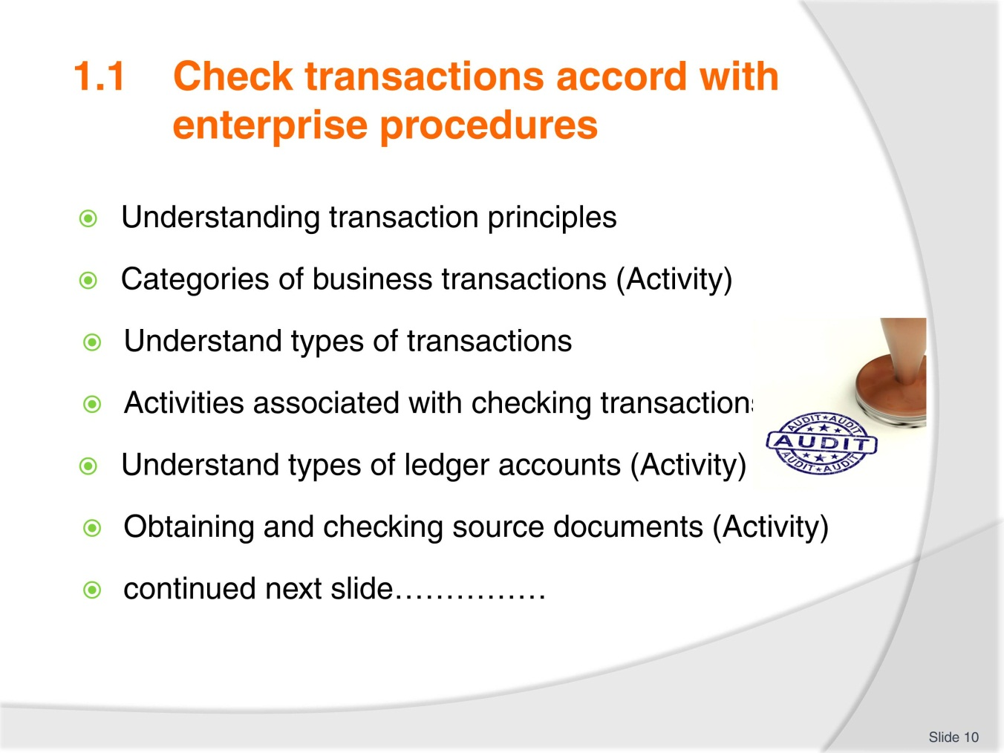
Slide No | Trainer Notes
- The remainder of this performance criteria has many points to cover (on this slide and the next) which may not maintain the interest of trainees. Engage trainees by having them deliver the training
- Divide the group into groups of 2-3. Allocate topics. Ask trainees to read the associated information and prepare a short training session for the group. Any Activities in the TM (available for individual printing from Trainer guide if needed) are to be included with the topic. Allocate an appropriate time allowance for delivery based on the number and size of topic/s
- Provide a time frame for preparation and any other research
- During this time trainer must circulate groups to ensure they understand their topics and are including adequate and necessary information. Trainer can advise trainees on presentation methods that could be included. (power point, handout, quiz, activity and so on)
- After each presentation have question time. Trainer can cover any key points missed or clarify as necessary information
- If possible have some reward to thank trainees for their efforts.

Slide
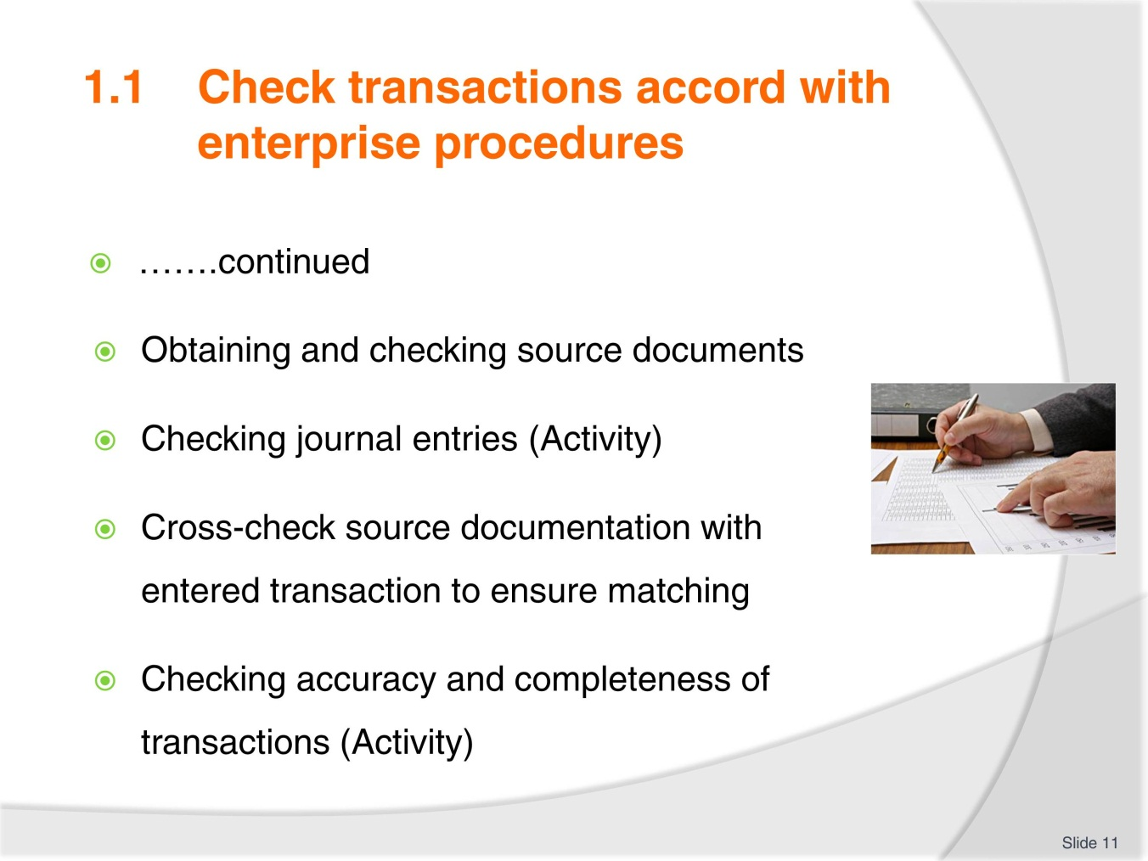
Slide No | Trainer Notes
- See notes on previous slide
- After each presentation have question time. Trainer can cover any key points missed or clarify as necessary information
- If possible have some reward to thank trainees for their efforts.

Slide
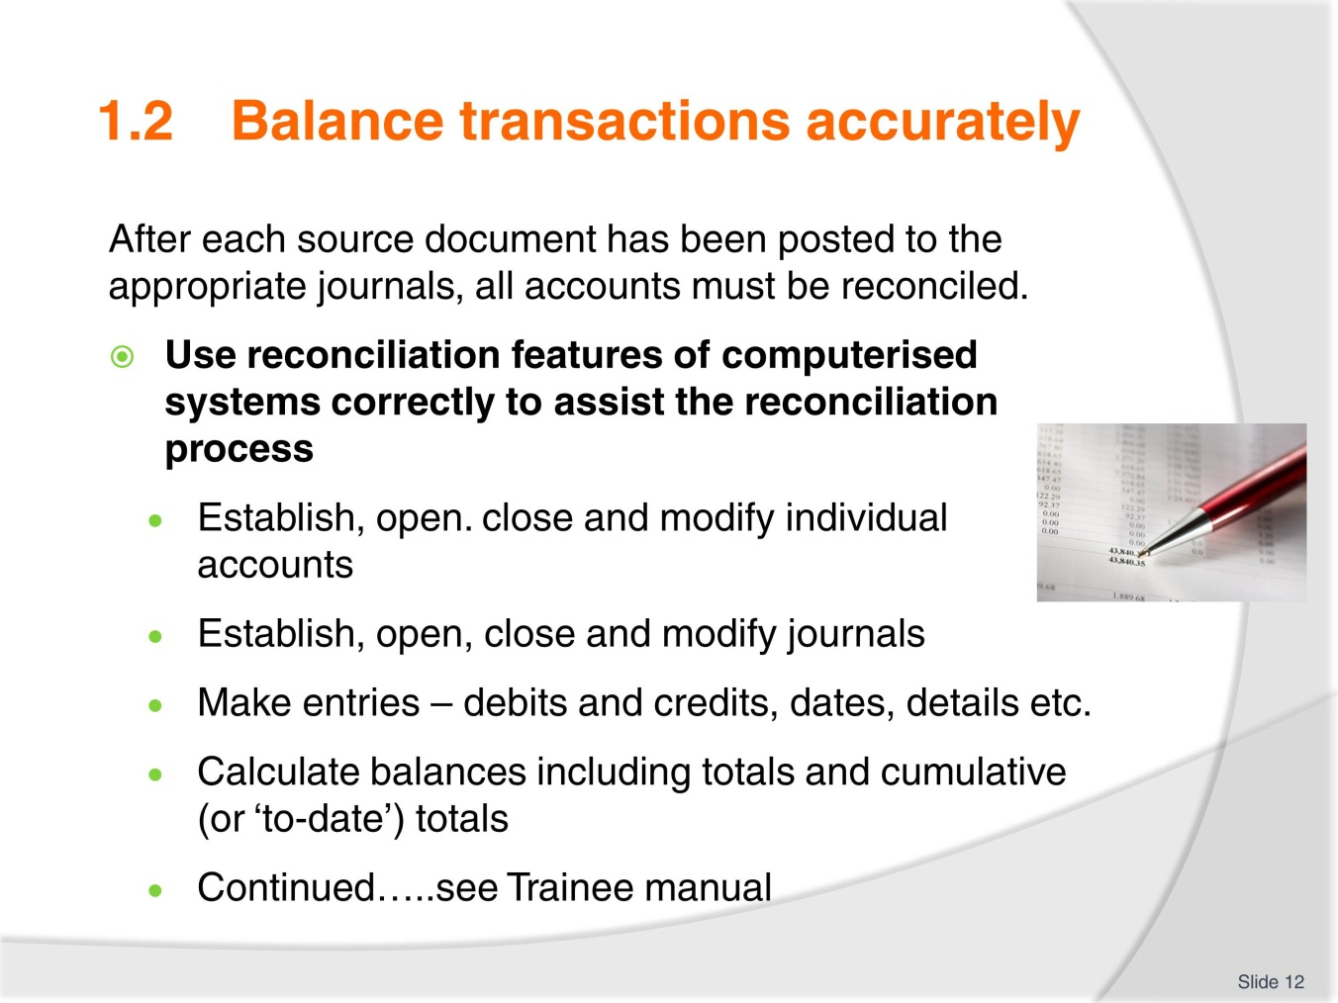
Slide No | Trainer Notes
- Discuss as necessary
- Brainstorm any well-known ‘of the shelf’ book keeping systems
- Have trainees share any relevant skills and knowledge.

Slide
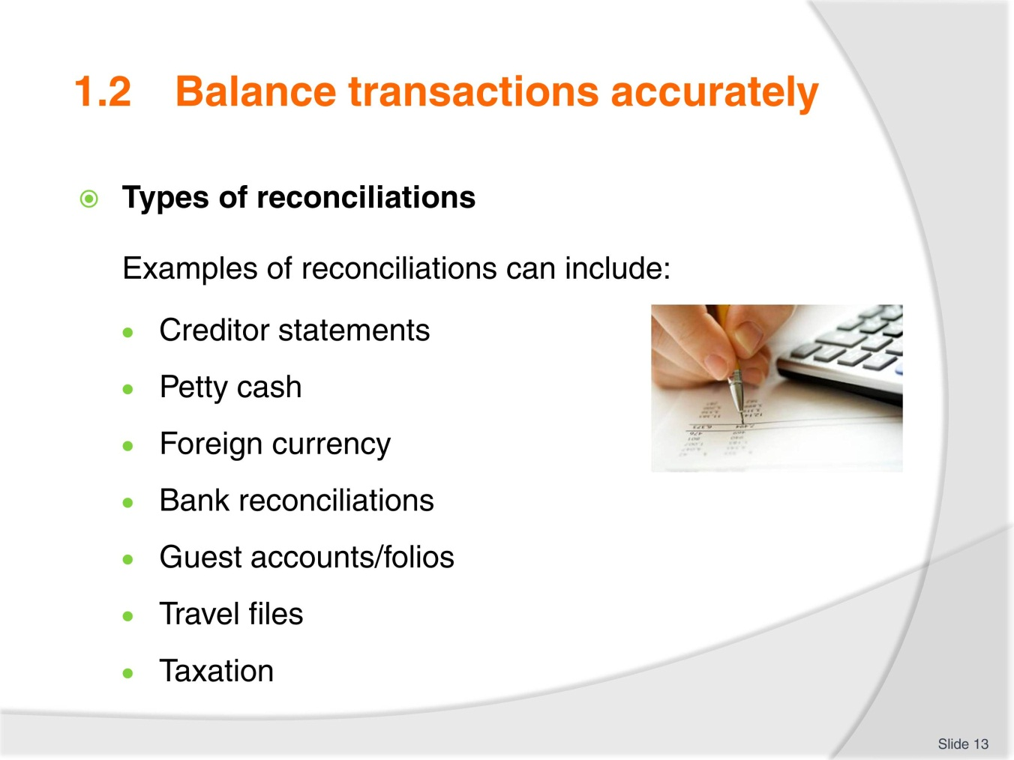
Slide No | Trainer Notes
- Discuss as necessary
- Ensure knowledge of terms used
- Show samples of each type of document if available
- Explain the use of Subsidiary ledgers to support General ledger.

Slide
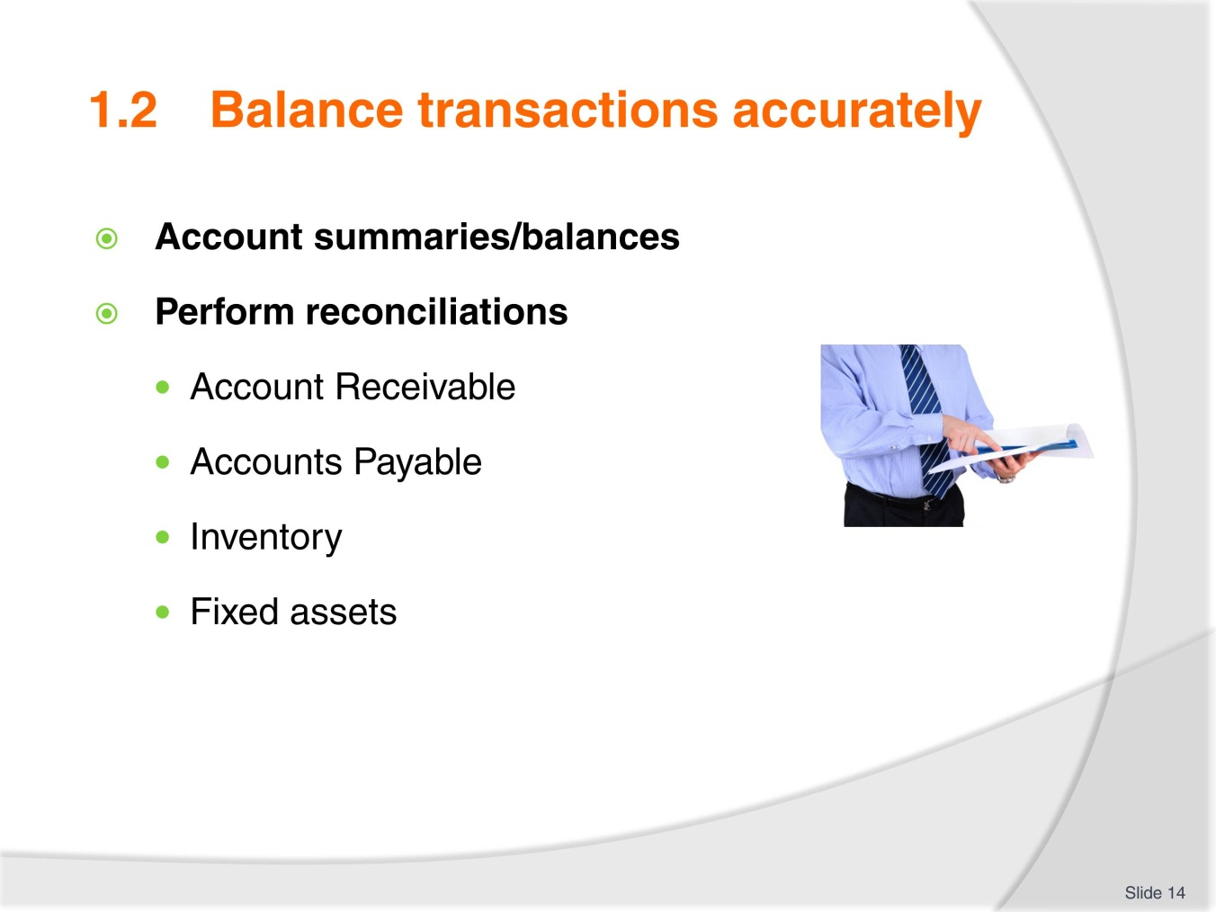
Slide No | Trainer Notes
- Discuss each point as necessary and ensure trainees have a clear understanding of each
- Show samples if available.

Slide
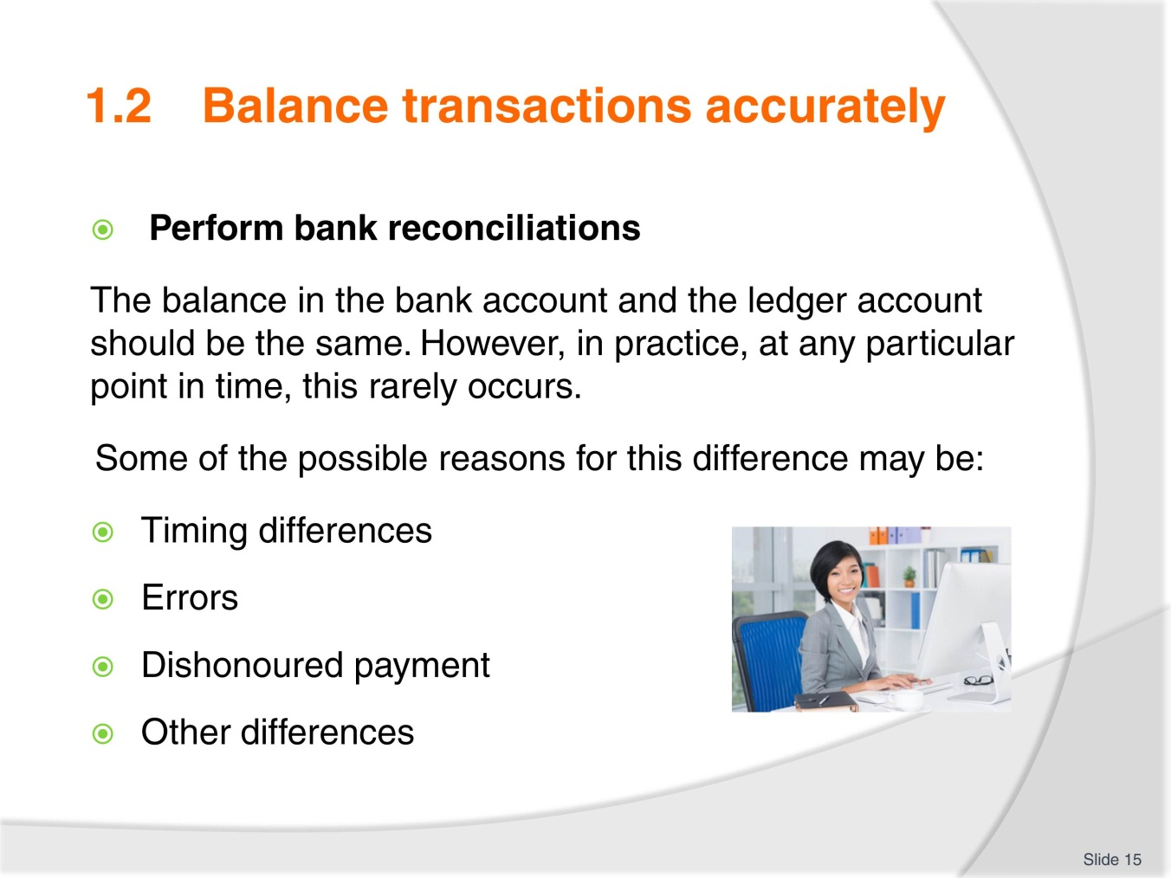
Slide No | Trainer Notes
- Discuss each point as necessary and ensure trainees have a clear understanding of each
- Show samples if available or search bank reconciliation templates on Google Images
- Review the steps for preparing a bank rec. and complete exercise 1 and 2. Review and discuss as needed.

Slide
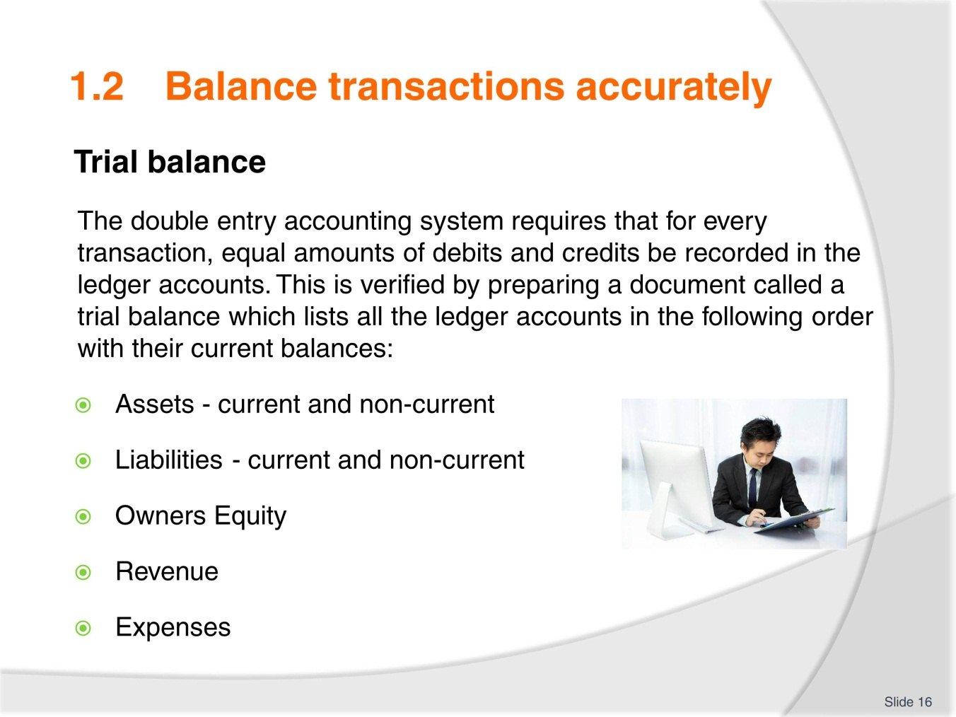
Slide No | Trainer Notes
 | Discuss each point as necessary and ensure trainees have a clear understanding of each.

Slide
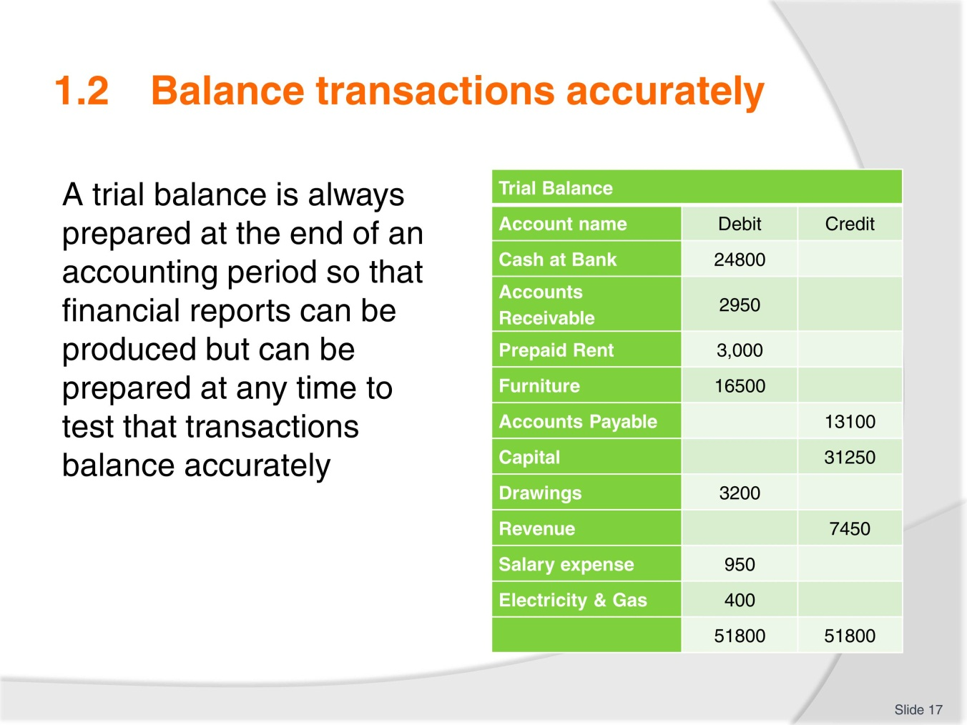
Slide No | Trainer Notes
- Explain Trial Balance image
- Quiz trainees on their understanding to determine if further explanation is required.

Slide
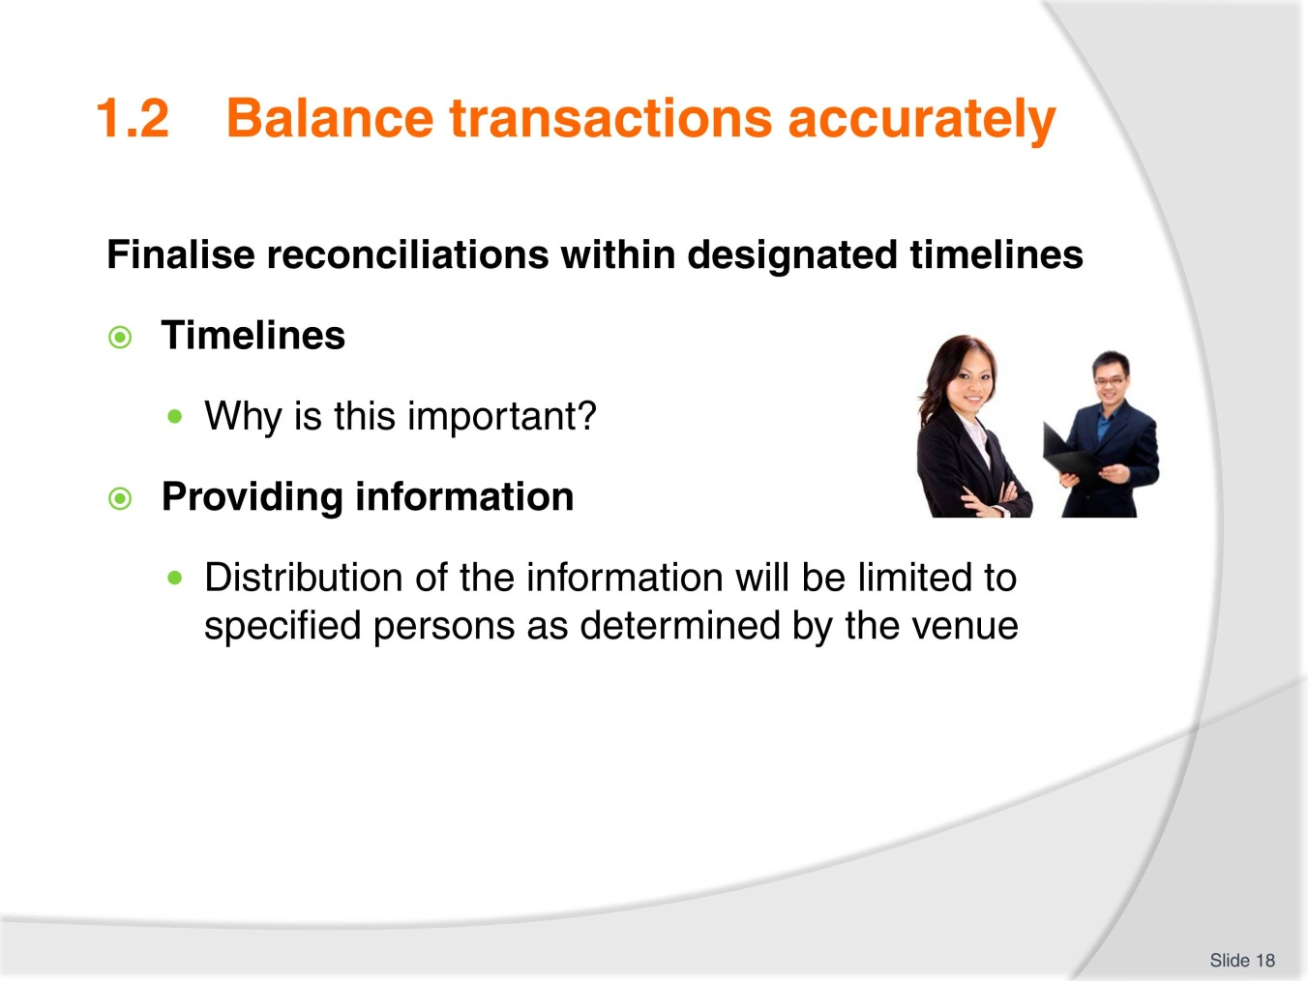
Slide No | Trainer Notes
- Discuss each point as necessary
- Providing information will be covered again later
- Complete Activity 8 and have trainees share their answers.

Slide
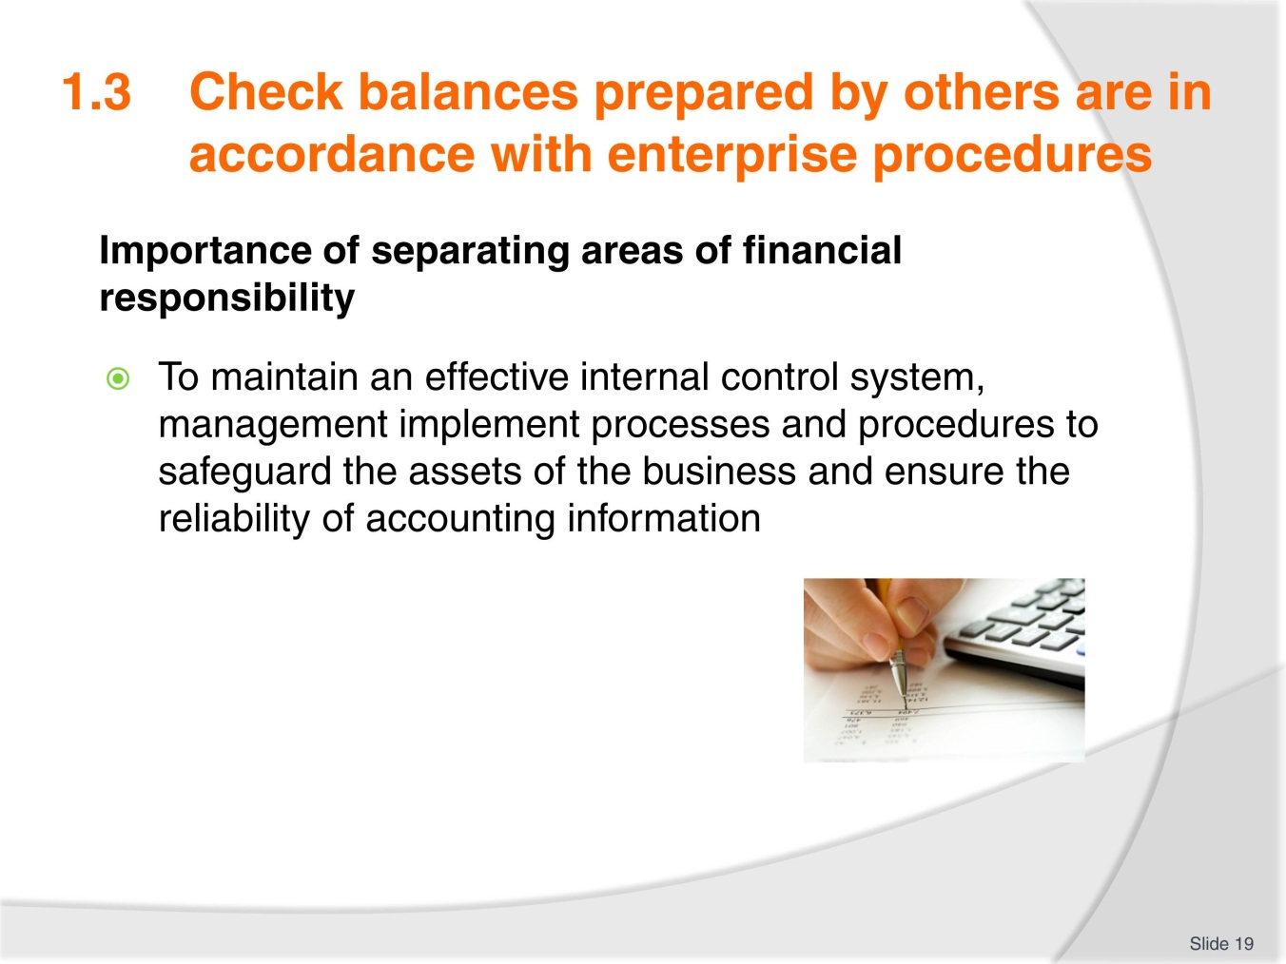
Slide No | Trainer Notes
- In accounting circles there is a saying ‘who is checking the checker?’
- Everyone must be accountable to avoid the possibility of embezzlement or fraud
- Share any knowledge or experience that may be relevant to this
- Complete Activity 9.

Slide
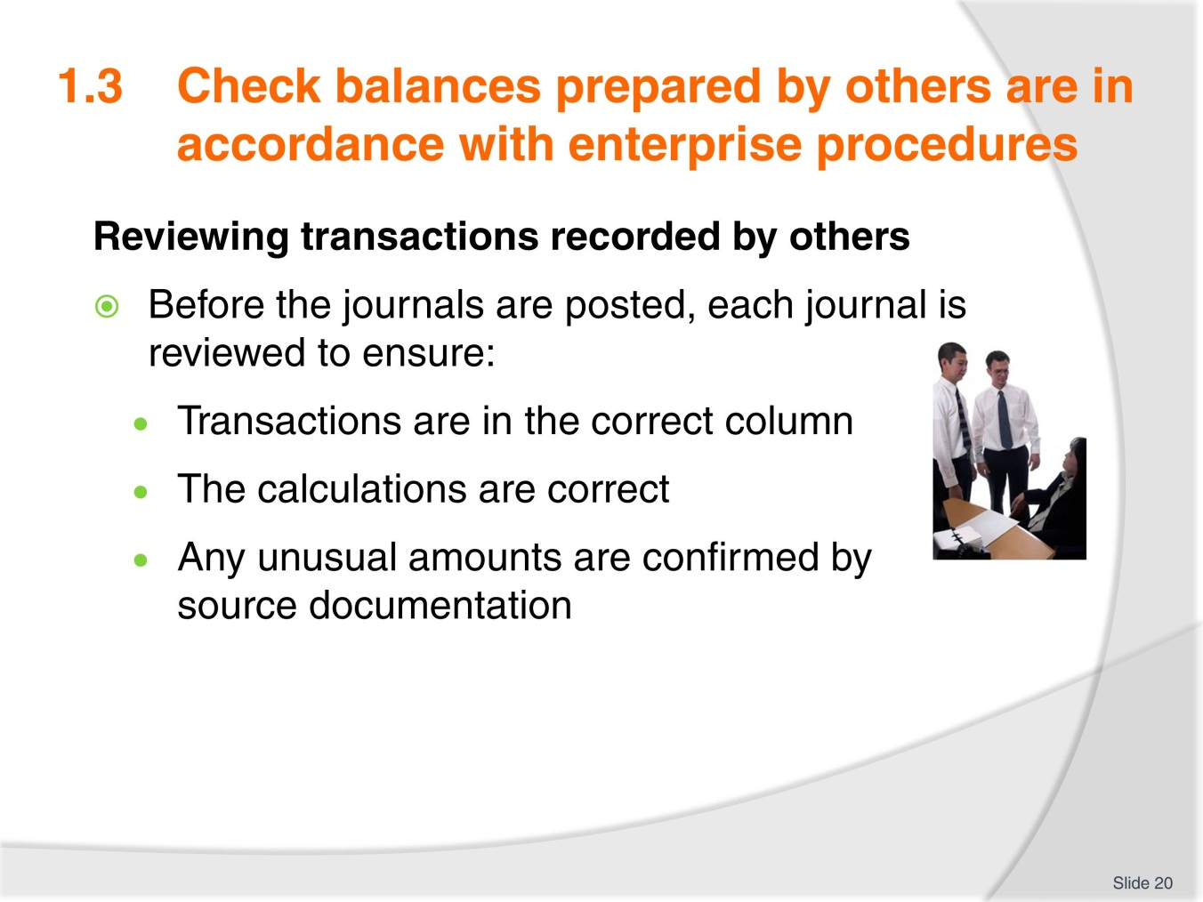
Slide No | Trainer Notes
 | Highlight key points and share relevant knowledge and experience.

Slide
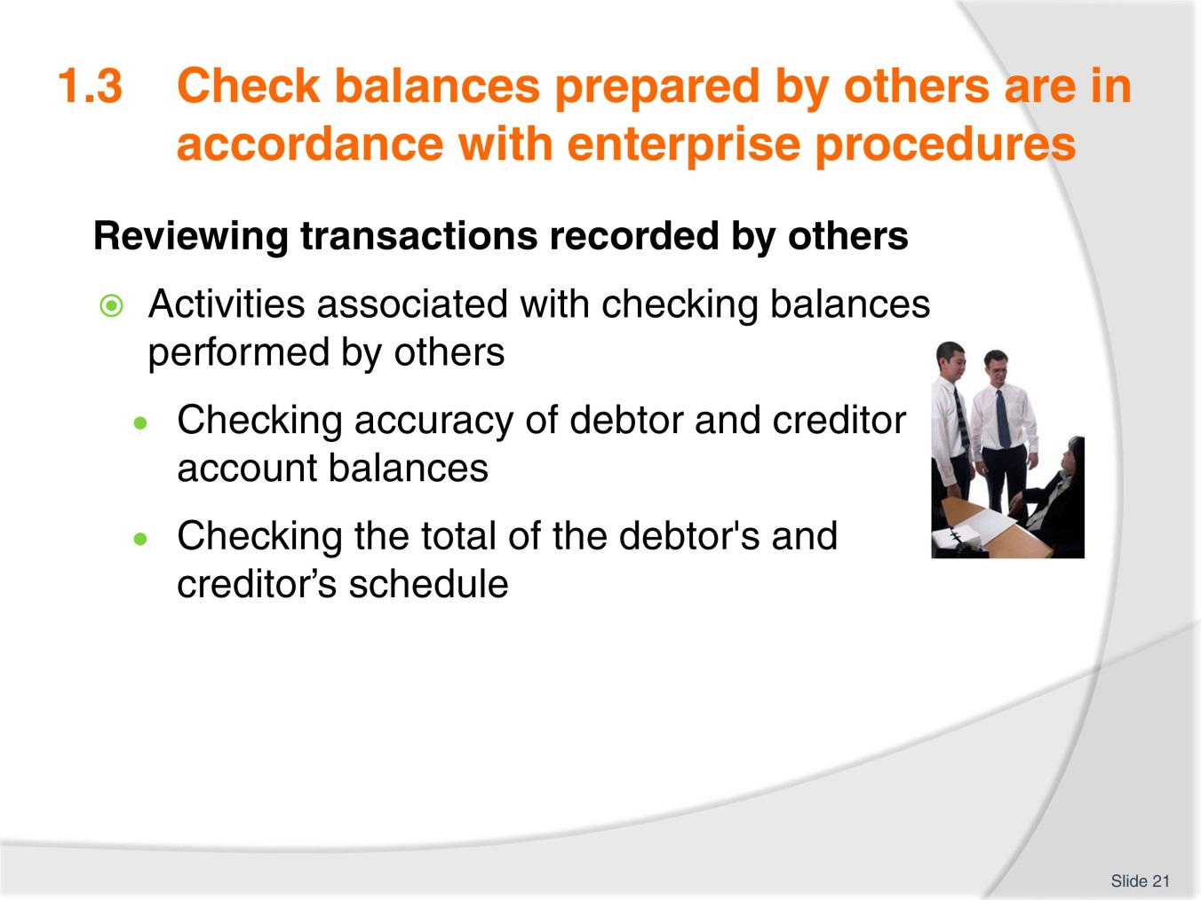
Slide No | Trainer Notes
 | Highlight key points and complete Activities 10 and 11.

Slide
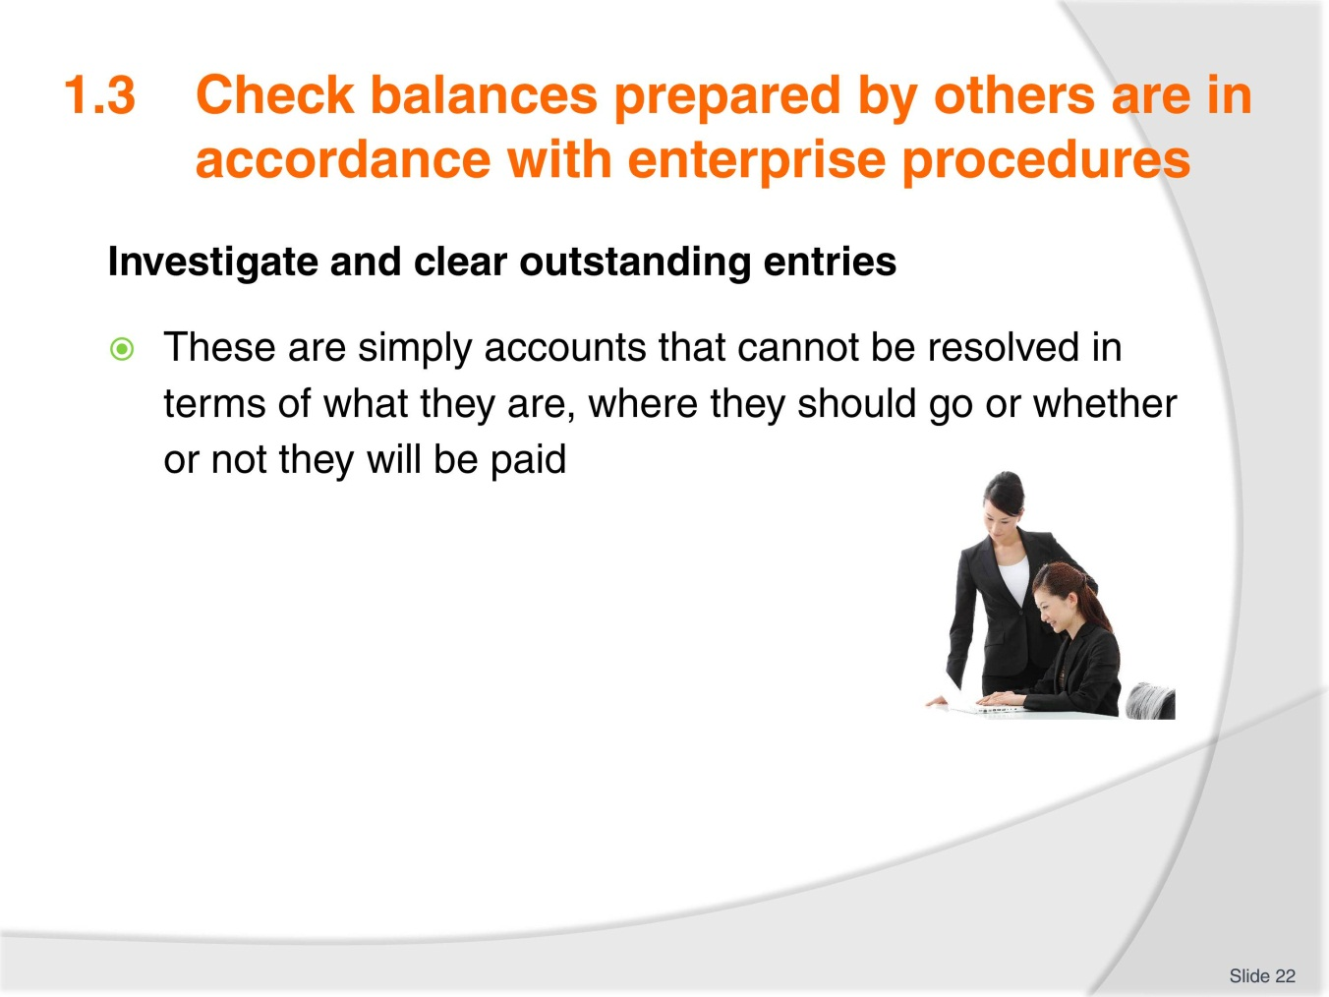
Slide No | Trainer Notes
- Discuss possible scenarios this may relate to. Ask trainees if they have any knowledge or experience in this area
- Discuss who appropriate colleagues may be to help resolve such situations
- Complete Activity 12 and share answers.

Slide
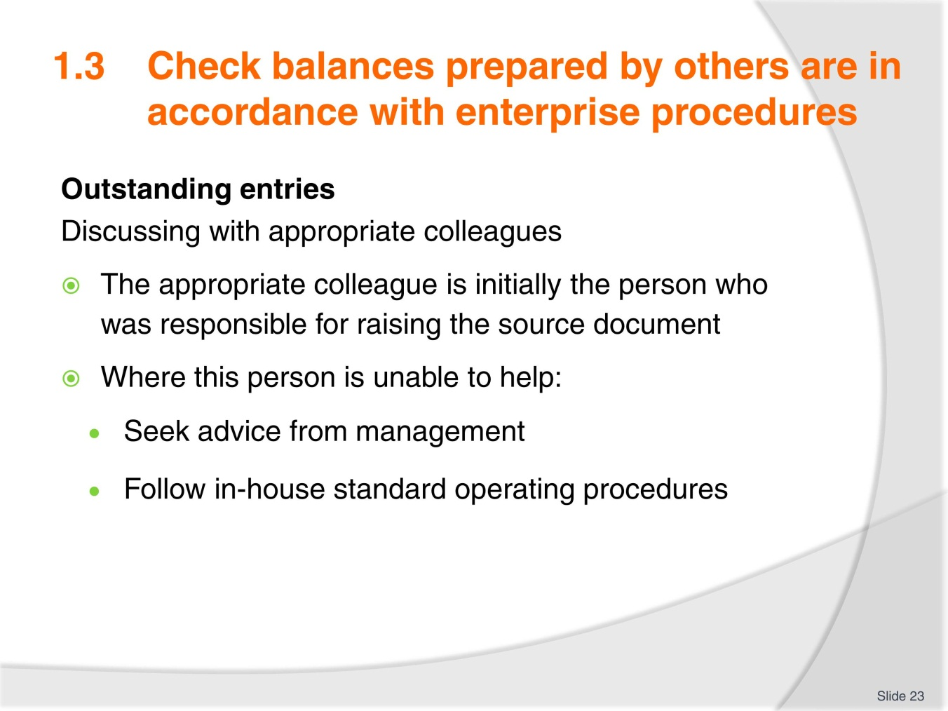
Slide No | Trainer Notes
- Have discussion about outstanding entries or accounts. Does anyone have any experience with this?
- Outstanding entries may reflect back on employees not following procedure properly which would result in staff memos or re-training
- Consider what might happen in the workplace regarding larger outstanding entries.

Slide
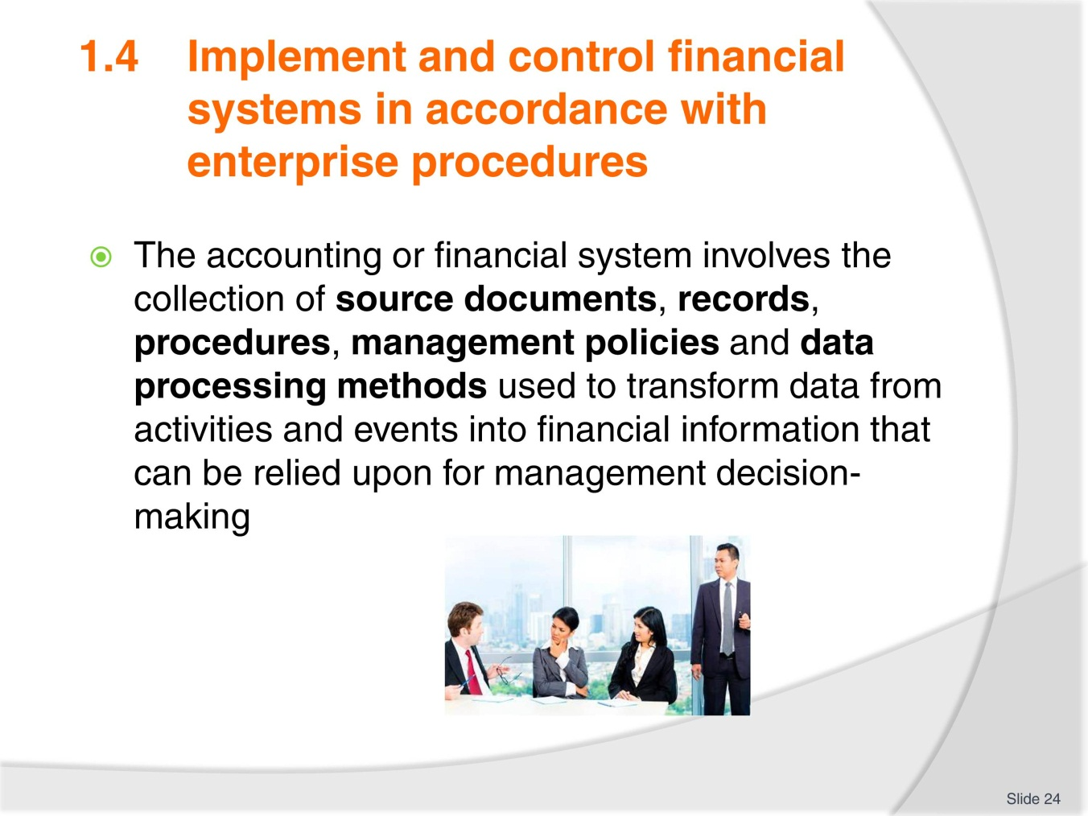
Slide No | Trainer Notes
- Highlight the types of documents required to source information
- Brainstorm this.

Slide
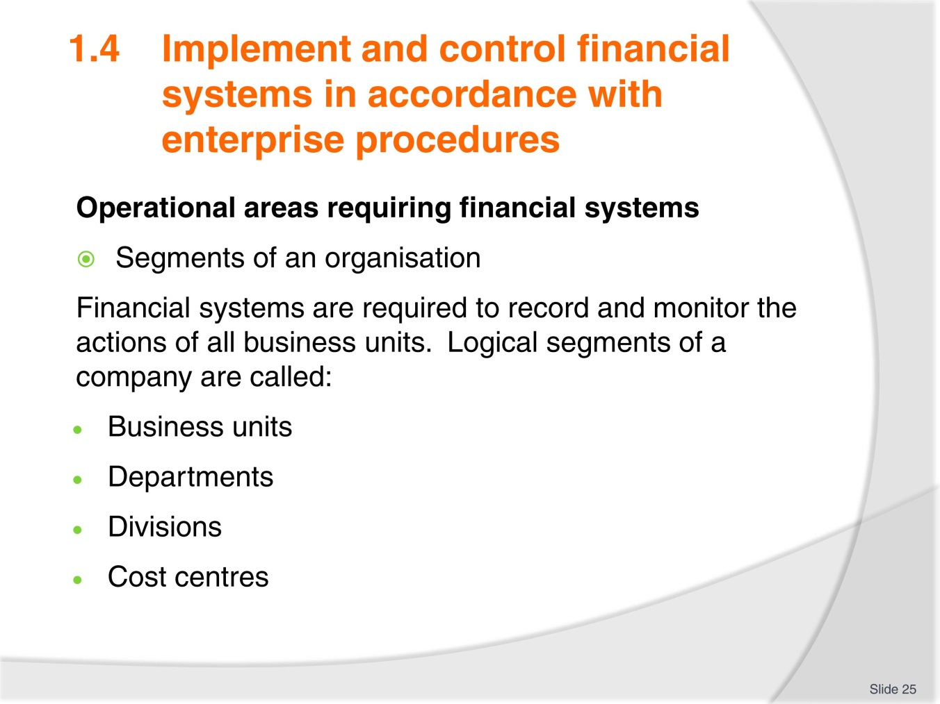
Slide No | Trainer Notes
 | Confirm with trainees if they know any other terms that may be used.

Slide
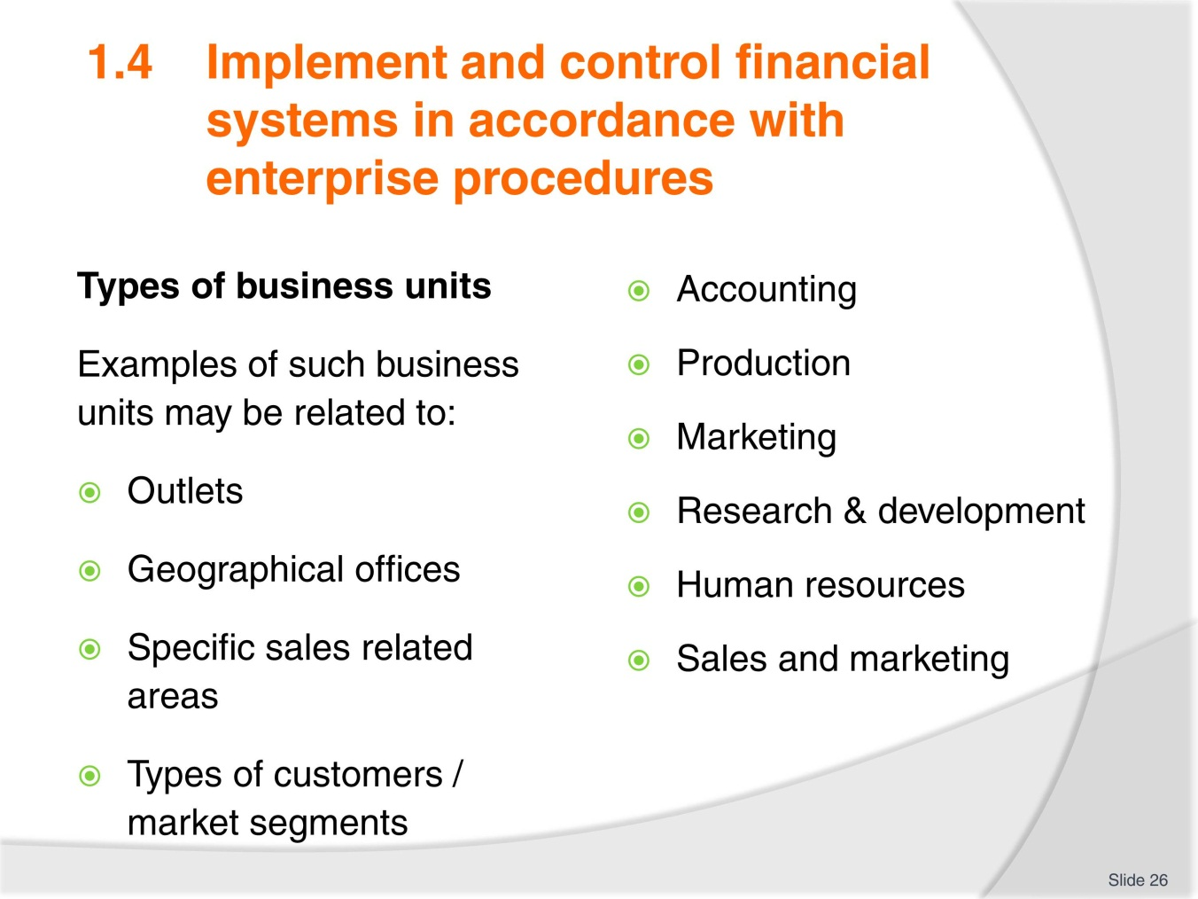
Slide No | Trainer Notes
- Consider which of these units may be found in small and large organisations. Can anyone think of any others?
- Have some discussion about the financial responsibility of these units as this is the requirement of the activity
- Complete Activity 13 and review answers.

Slide
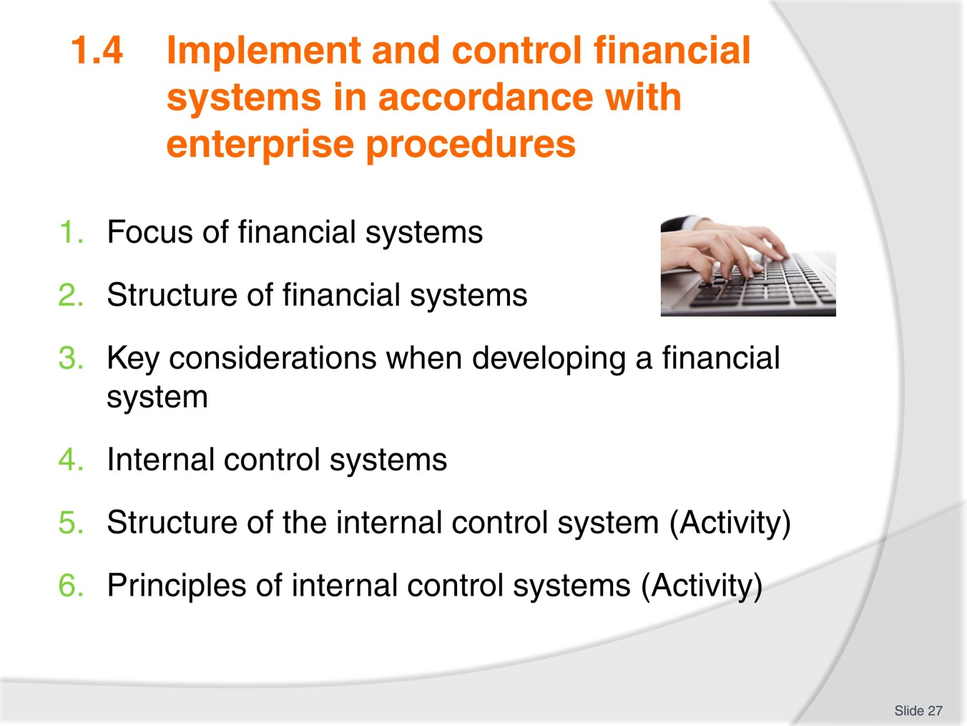
Slide No | Trainer Notes
Activity
- This performance criterion is very large and relates to the many controls in place with financial procedures. As with Performance Criteria(PC) 1.1 this PC will be more engaging for trainees if they are required to read, research and present the information with trainer support
- Divide the group into small groups (consider if the groups should be different to last time).
- Allocate topics
- Ask trainees to read the associated information and prepare a short training session for the group. Any Activities in the TM (available for individual printing from Trainer guide if needed) are to be included with the topic. Allocate an appropriate time allowance for delivery based on the number and size of topic/s. Remind trainees information falls into three categories
- Must know
- Need to know
- Nice to know
- It is the ‘must know’ that is essential when working to a time frame.
- Provide a time frame for preparation and any other research

- During this time trainer must circulate groups to ensure they understand their topics and are including adequate and necessary information. Trainer can advise trainees on presentation methods that could be included. (you tube clips, internet links, power point, handout, quiz, activities and so on)
- After each presentation have question time. Trainer can cover any key points missed or clarify as necessary information. Trainer must quiz or question trainees to ensure they have learned key information
- If possible have some reward to thank trainees for their efforts.

Slide
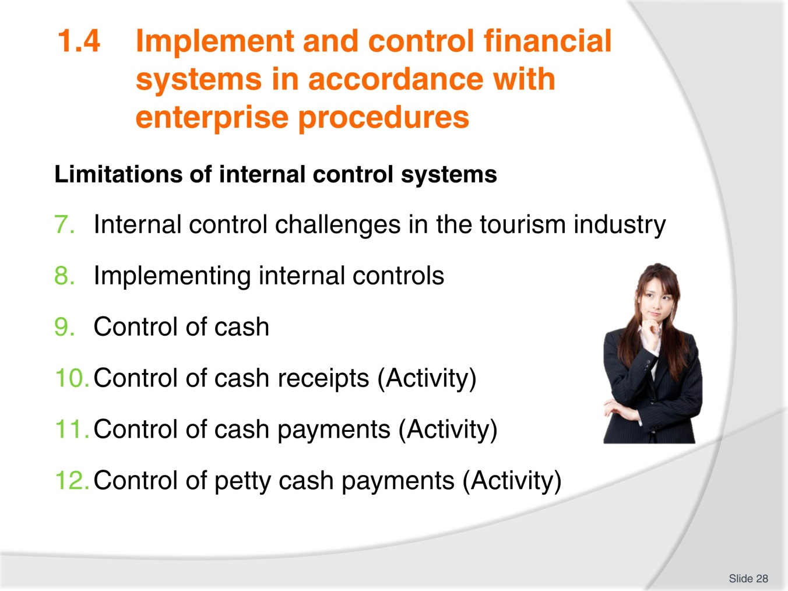
Slide No | Trainer Notes
 | See notes slide 27.

Slide
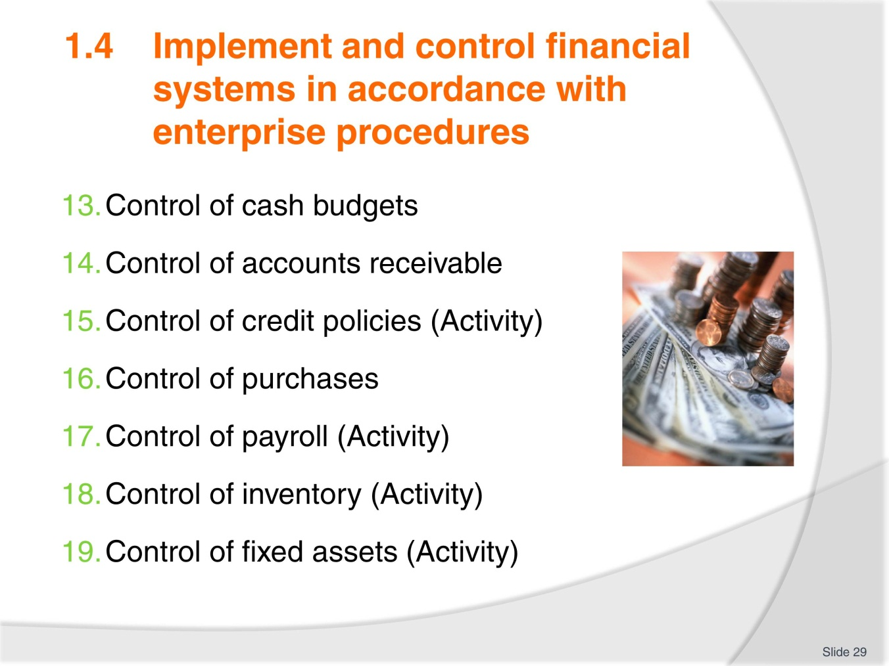
Slide No | Trainer Notes
 | See notes slide 27.

Slide
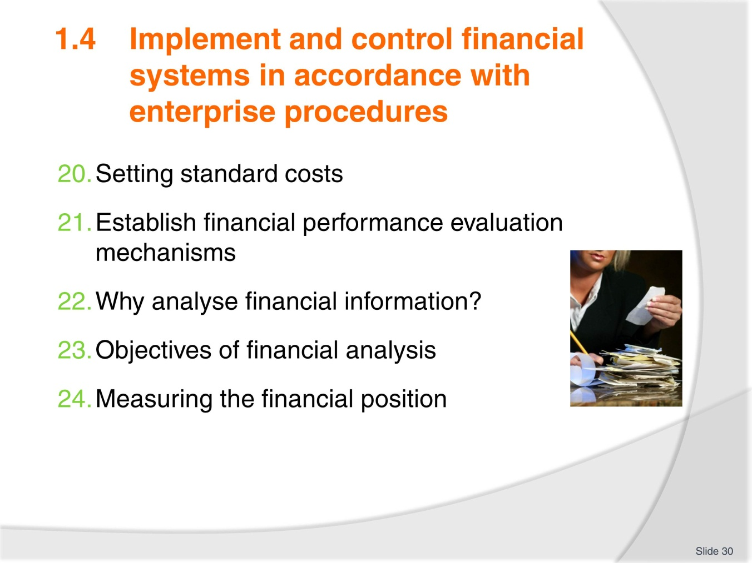
Slide No | Trainer Notes
 | See notes slide 27.

Slide
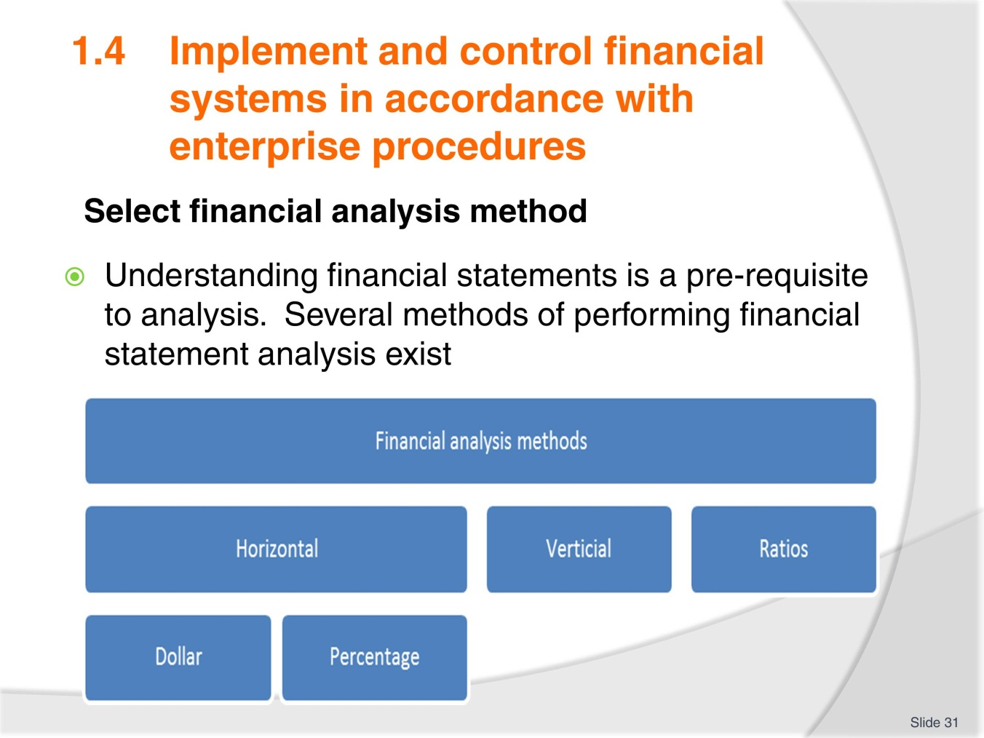
Slide No | Trainer Notes
The 3 common analysis methods are as follows:
- Horizontal
- Vertical
- Ratio.

Slide
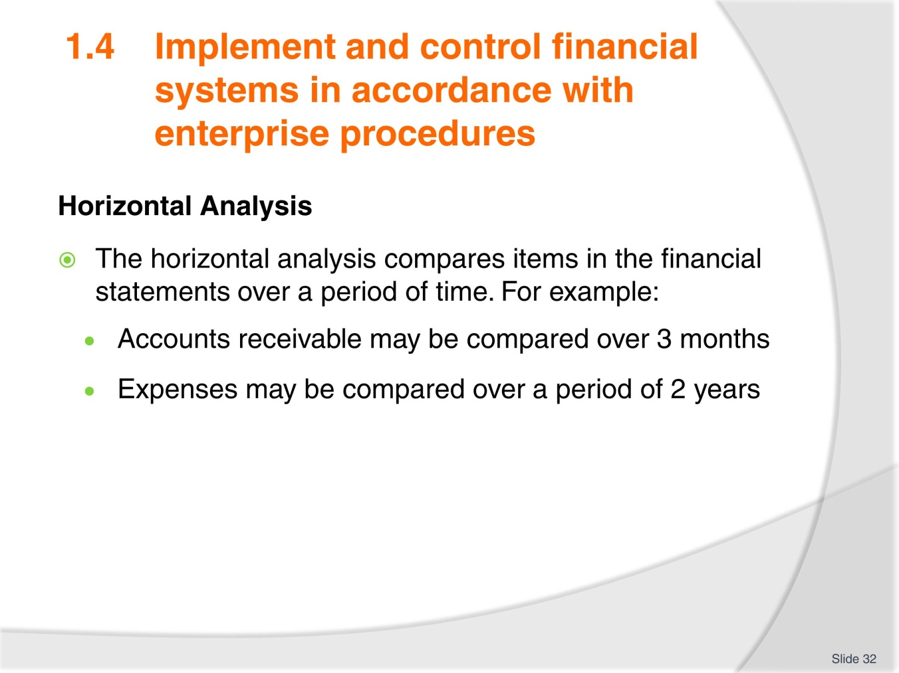
Slide No | Trainer Notes
Methods of financial statement analysis generally involve comparing certain information:
- Across periods
- Across companies
- Against benchmarks.
Enquire if any trainees have knowledge or experience in this area.

Slide
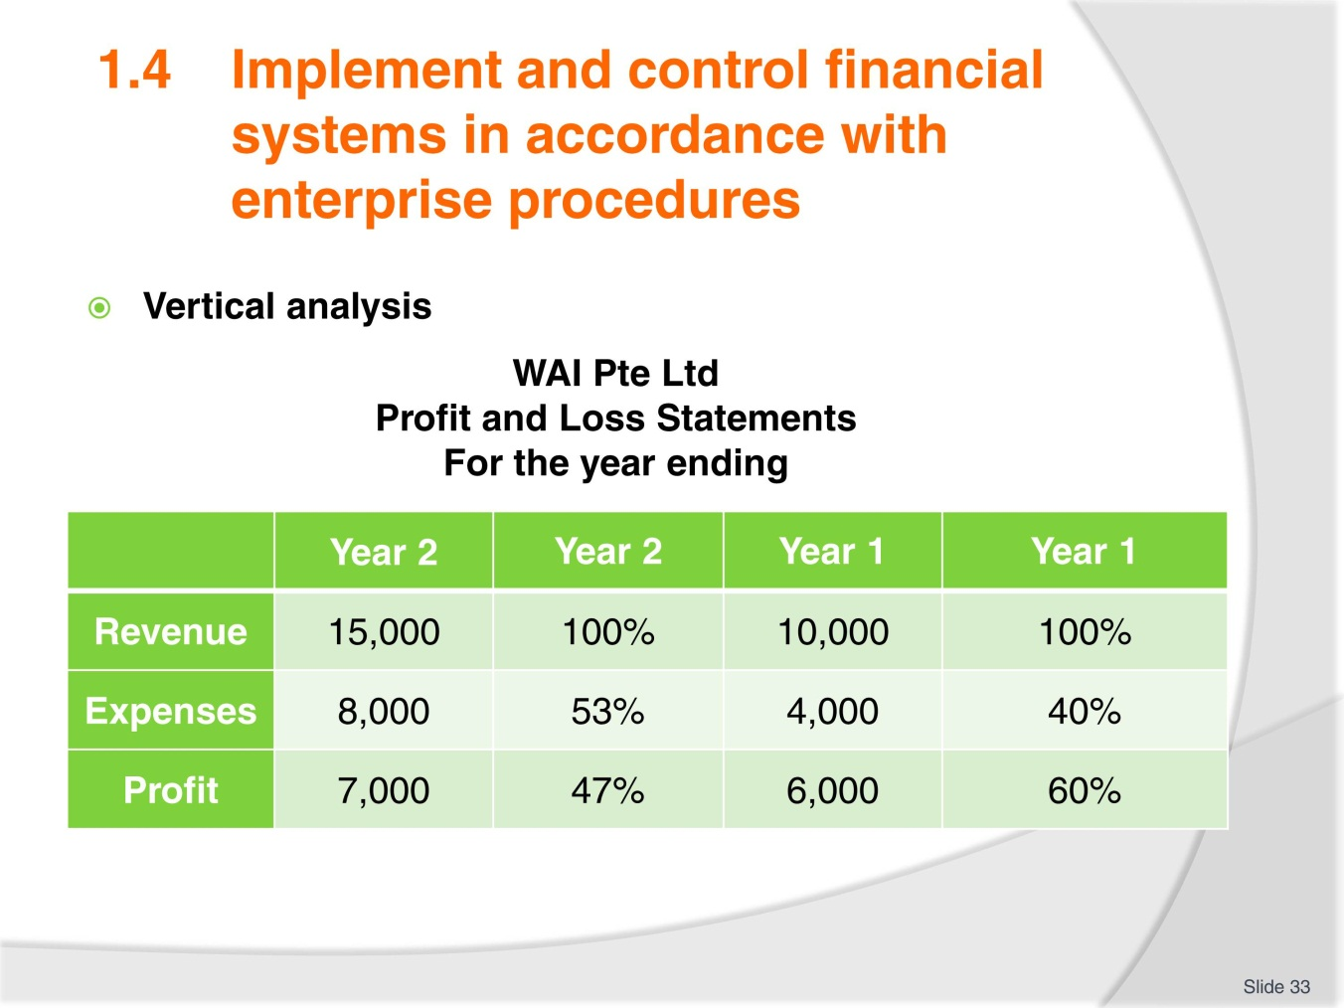
Slide No | Trainer Notes
- Discuss the following
- In the following example, we noted the following:
- Sales in Year 2 is better than Year 1
- Expenses in Year 2 is higher than Year 1
- Profit in Year 2 is higher than Year 1
- Question: Is Year 2 doing better than year 1?
- If we are to express sales as a base for both years, the following points are noted:
- Out of $100 sales made in Year 2, $53 is spent leaving a profit of $47
- Out of $100 sales made in Year 2, $40 is spent leaving a profit of $60
- The size of the financial statements in the above example has been made to be of common size for meaningful comparison.

Slide
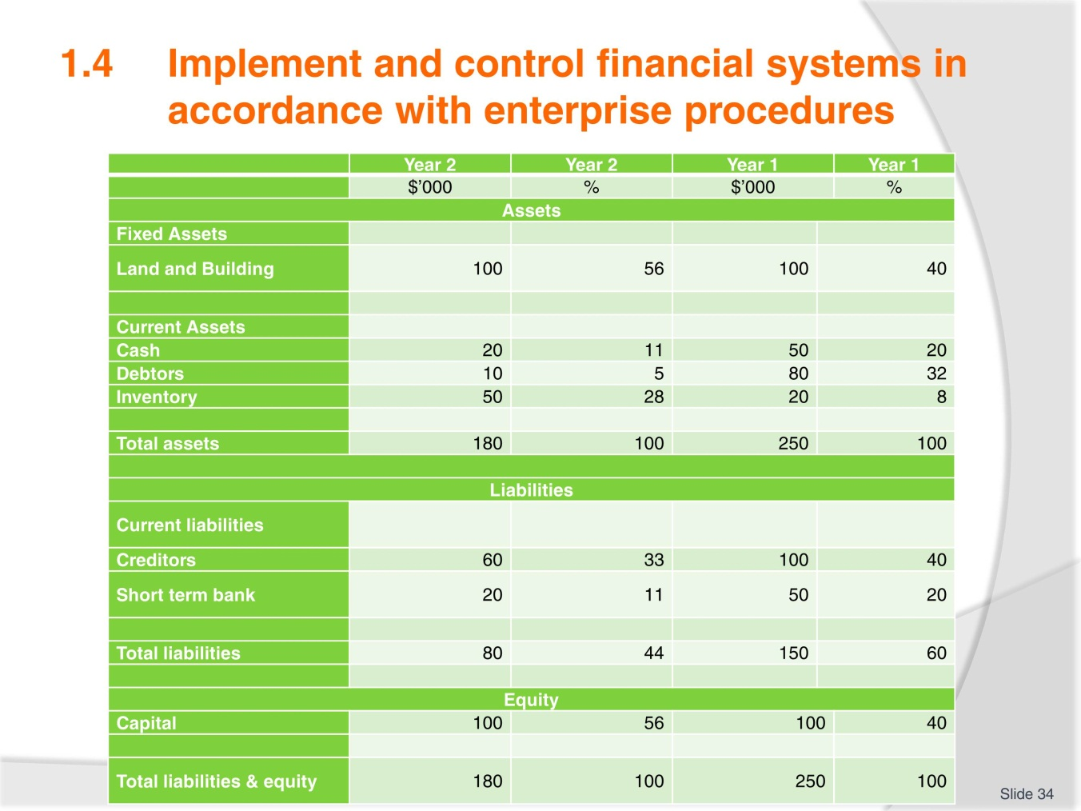
Slide No | Trainer Notes
- Review this balance sheet from the TM
- Balance sheet can be analysed using vertical financial analysis. Each item of the balance sheet can be compared to the total assets calculated
- Vertical analysis is useful for answering the queries relating to company’s assets, liabilities and equity. Vertical analysis is also referred to as common-size analysis
- Discuss the advantages of comparison over two or more years to see financial performance.

Slide
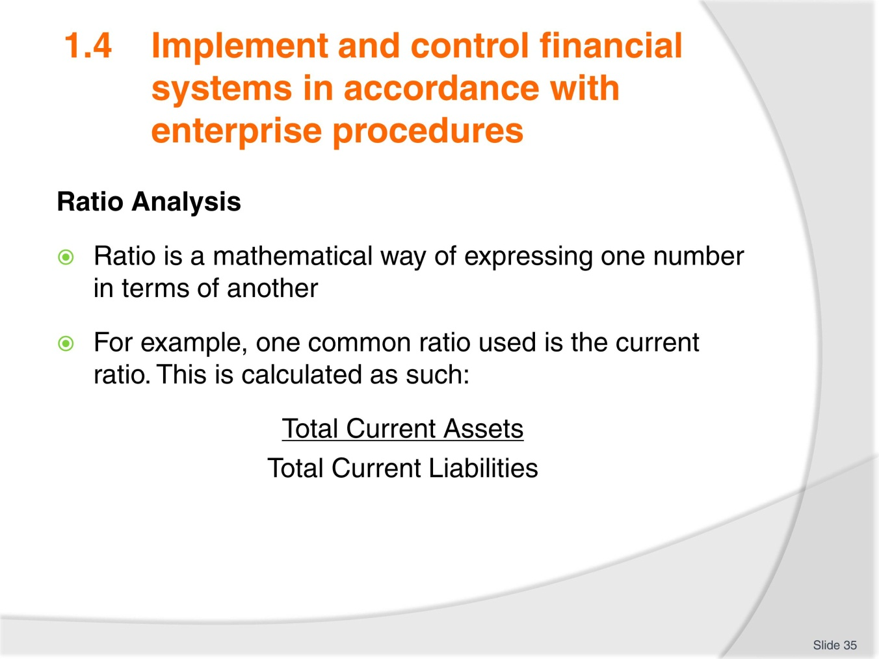
Slide No | Trainer Notes
- Financial ratio refers to ratios used in analysis of financial numbers. It is a way of assessing a company’s performance
- Discuss further as needed.

Slide
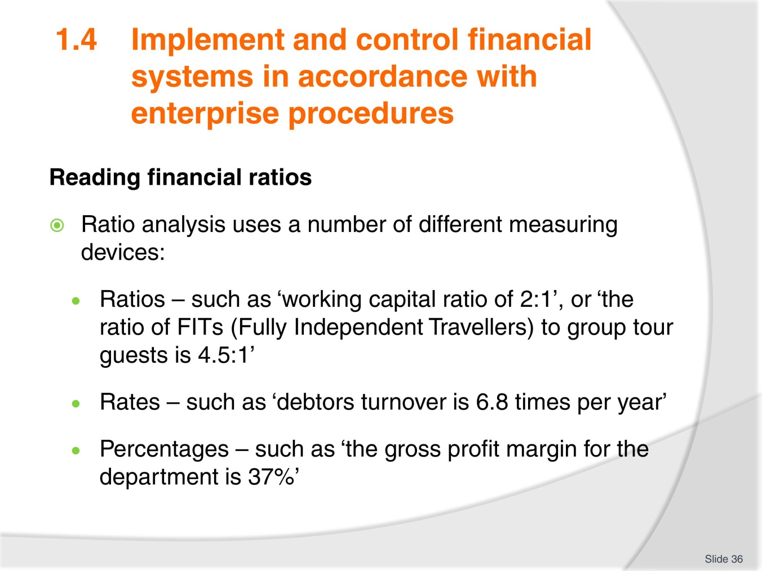
Slide No | Trainer Notes
- Take time to explain the formula and ensure all trainees understand how to use it effectively
- Ratio analysis is the technique of manipulating information contained in financial reports to produce measures of performance
- All the above are common examples of industry ratios used to describe the financial situation, and performance of, the business.

Slide
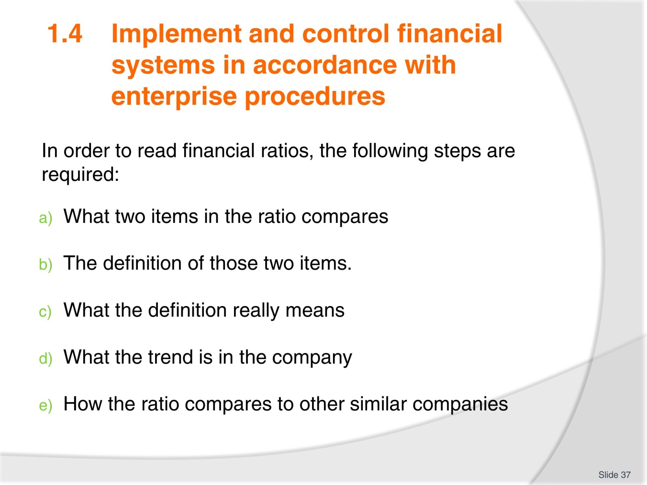
Slide No | Trainer Notes
- Understanding and interpreting financial ratios is a key business skill for users of the financial statements. Financial ratios illustrate the company’s strengths and weaknesses
- There are many financial ratios available. Some are generic to all companies and some are industry-specific. Too many ratios used may cause confusion
- It is even more unproductive when numerous ratios are just calculated without interpretation and analysis.

Slide
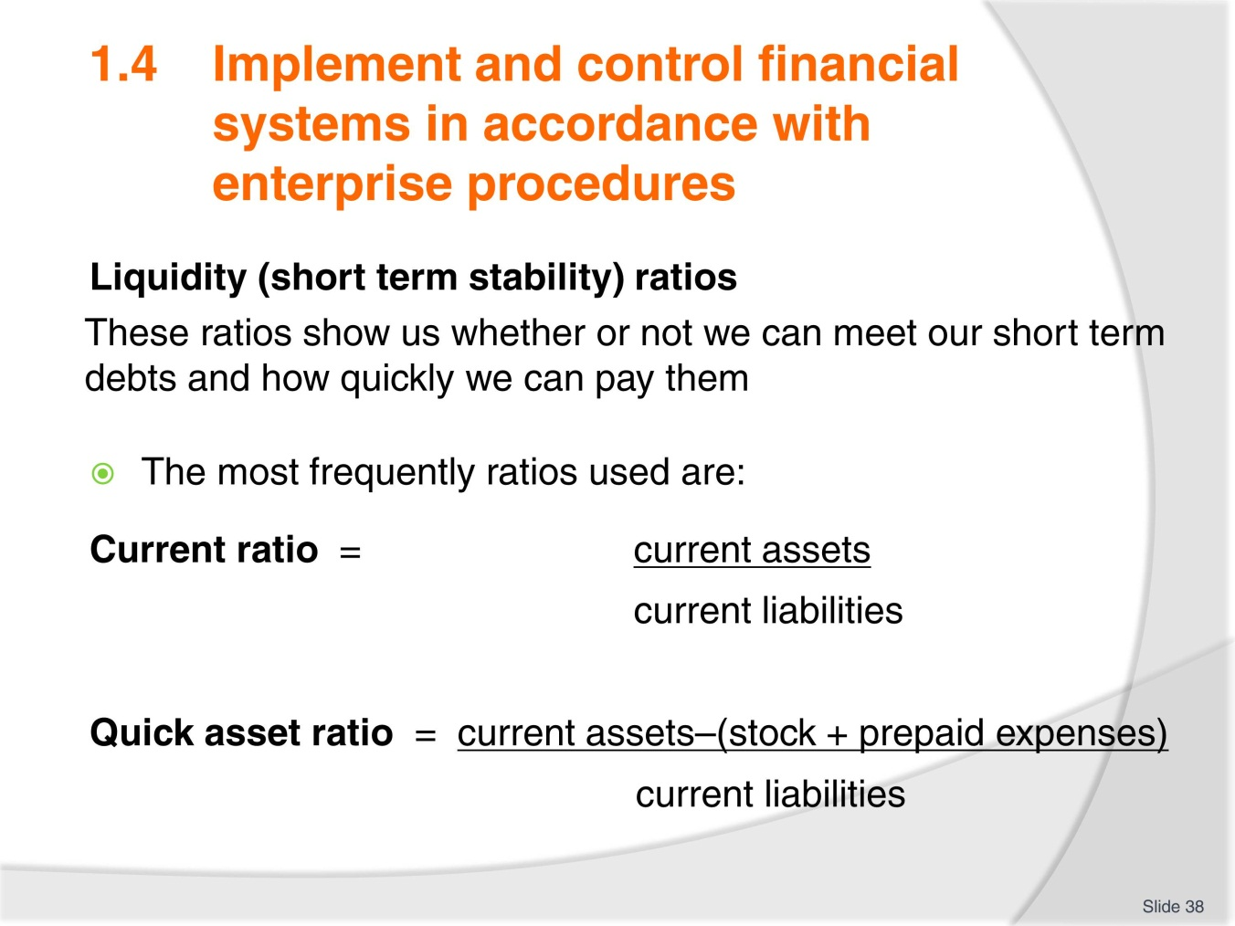
Slide No | Trainer Notes
 | Provide sample scenarios with figures and ask students to calculate ratios.

Slide
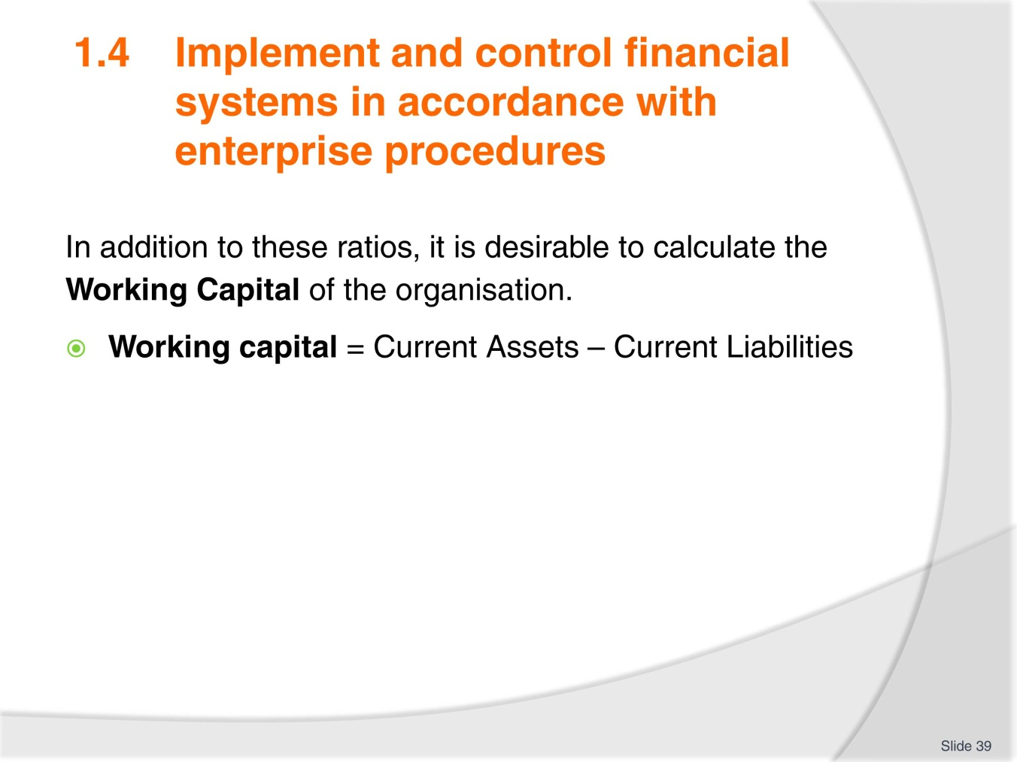
Slide No | Trainer Notes
- Provide sample scenarios and have students calculate working capital
- This exercise may be done using the personal example of mature age students, provided they are comfortable to do so.

Slide
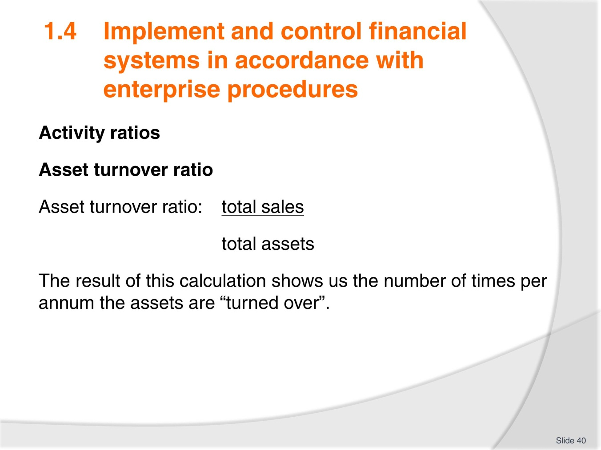
Slide No | Trainer Notes
- This ratio tells us how efficiently we use our assets to provide us with income
- When interpreting this ratio we try to see a trend emerging
- We want our ratio to be steadily increasing. This would mean that we are getting better at what we do.

Slide
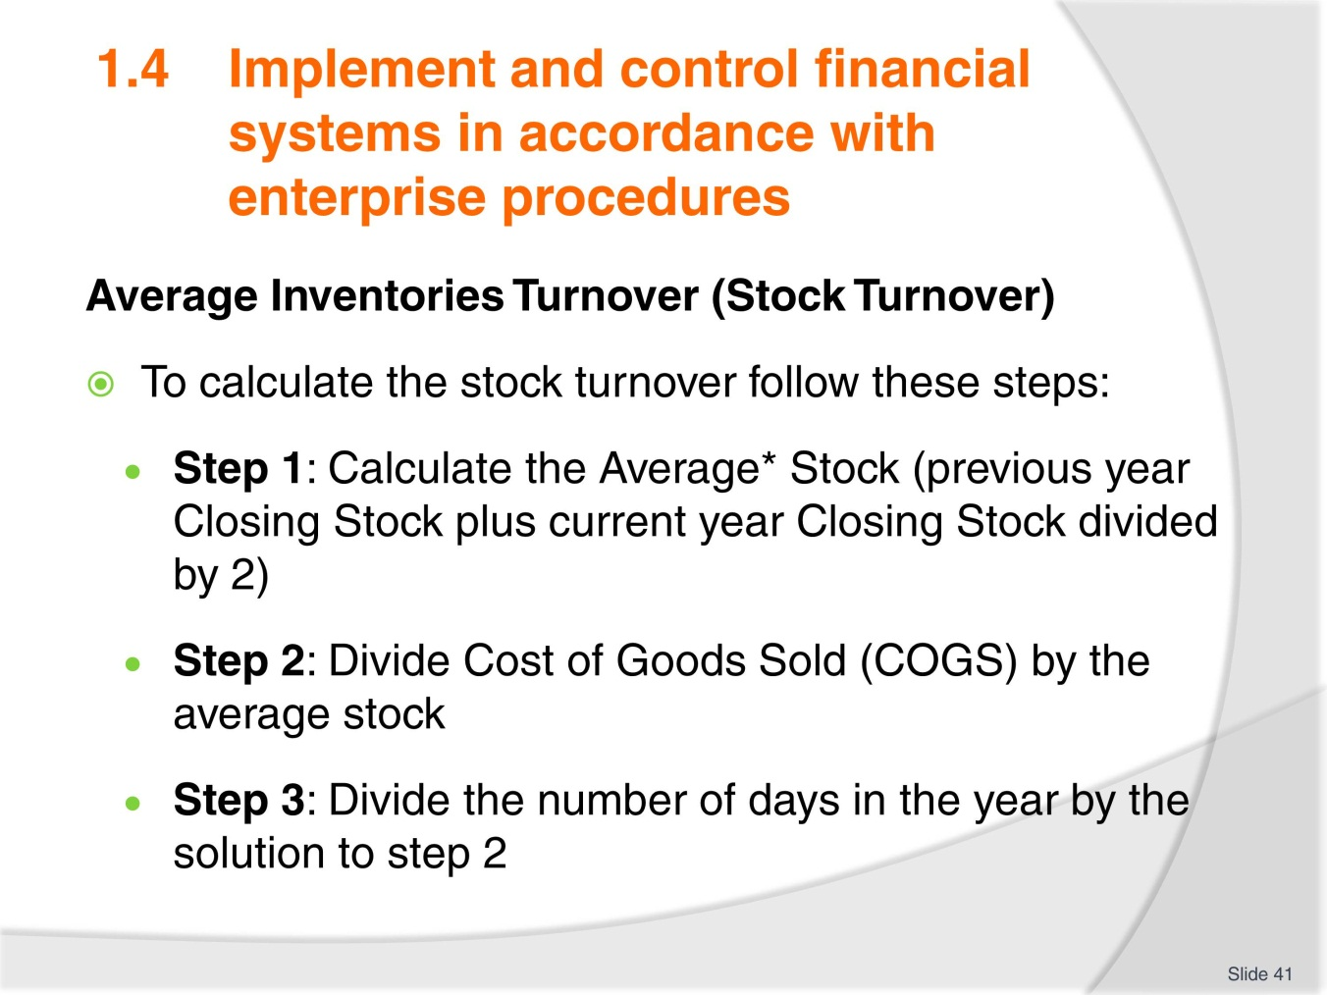
Slide No | Trainer Notes
 | This calculation shows how long it takes to “turnover” or sell the inventory of the organisation. The longer it takes, the less efficient the organisation.

Slide
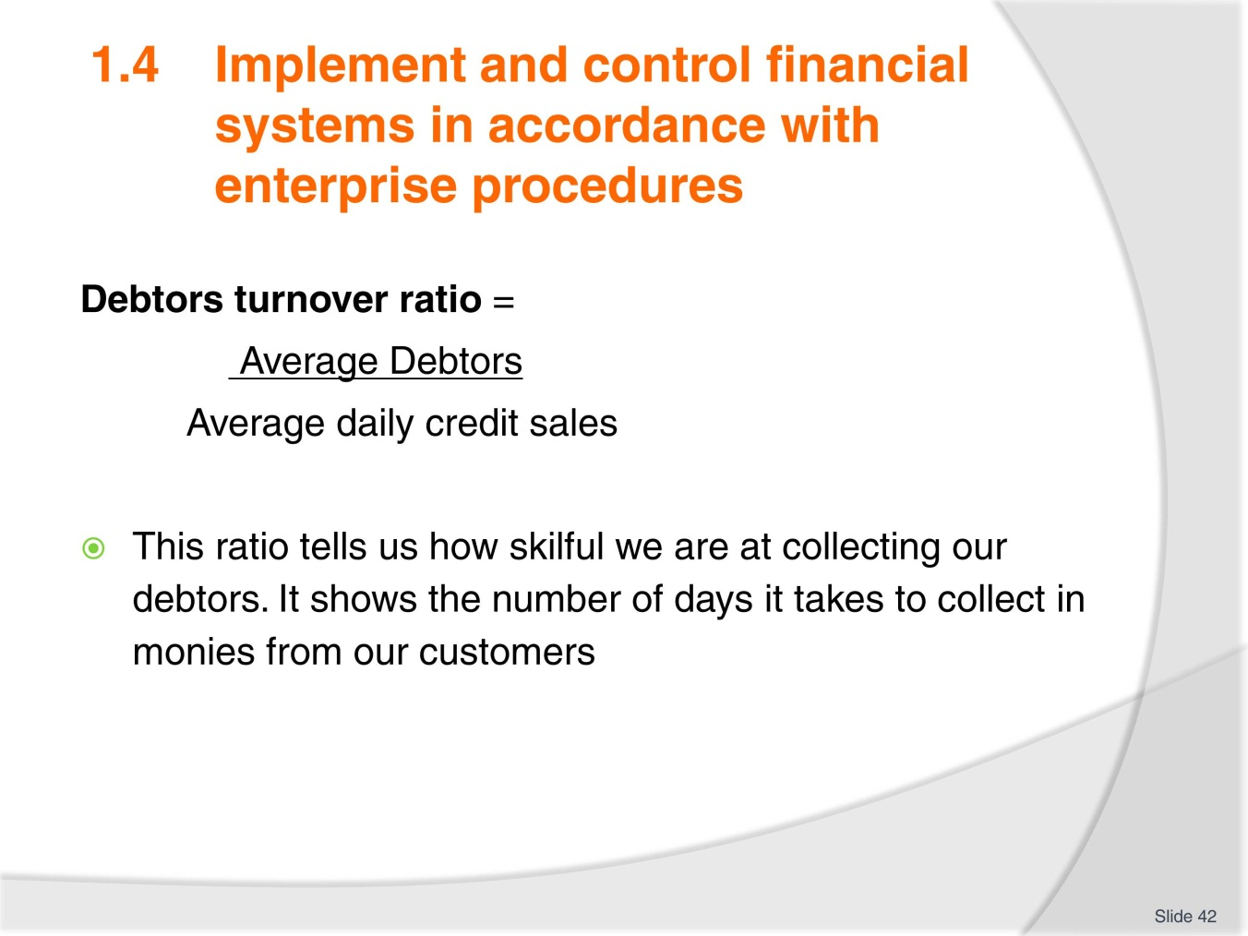
Slide No | Trainer Notes
 | Discuss and provide examples to the group.

Slide
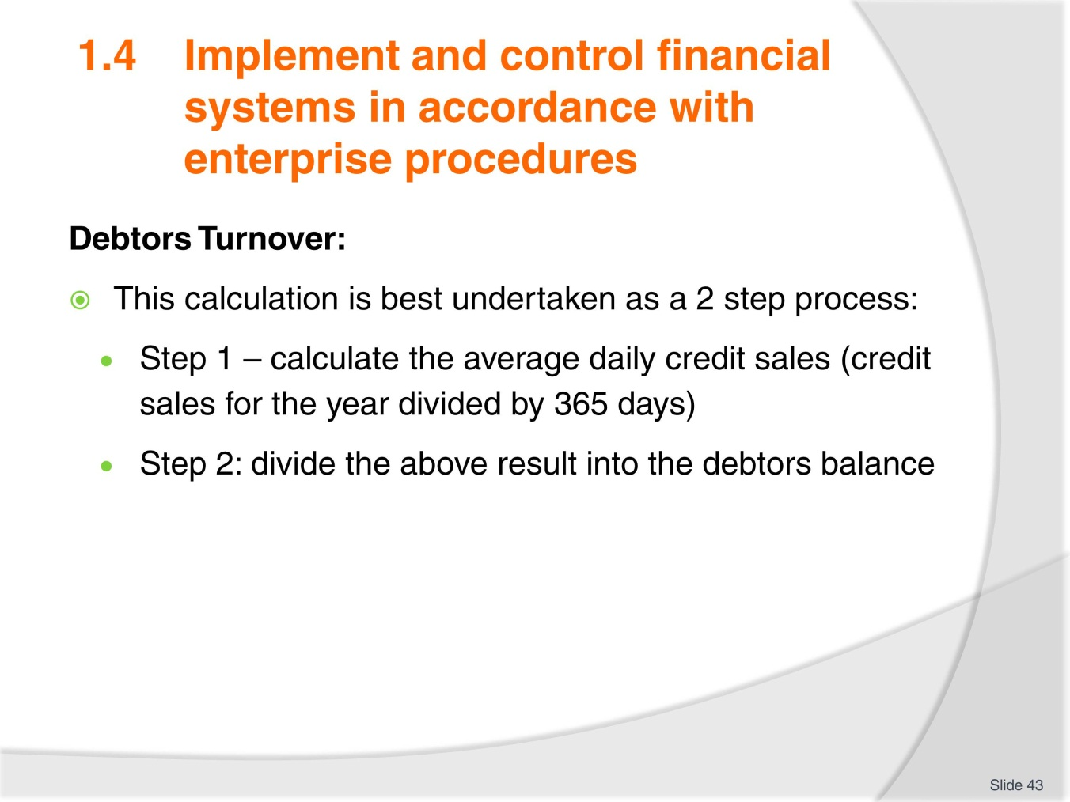
Slide No | Trainer Notes
 | Most retail organisations operate a 30 day credit cycle with an expectation that they will receive payment within 45 days. However in travel and tourism credit is usually desirable at 7-14 days.

Slide
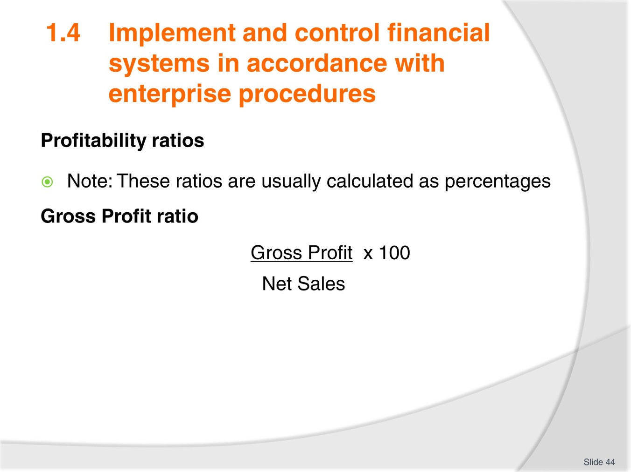
Slide No | Trainer Notes
- These ratios tell us about our profit margins and how profitable our business is. Changes in ratios for a business over several years can indicate favourable or unfavourable trends
- Gross profit ratio demonstrates the direct relationship between Sales and the Cost of Goods Sold. If the mark up on stock is not high enough, then the business will not be profitable.

Slide
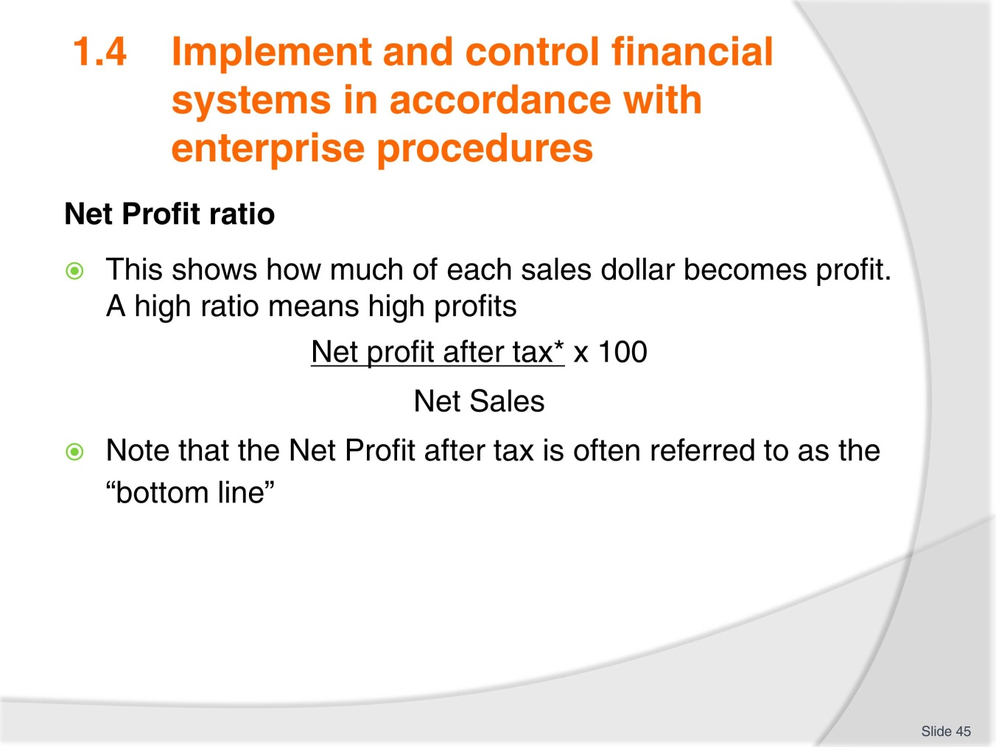
Slide No | Trainer Notes
 | Explain as necessary.

Slide
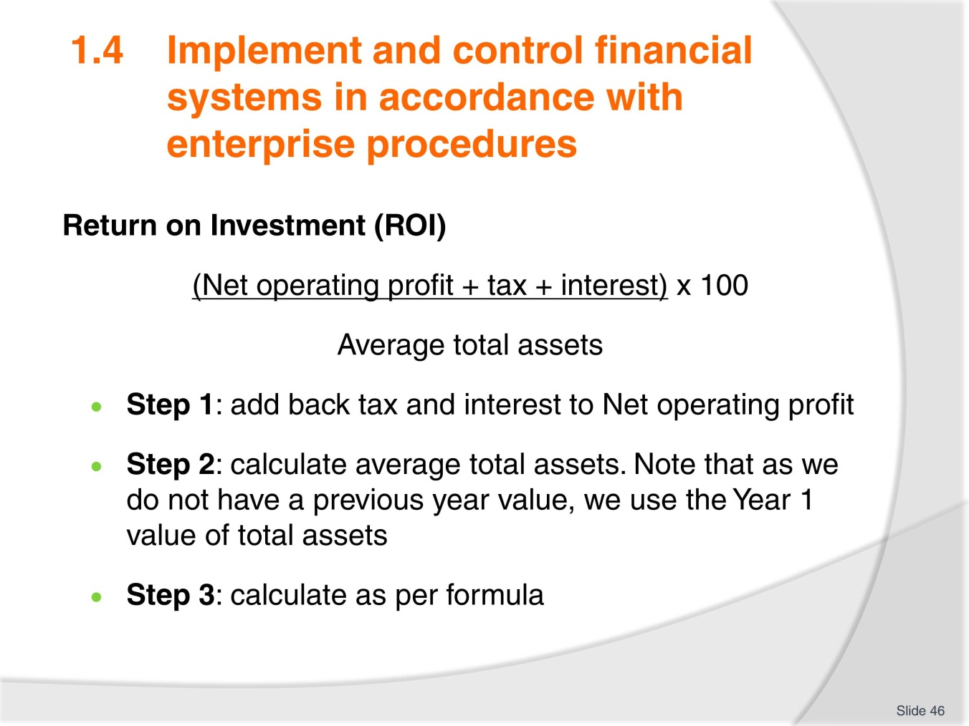
Slide No | Trainer Notes
- ROI indicates the efficiency of management’s decisions regarding the purchase and use of Assets
- Operating profit has tax and interest added back to enable the business to compare its results with other organisations
- This ratio shows us how much our assets are earning. The higher this ratio is, the more desirable the business is as an investment for the owners.

Slide
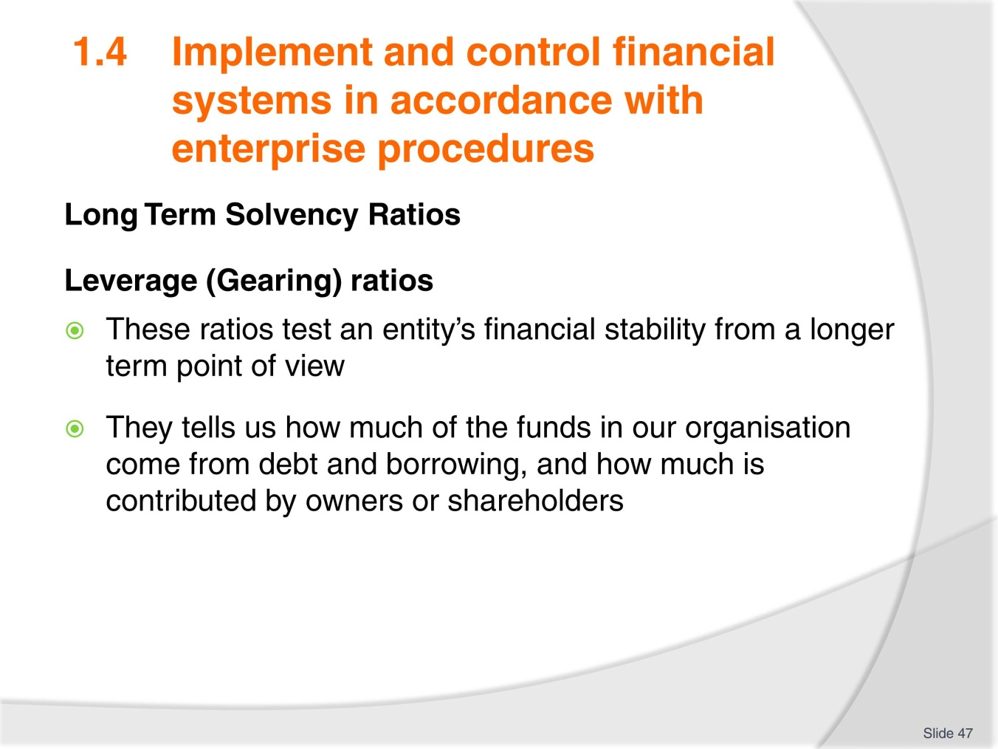
Slide No | Trainer Notes
 | Explain further as needed and review formula on next slide.

Slide
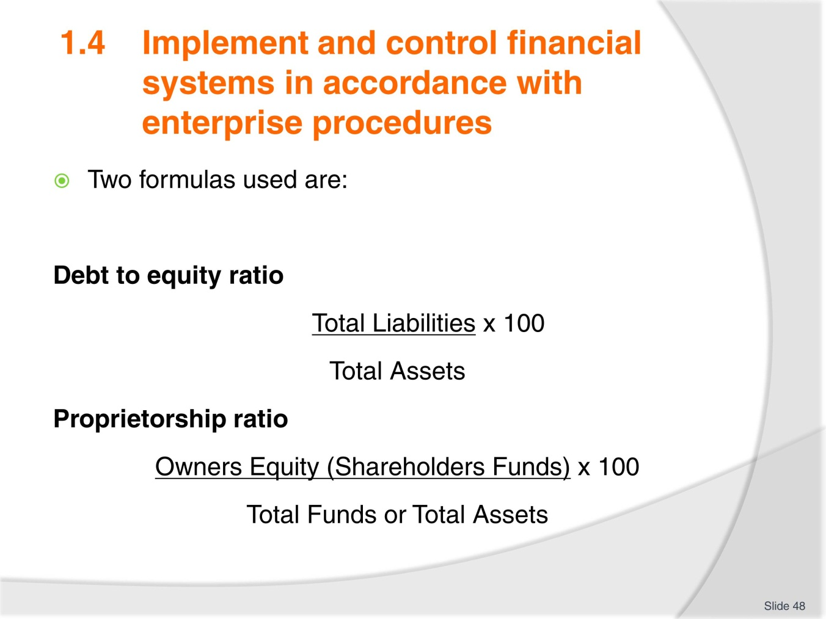
Slide No | Trainer Notes
The Proprietorship ratio shows the percentage of assets that have been funded by the owners of the business.
It is important not to look at the ratios in isolation. To get a true picture of how a company is performing you need to examine the:
- Combined effects of the ratios
- Trends found by comparing several years ratios and percentages (a minimum of three consecutive years is desirable)
- Comparisons across an industry
- Complete exercise 3.

Slide
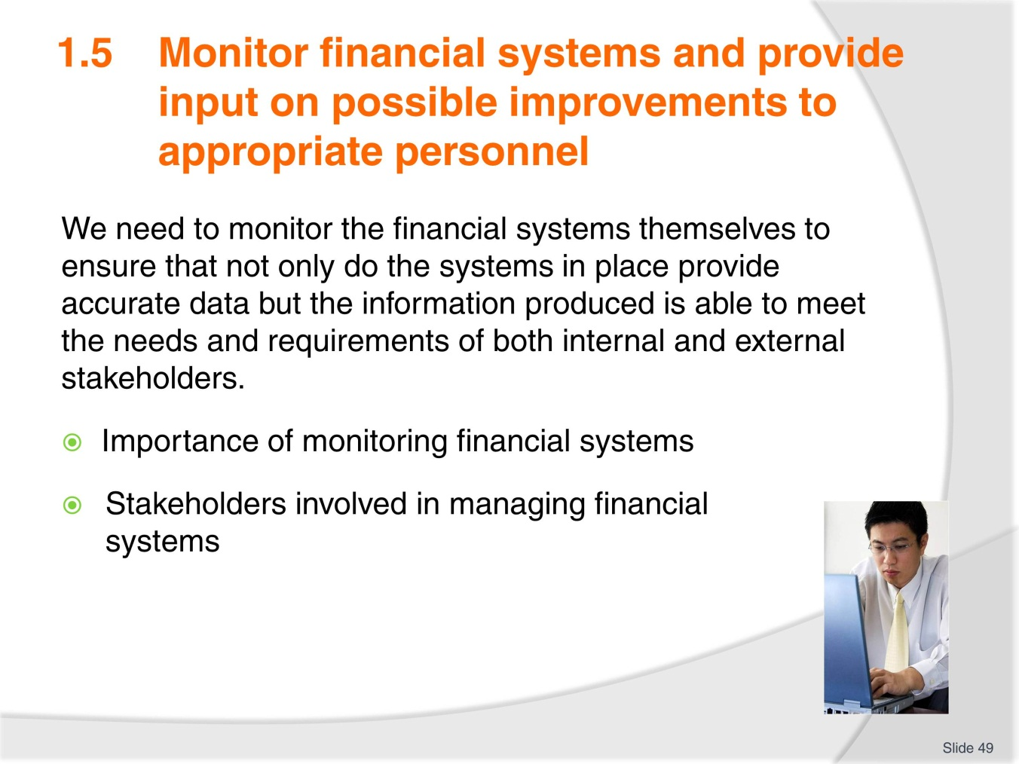
Slide No | Trainer Notes
- Discuss the role of supervisors and managers in monitoring financial controls
- Discuss these points as necessary
- Complete Activity 27.

Slide
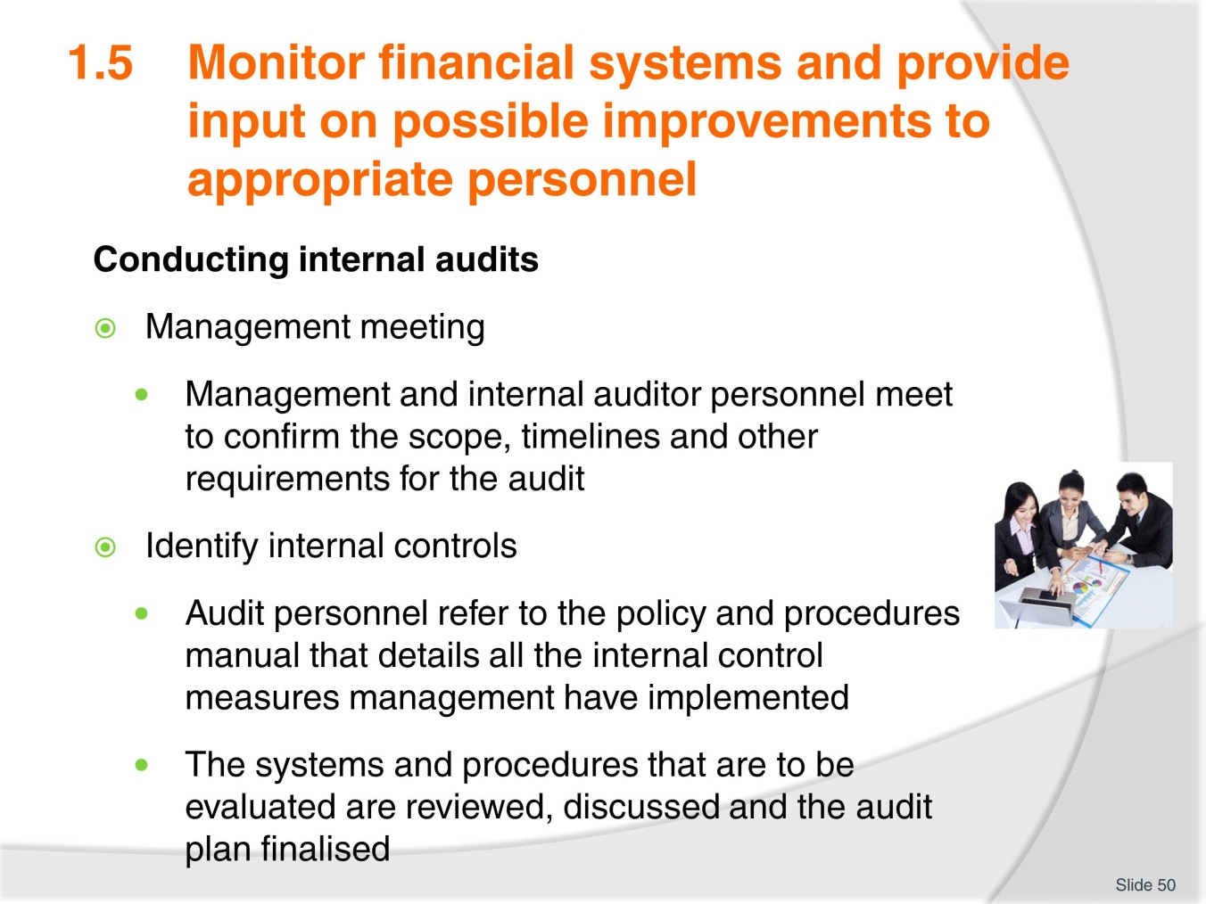
Slide No | Trainer Notes
- Discuss knowledge and experience in the room regarding audits and internal audits
- Remind trainees that large organisations may choose to employ an external company to do this.

Slide
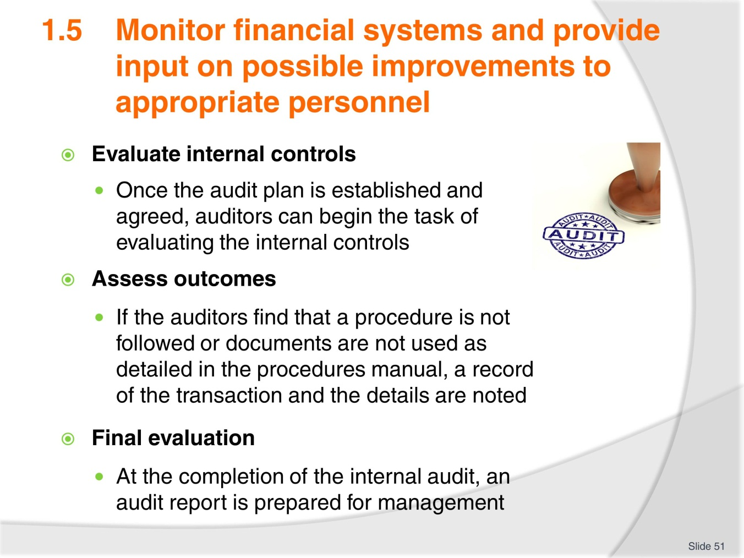
Slide No | Trainer Notes
- Continued from previous slide
- Discuss in particular notes for Assess outcomes. It is not unusual for staff to decide they have a better way of doing things and alter procedures without informing management
- Discuss the possibilities of staff undermining the system and looking for or discovering ways to steal from the business
- Complete Activity 28.

Slide
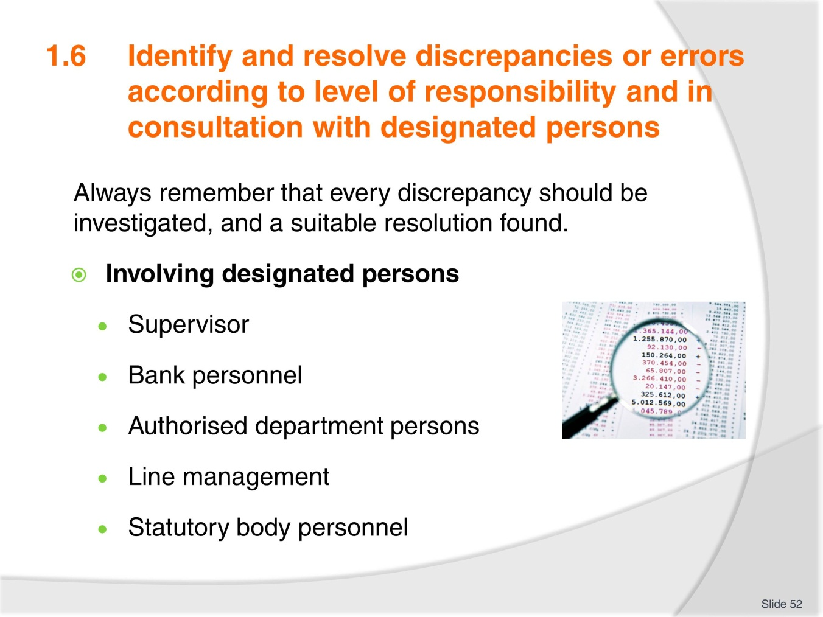
Slide No | Trainer Notes
- Consider who would be involved in a small, medium and large organisation. Have trainees draft a list for each
- Ask trainees to close their Trainee manual now (in preparation for next task on the next slide)
- Trainer to read notes on the next slide and instruct trainees.

Slide
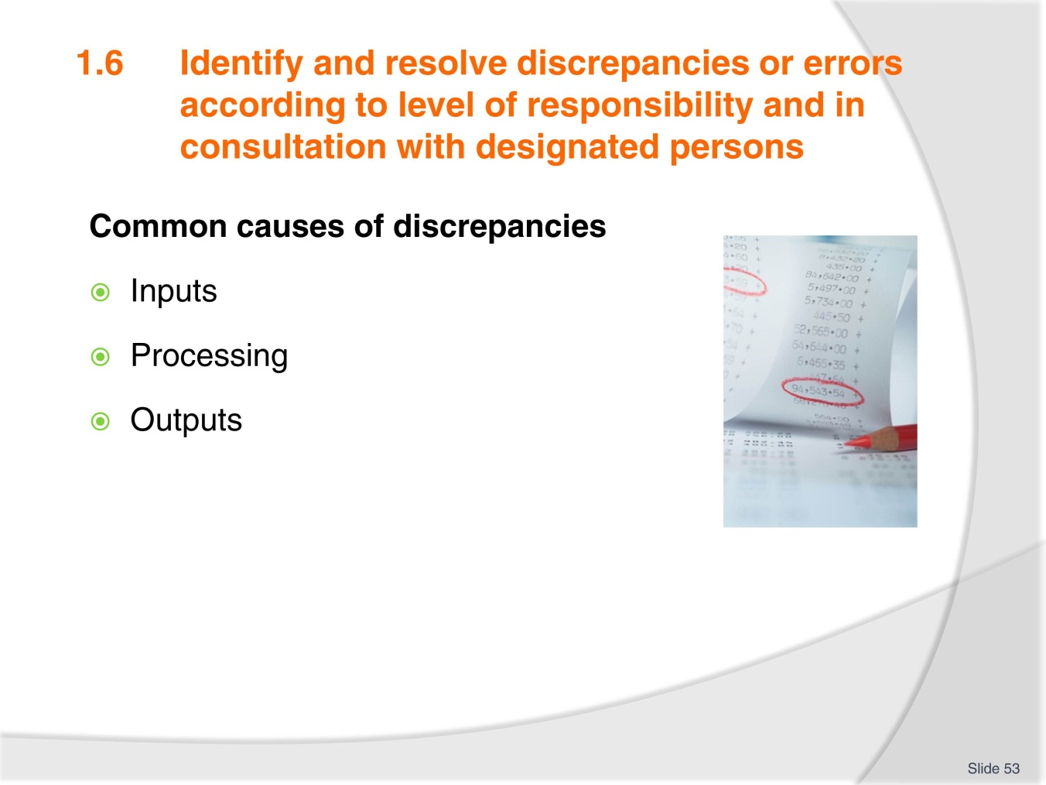
Slide No | Trainer Notes
- In groups have trainees list the three causes for discrepancies and identify as many reasons as they can think of
- Give a time allowance
- No looking at manuals
- Work from knowledge only at this point
- Have each group share answers and allow groups to extend lists as you go
- Once all groups have shared answers refer back to TM for any other reasons listed that were missed
- Discuss possible actions to resolve these discrepancies.

Slide
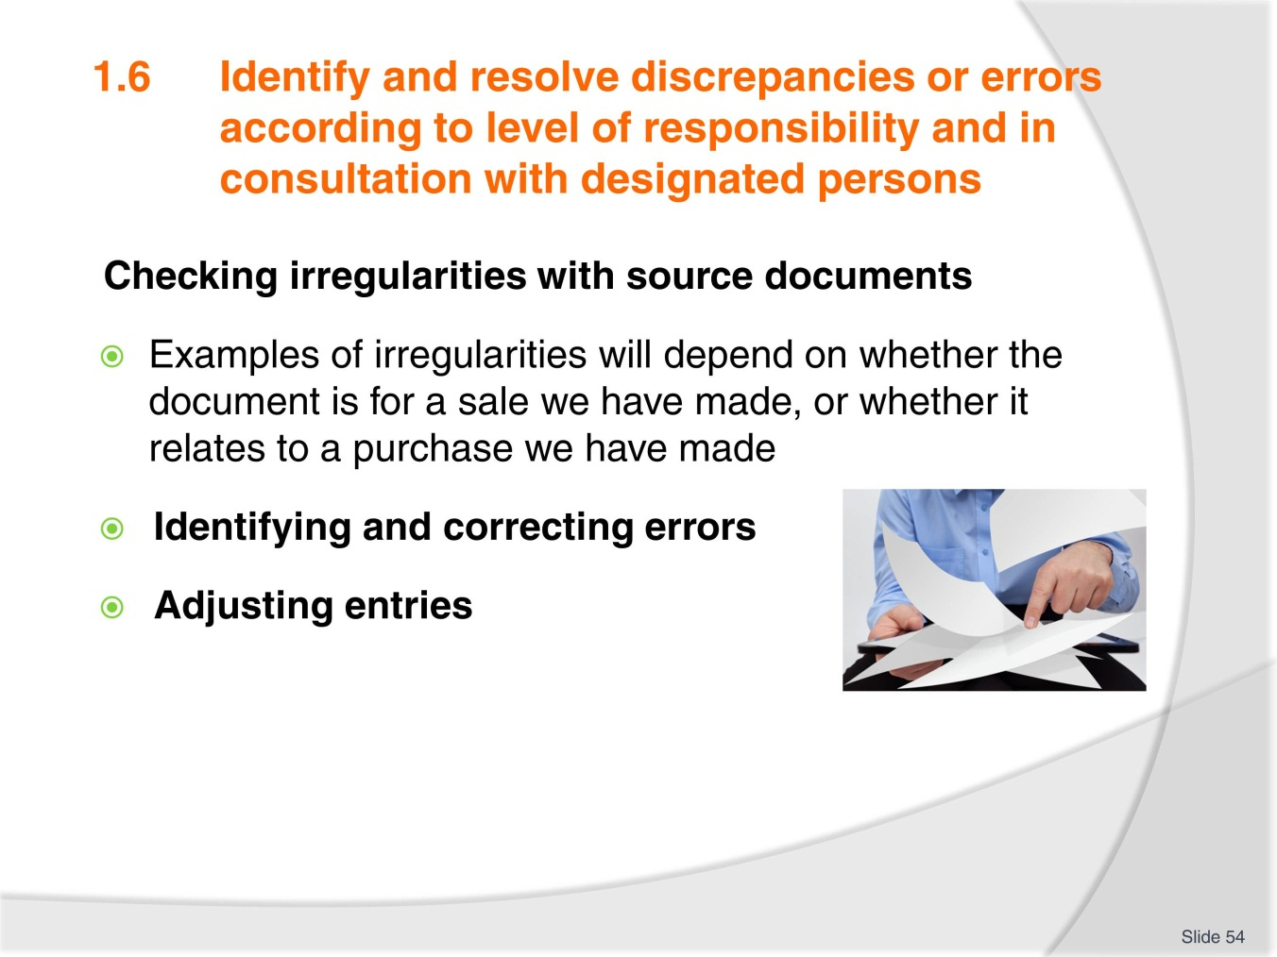
Slide No | Trainer Notes
- Refer to TM and discuss each point as necessary
- Many of these points are simple errors that shouldn’t occur but do, generally because employees are rushing, not concentrating, have not been properly trained or are simply cutting corners
- Discuss ‘Adjusting entries’ and ensure trainees understand point numbers 1-4 and its associated explanation over the page
- Trainer to provide verbal examples
- Have a sample completed worksheet to show Trainees
- Complete Activity 29
- Ensure all work projects have been completed and handed into trainer ensuring cover page details are attached for assessment tracking
- Review the summary page for Element 1 to confirm what has been completed for this element.

Slide
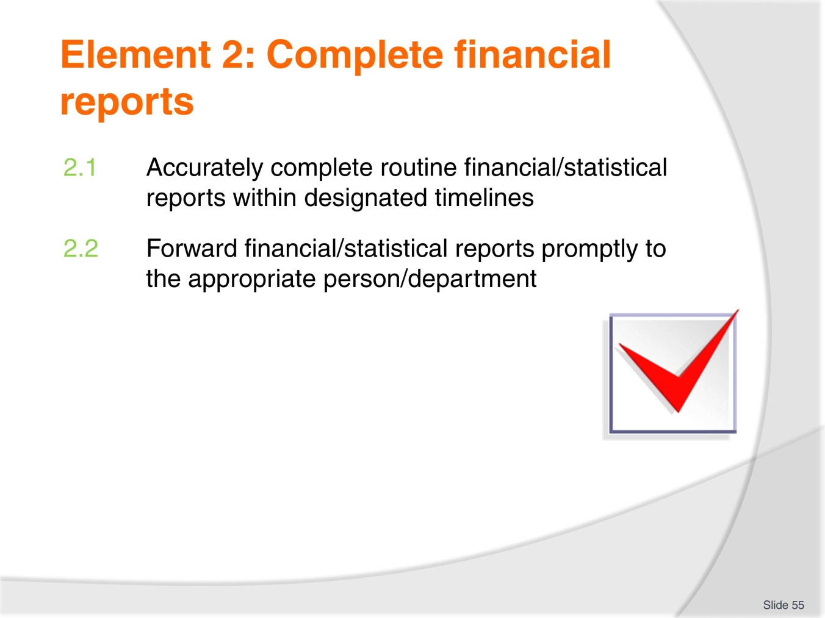
Slide No | Trainer Notes
- Trainer advises trainees this Element is comprised of two Performance Criteria which will be identified throughout the class and explained in detail
- Trainees can obtain more detail from their Trainee Manual.

Slide
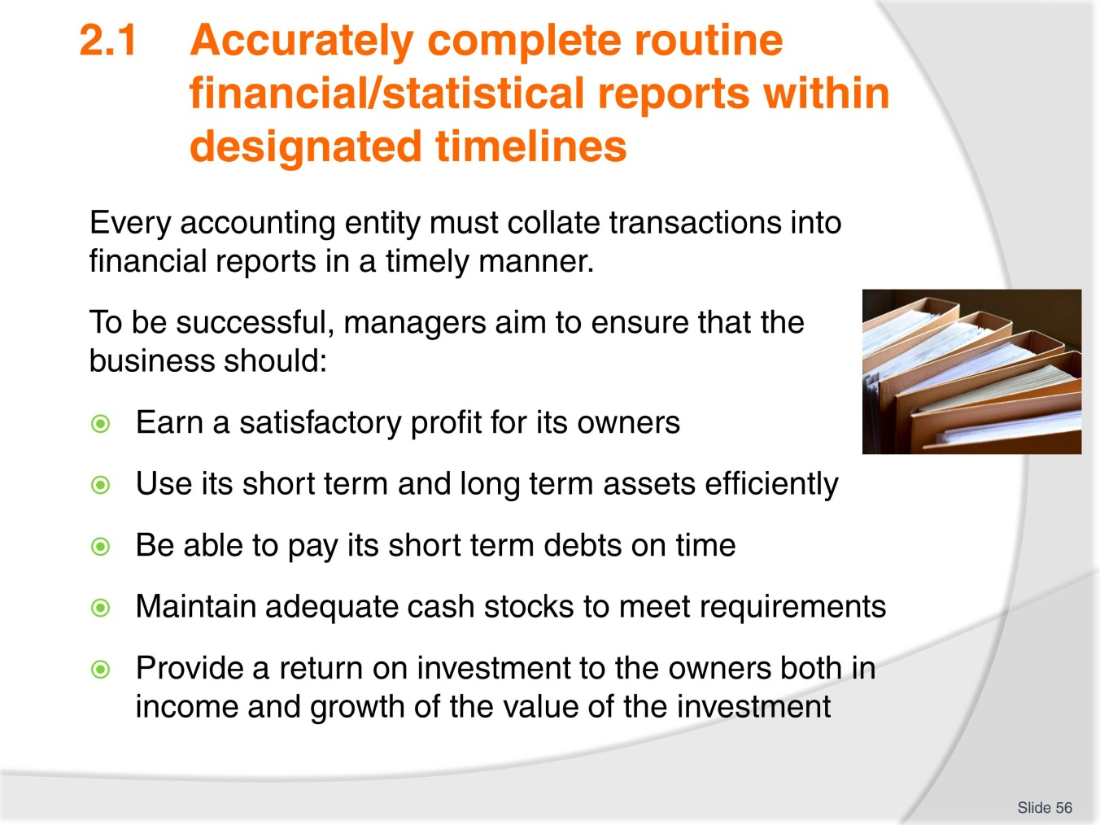
Slide No | Trainer Notes
- Discuss notes as needed
- Highlight the importance of confidentiality with reports.

Slide
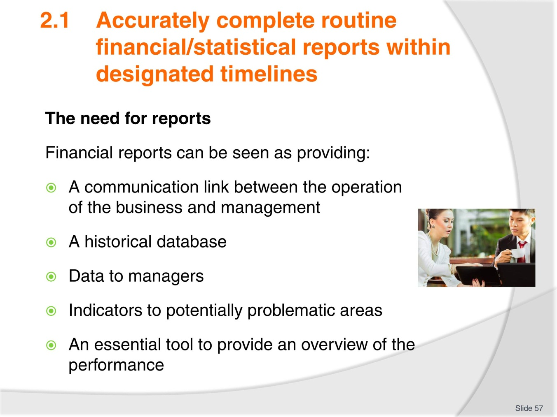
Slide No | Trainer Notes
- Refer to TM notes and discuss as necessary
- Also discuss the accounting period. Why would businesses of different sizes have different accounting periods?

Slide
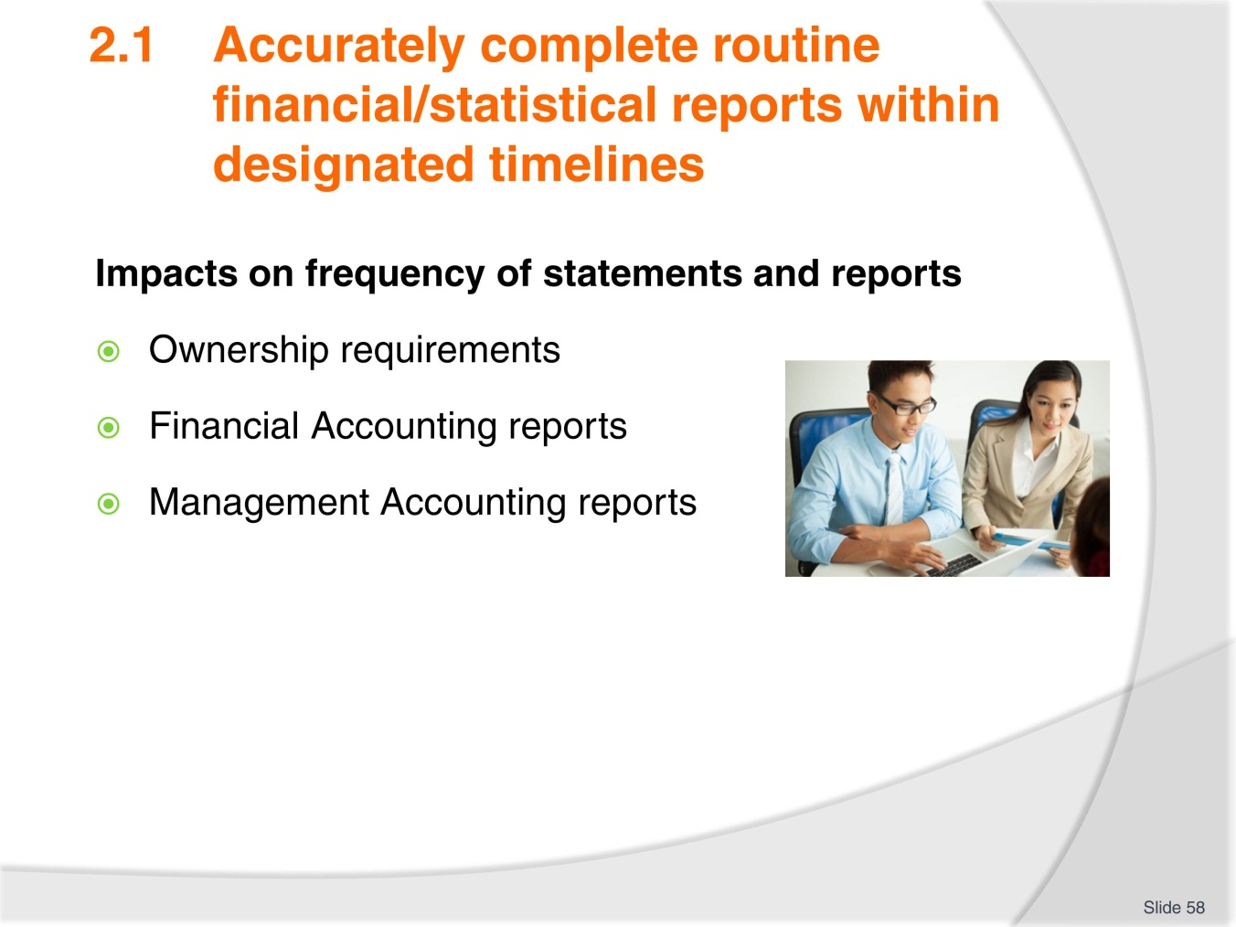
Slide No | Trainer Notes
- Discuss points as necessary
- Have trainees highlight key points and identify any requirements that are specific to your country business laws
- Complete Activity 30
- Ask trainees to close their Trainee manual now (in preparation for next task on the next slide)
- Trainer to read notes on the next slide and instruct trainees.

Slide
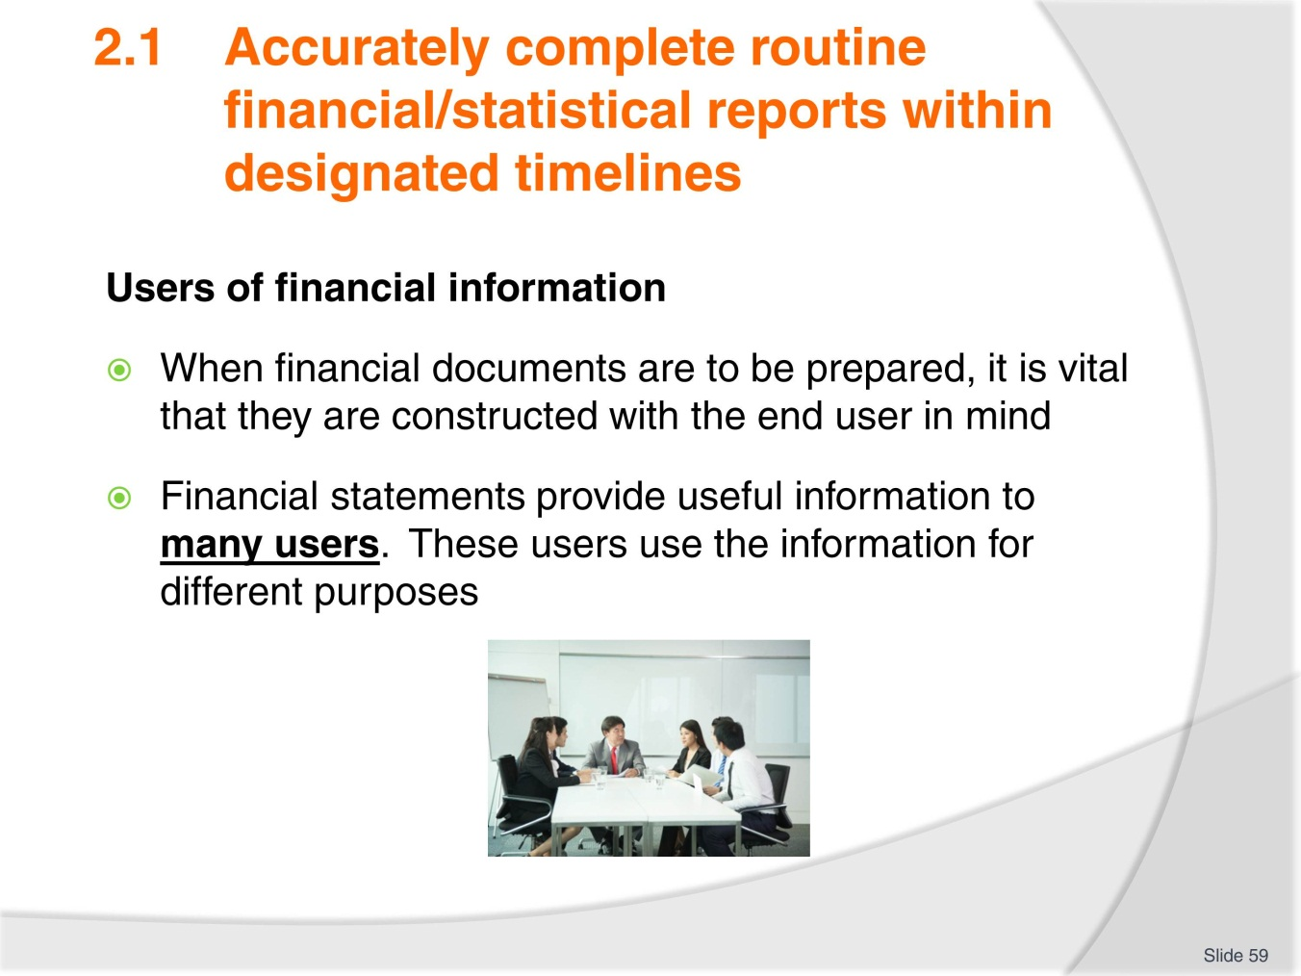
Slide No | Trainer Notes
- Trainee manuals should already be closed
- In groups brainstorm a list of users who would use financial information regarding a business. company or organisation
- Think broadly and list anyone and everyone who would consider the financial position before doing business
- Give a time allowance
- After a short period ask each group to share their first 1-2 suggestion to help push everyone along
- At the end of the time allowance brainstorm answers onto board and discuss each as needed
- Once discussion and sharing is completed TM can be used for further information
- Complete Activity 31.

Slide
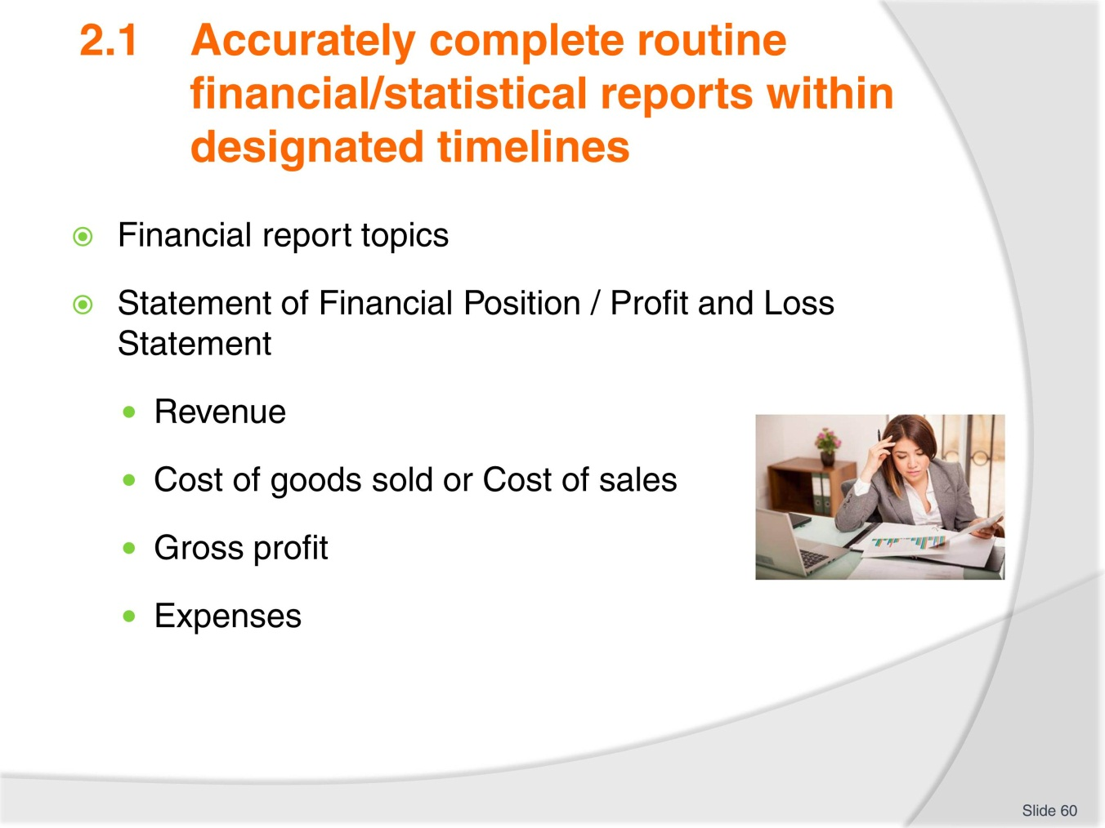
Slide No | Trainer Notes
- Review the notes in TM and have trainees highlight key points
- Review the Statement of financial position Profit & Loss table and explain as needed
- Trainees will be required to complete an exercise.

Slide
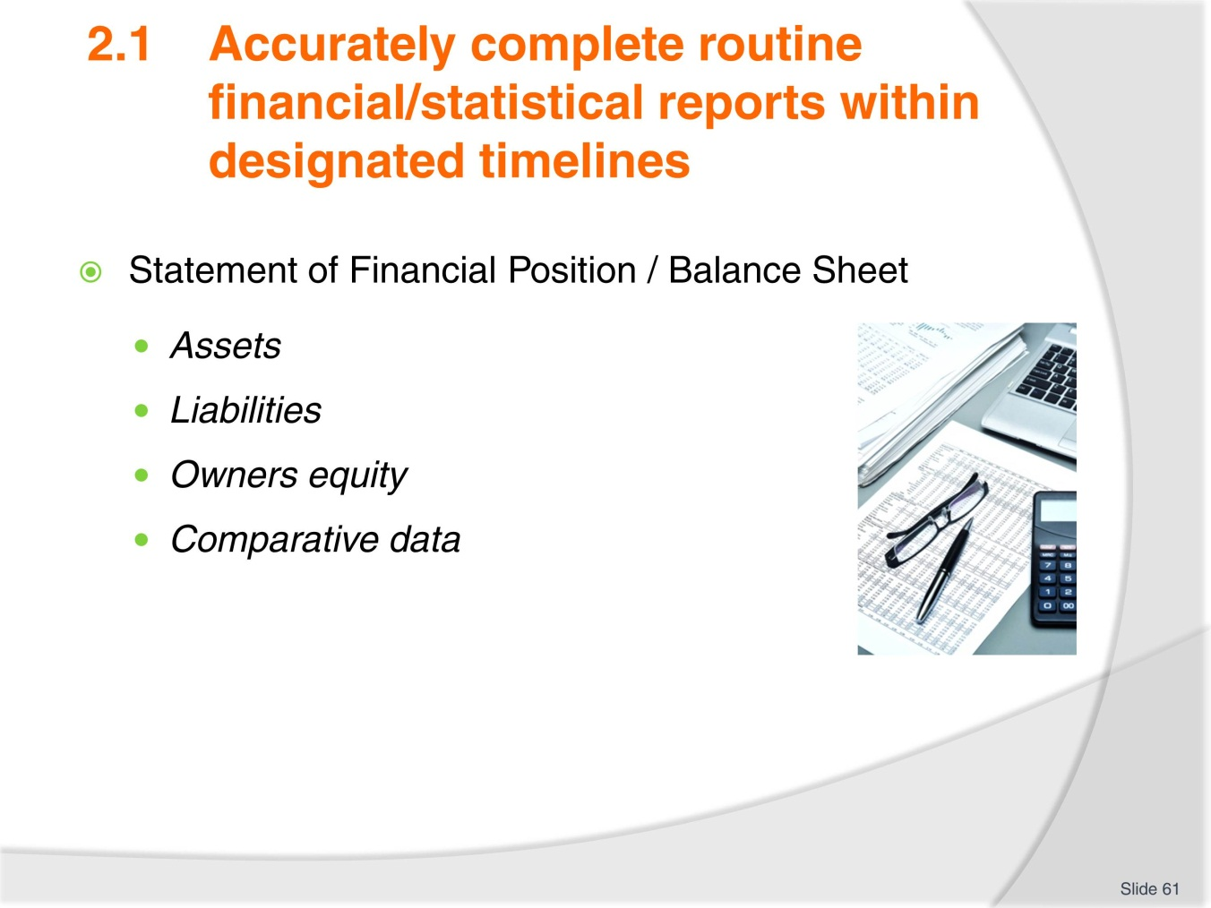
Slide No | Trainer Notes
- Review the notes in TM and have trainees highlight key points
- Review the Statement of financial performance Balance sheet table and explain as needed
- Complete Exercise 4 and 5 as directed by trainer.

Slide
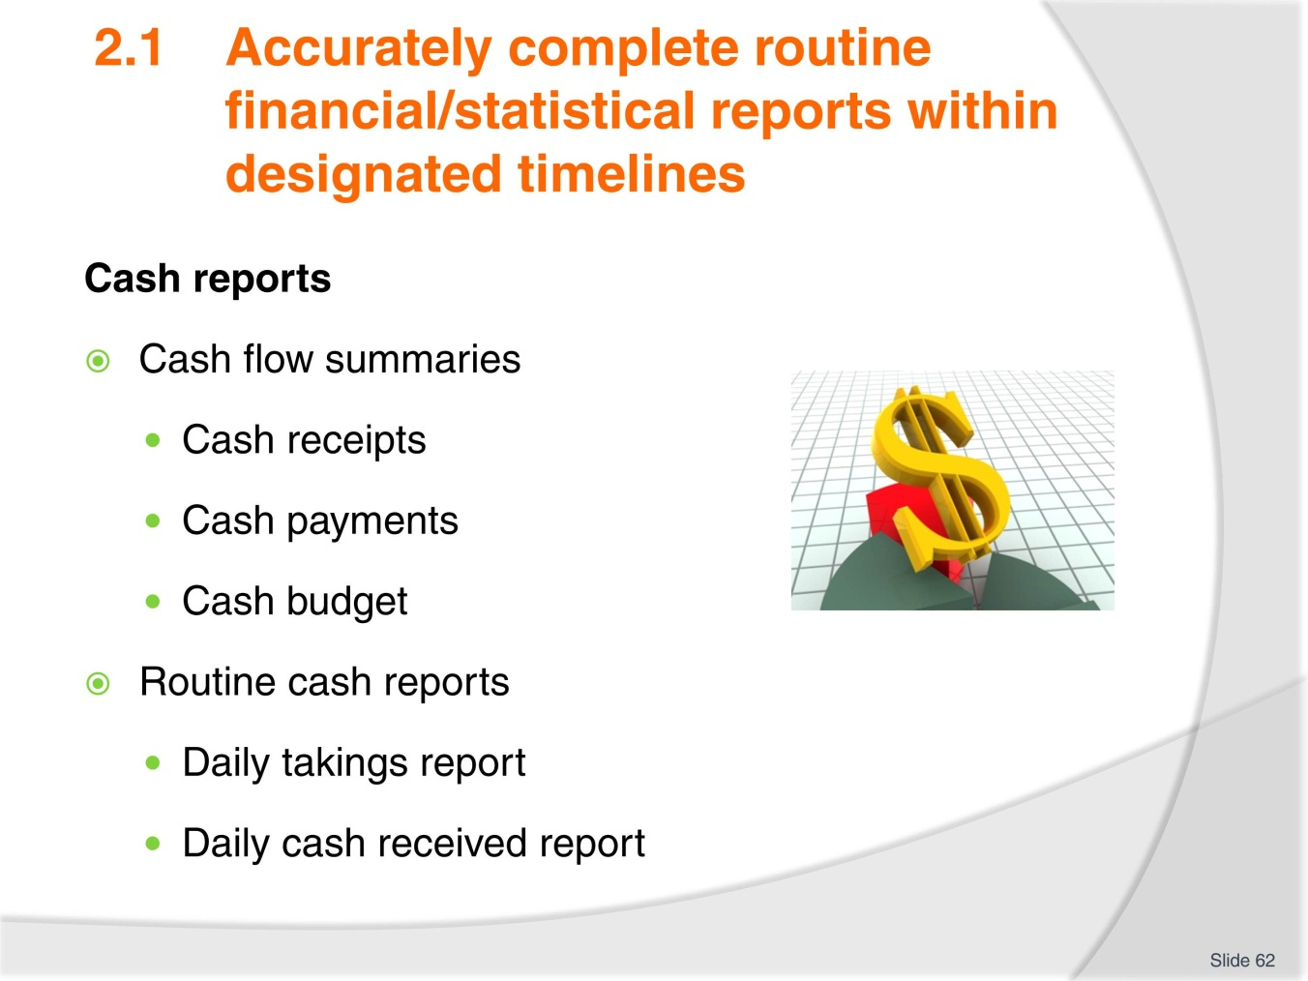
Slide No | Trainer Notes
- Discuss points as necessary. Ask trainees about any knowledge or experience in this area
- Review the Cash flow table
- Complete Exercises 3 and 4 as directed by trainer.

Slide
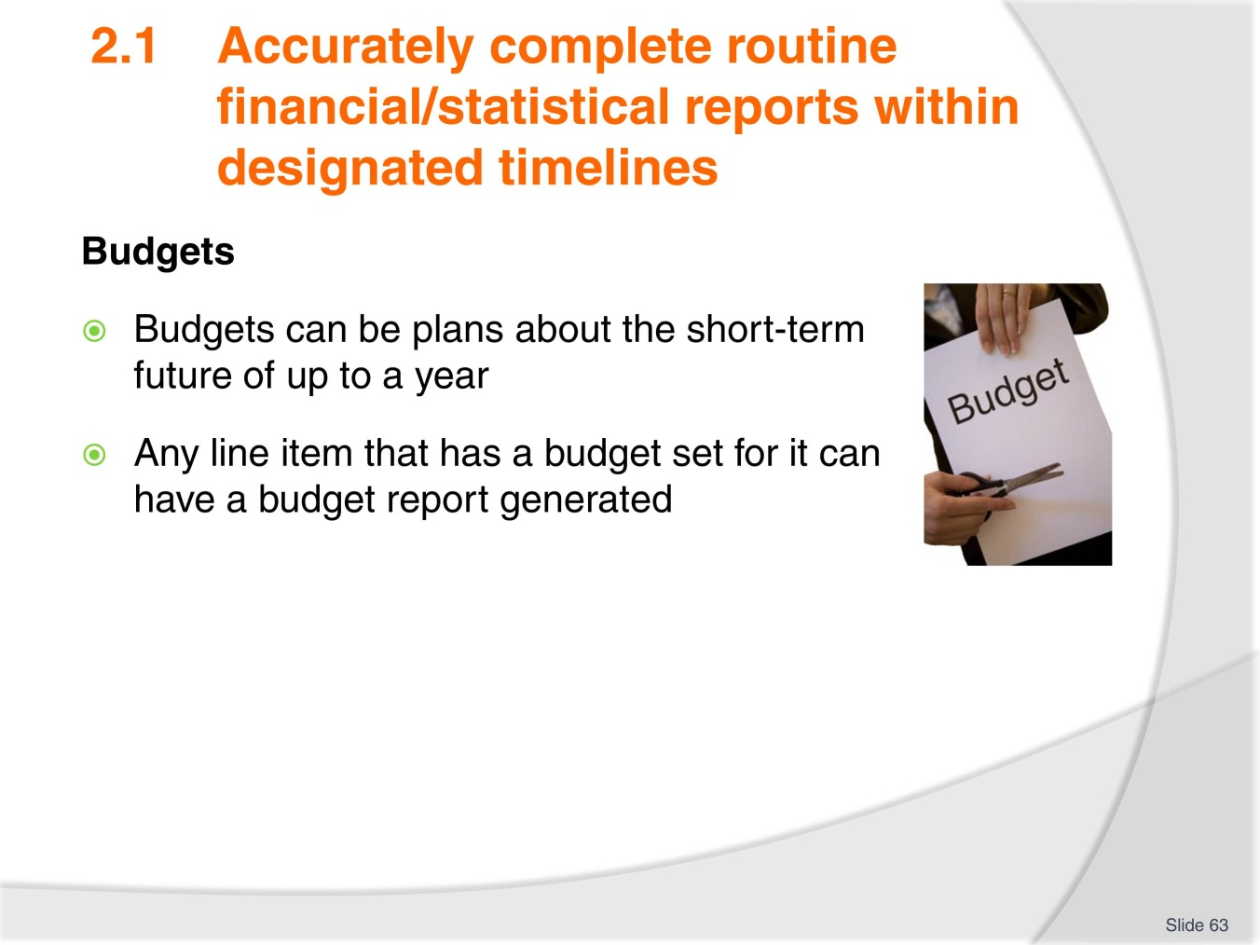
Slide No | Trainer Notes
- Consider the budgets listed in the TM
- Brainstorm other budgets:
- Expenditure budget
- Departmental budget
- Fixed budget
- Flexible budget
- Operating budgets
- Sales budget
- Project budget
- Purchases budget
- Master budgets.

Slide
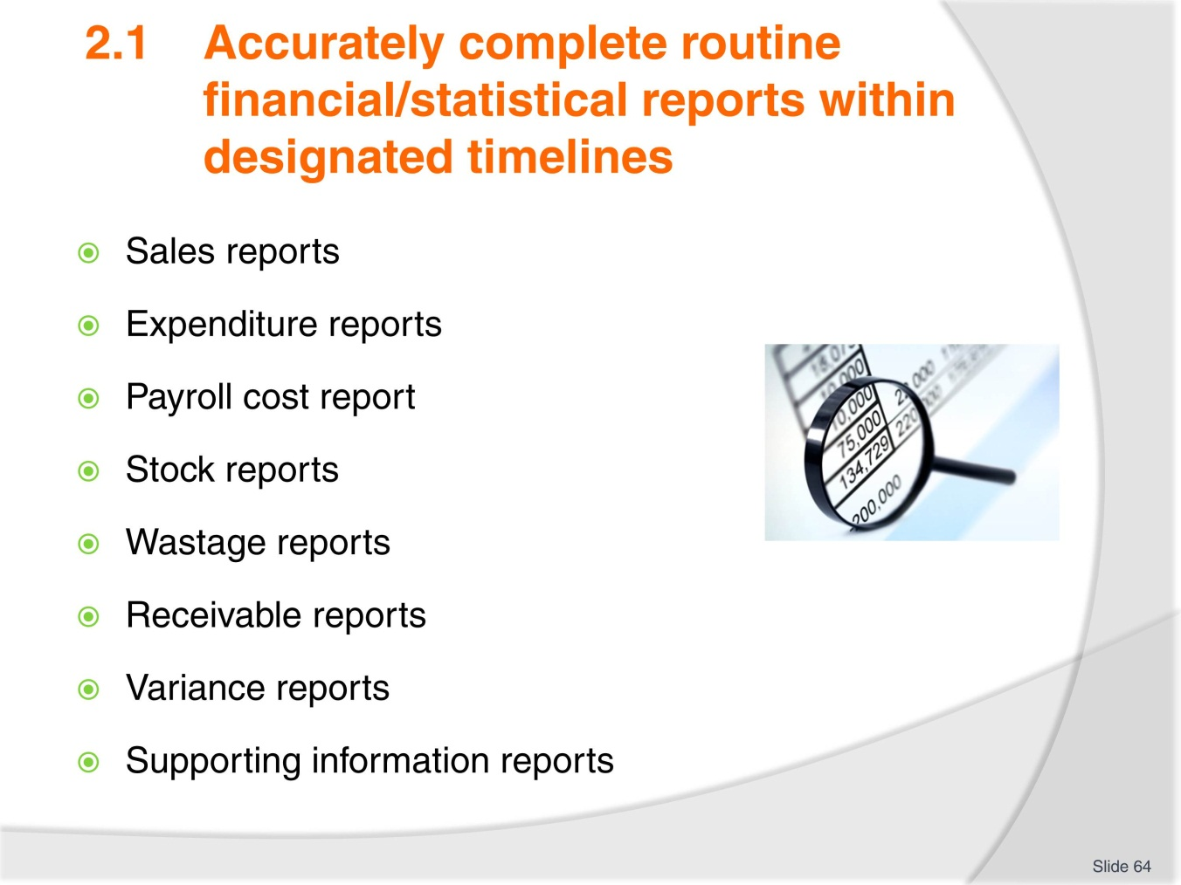
Slide No | Trainer Notes
- Discuss each of the types of reports
- With access to the internet these reports can be searched on Google images to demonstrate the varying ways they can be presented
- Complete Activity 32.

Slide
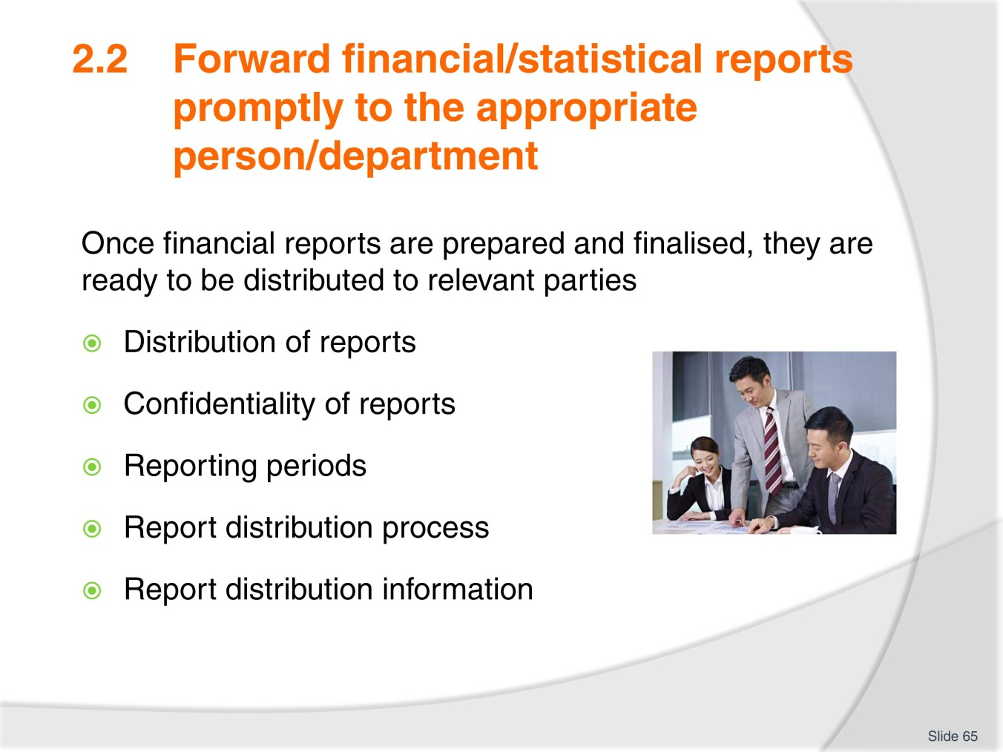
Slide No | Trainer Notes
- Discuss as necessary and have trainees highlight key points
- Complete Activity 33
- Ensure all work projects have been completed and handed into trainer ensuring cover page details are attached for assessment tracking
- Review the summary page for Element 2 to confirm what has been completed for this element.

Slide
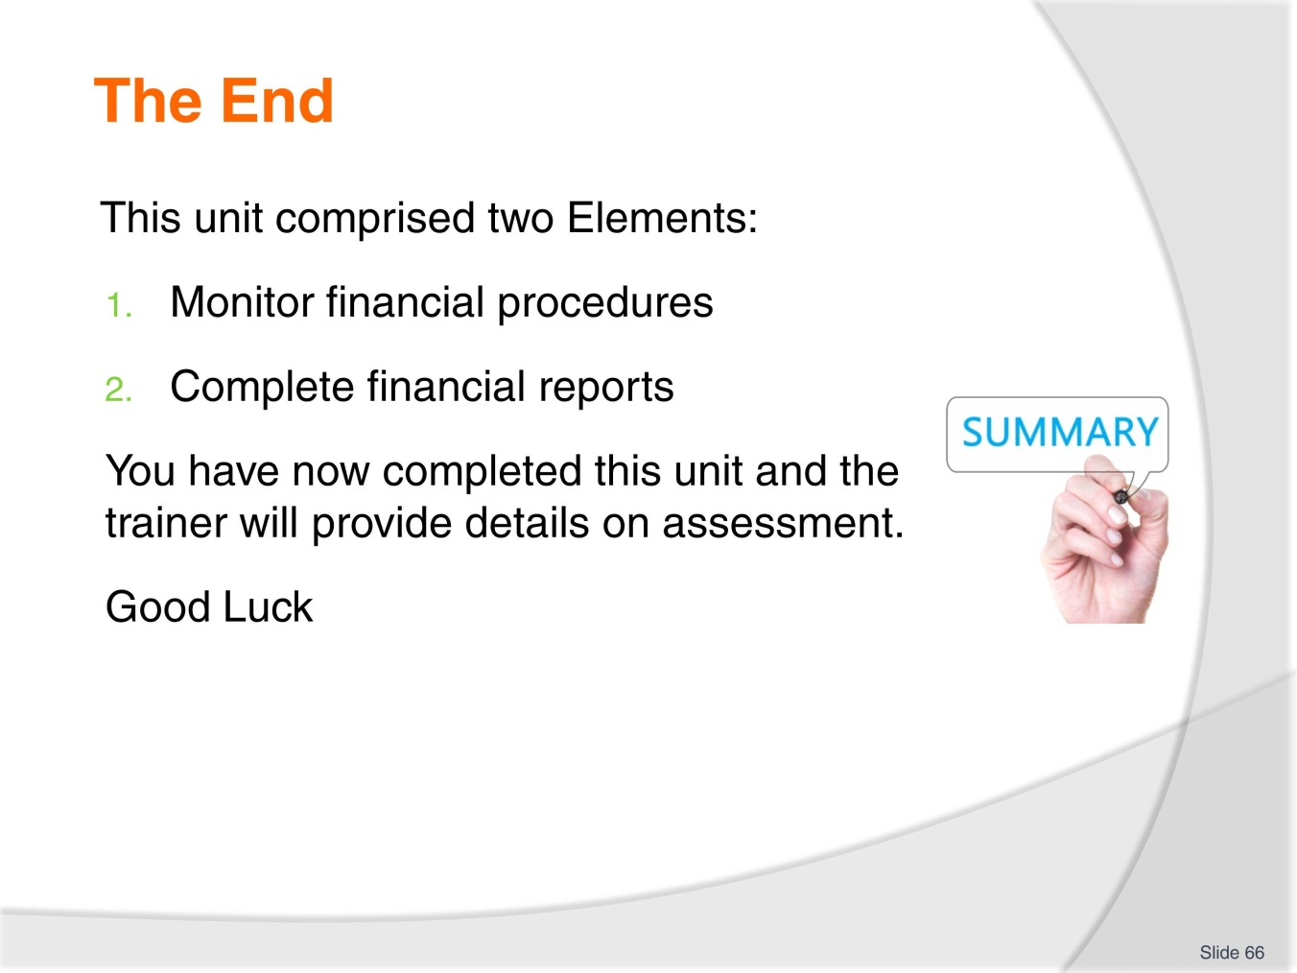
Slide No | Trainer Notes
 | Trainer advises learners on what assessment is required and how it is to be conducted.

Activities

Name_______________________________________________________
Date_________________________________________________________

Activity 1 - Identify persons responsible for managing financial records

For a tourism organisation you are required to identify the different roles that undertaken financial transaction and management of finances.
For each role identify the types of financial activity or responsibility they undertake.

Role | Financial activity or responsibility


Name_______________________________________________________
Date_________________________________________________________

Activity 2 - Identify categories of business transactions
For a tourism organisation you are required to provide examples of different types of items under each category.

Category | Examples  (Minimum of three for each category)
ASSET
LIABILITY
OWNERS EQUITY
REVENUE
EXPENSES


Name_______________________________________________________
Date_________________________________________________________

Activity 3 - Identify tourism ledger accounts

For a tourism organisation of your choice you are required to identify the ledger accounts that they use as part of their accounting system.
Current Assets
___________________________________________________________________________________________________________________________________________________________________________________________________________________________________________________________________________________________________________________________________________________________________
Fixed Assets
___________________________________________________________________________________________________________________________________________________________________________________________________________________________________________________________________________________________________________________________________________________________________
Current Liabilities
__________________________________________________________________________________________________________________________________________________________________________________________________________________________________________________________________________________________________________________________________________________________________________________________________________________________________________

Long-term Liabilities
___________________________________________________________________________________________________________________________________________________________________________________________________________________________________________________________________________________________________________________________________________________________________
Operating Revenues
___________________________________________________________________________________________________________________________________________________________________________________________________________________________________________________________________________________________________________________________________________________________________
Cost of Goods Sold
___________________________________________________________________________________________________________________________________________________________________________________________________________________________________________________________________________________________________________________________________________________________________
Other operating expenses
___________________________________________________________________________________________________________________________________________________________________________________________________________________________________________________________________________________________________________________________________________________________________


Name_______________________________________________________
Date_________________________________________________________

Activity 4 - Identify source documents

You are required to identify common source documents used in tourism organisation showing evidence that transactions have taken place.

Source Document | What type of transaction does it record?


Name_______________________________________________________
Date_________________________________________________________

Activity 5 - Identify ledger transactions
You are required to show the correct ledger account entries that would occur for the following transactions for the amount of 'X'.
Please identify the source documents that would show evidence of these transactions.
Cash receipts
Date | Ledger account | Reference / Source document | Debit | Credit
Cash payments
Date | Ledger account | Reference / Source document | Debit | Credit
Petty cash
Date | Ledger account | Reference / Source document | Debit | Credit

Sales
Date | Ledger account | Reference / Source document | Debit | Credit
Refunds
Date | Ledger account | Reference / Source document | Debit | Credit
Rebates
Date | Ledger account | Reference / Source document | Debit | Credit
Interest expenses or interest received
Date | Ledger account | Reference / Source document | Debit | Credit

Purchasing of a fixed asset on credit
Date | Ledger account | Reference / Source document | Debit | Credit

Selling of a fixed asset on credit
Date | Ledger account | Reference / Source document | Debit | Credit

Correcting posting errors
Date | Ledger account | Reference / Source document | Debit | Credit

Writing-off a bad debt
Date | Ledger account | Reference / Source document | Debit | Credit

Withdrawing of stock or assets by owner
Date | Ledger account | Reference / Source document | Debit | Credit

Making non-cash transactions, e.g. writing off depreciation, stock losses
Date | Ledger account | Reference / Source document | Debit | Credit

Working in foreign currency amounts
Date | Ledger account | Reference / Source document | Debit | Credit


Name_______________________________________________________
Date_________________________________________________________

Activity 6 - Research common tourism transactions

You are required to collect evidence of financial records for a tourism organisation of your choice.
The records must show evidence of common transactions showing ledger accounts these transactions are allocated to.
You must also provide evidence of source documents commonly used in tourism establishments, as identified in Activity 3.


Name_______________________________________________________
Date_________________________________________________________

Activity 7 - Identify areas of focus

Based on the evidence collected in Activity 6, you are required to explain what areas you would focus on when checking transactions.

___________________________________________________________________________________________________________________________________________________________________________________________________________________________________________________________________________________________________________________________________________________________________________________________________________________________________________________________________________________________________________________________________________________________________________________________________________________________________________________________________________________________________________________________________________________________________________________________________________________________________________________________________________________________________________________________________________________________


Name_______________________________________________________
Date_________________________________________________________

Activity 8 - Identify 'balancing / reconciliation' activities

You are required to conduct research on the financial practices of a tourism organisation.
Please answer the following questions, providing evidence where possible to support your findings.

Identify the types of systems used to perform reconciliations.
________________________________________________________________________________________________________________________________________________________________________________________________________________________________________________________________________________________________________________________________________________________________________________________________________________________________________________________________________________________________________________________________________________________________________________________

Identify common areas of operation where reconciliations are required
________________________________________________________________________________________________________________________________________________________________________________________________________________________________________________________________________________________________________________________________________________________________________________________________________________________________________________________________________________________________________________________________________________________________________________________

Describe in detail the process used to reconcile transactions to a balance

__________________________________________________________________________________________________________________________________________________________________________________________________________________________________________________________________________________________________________________________________________________________________________________________________________________________________________________________________________________________________________________________________________________________________________________________________________________________________________________________________________________________________________________________________________________________________________________________________________________________________________________________________________________________________________________________________________________________________________________________________________________________________

Describe the policies and procedures that are used for investigating and clearing outstanding entries

________________________________________________________________________________________________________________________________________________________________________________________________________________________________________________________________________________________________________________________________________________________________________________________________________________________________________________________________________________________________________________________________________________________________________________________

Describe the timelines that apply to finalising reconciliations
__________________________________________________________________________________________________________________________________________________________________________________________________________________________________________________________________________________________________________________________________________________________________________________________________________________________________________


Name_______________________________________________________
Date_________________________________________________________

Activity 9 - Identify others who record transactions or undertake 'balancing' activities

You are required to identify the different persons inside a tourism organisation who either record or balance transactions.
Please answer the following questions, providing evidence where possible to support your findings.

DEPARTMENT | POSITION / PERSON | ACTIVITIES THEY PERFORM (RECORD / BALANCE) | EXAMPLES OF TRANSACTIONS RECORDED / BALANCED


Name_______________________________________________________
Date_________________________________________________________

Activity 10 - Identify persons responsible for checking balances prepared by others

You are required to identify the different persons responsible for checking the balances prepared by others.
POSITION / PERSON RESPONSIBLE FOR CHECKING BALANCES OF OTHERS | AREAS / DEPARTMENTS/ DOCUMENTS THEY CHECK


Name_______________________________________________________
Date_________________________________________________________

Activity 11 - Identify procedures performed when checking balances prepared by others

You are required to identify the different procedures that would be performed when checking the balances performed by others.
This includes:
Checking accuracy of debtor account balances
(E.g. Cash receipts journal, sales return journal, general journal)

________________________________________________________________________________________________________________________________________________________________________________________________________________________________________________________________________________________________________________________________________________________________________________________________________________________________________________________________________________________________________________________________________________________________________________________
Checking accuracy of creditor account balances
(E.g. Cash payments journal, purchases journal, purchases returns journal, general journal)

________________________________________________________________________________________________________________________________________________________________________________________________________________________________________________________________________________________________________________________________________________________________________________________________________________________________________________________________________________________________________________________________________________________________________________________

Checking the total of the debtor's schedule equals the balance of the debtor's control account

________________________________________________________________________________________________________________________________________________________________________________________________________________________________________________________________________________________________________________________________________________________________________________________________________________________________________________________________________________________________________________________________________________________________________________________
Checking the total of the creditor's schedule equals the balance of the creditor's control account

_______________________________________________________________________________________________________________________________________________________________________________________________________________________________________________________________________________________________________________________________________________________________________________________________________________________________________________________________________________________________________________________________________________________________________________________________________________________________________________________________


Name_______________________________________________________
Date_________________________________________________________

Activity 12 - Identify types of outstanding accounts
You are required to identify the different types of common outstanding accounts that may lead to an 'unbalance' of accounts.

TYPE OF OUTSTANDING ACCOUNT | REASON FOR OUTSTANDING ACCOUNT | ACTION TO BE TAKEN TO 'BALANCE' ACCOUNT


Name_______________________________________________________
Date_________________________________________________________

Activity 13 - Identify business units
You are required to identify the different business units / areas of responsibility in a typical travel and tourism organisation.
You are also required to identify the financial responsibilities of that business units / areas of responsibility.

BUSINESS UNIT/ AREA OF RESPONSIBILITY | FINANCIAL RESPONSIBILITIES
E.g. - Travel consultants | E.g. - Sell tours


Name_______________________________________________________
Date_________________________________________________________

Activity 14 - Identify organisational chart

You are required to collect or prepare an organisational chart for a tourism organisation of your choice.


Name_______________________________________________________
Date_________________________________________________________

Activity 15 - Identify importance of 'separation'

You are required to explain the importance for having 'separation' mechanisms in a financial system.
_______________________________________________________________________________________________________________________________________________________________________________________________________________________________________________________________________________________________________________________________________________________________________________________________________________________________________________________________________________________________________________________________________________________________________________________________________________________________________________________________


Name_______________________________________________________
Date_________________________________________________________

Activity 16 - Identify procedures used in a financial system

You are required to identify three procedures that exist or you would implement as part of a financial system for a tourism organisation.

TYPE OF PROCEDURE | EXPLANATION


Name_______________________________________________________
Date_________________________________________________________

Activity 17 - Identify standards used in a financial system
You are required to identify categories and examples of standards within these categories that exist or you would implement as part of a financial system for a tourism organisation.
Some examples have been added to guide your responses.

CATEGORY OF STANDARD | EXAMPLES OF STANDARDS
Revenue | Tour sales  Merchandise sales

Expenses

Productivity


Name_______________________________________________________
Date_________________________________________________________

Activity 18 - Identify devised used in a financial system

You are required to identify three different devices, either mechanical or electrical that can be used as part of a financial system

DEVICE | PURPOSE OF DEVICE


Name_______________________________________________________
Date_________________________________________________________

Activity 19 - Identify importance of internal audits

You are required to identify the purpose and importance of having internal audit mechanisms as part of a financial system.

___________________________________________________________________________________________________________________________________________________________________________________________________________________________________________________________________________________________________________________________________________________________________


Name_______________________________________________________
Date_________________________________________________________

Activity 20 - Control receipts

You are required to identify common ways a tourism organisation receives money and ways to ensure that each of these methods can be controlled and safeguarded.

COMMON METHODS TO RECEIVE MONEY | METHODS TO CONTROL AND SAFEGUARD MONEY RECEIVED


Name_______________________________________________________
Date_________________________________________________________

Activity 21 - Control payments
You are required to identify common ways a tourism organisation pays money and ways to ensure that each of these methods can be controlled and safeguarded.

COMMON METHODS TO PAY MONEY | METHODS TO CONTROL AND SAFEGUARD MONEY PAID


Name_______________________________________________________
Date_________________________________________________________

Activity 22 - Control petty cash

You are required to identify the different reasons why petty cash may be used by a travel organisation and methods to control petty cash usage.

REASONS WHY PETTY CASH IS USED IN A TOURISM ORGANISATION
- _________________________________________________________
- _________________________________________________________
- _________________________________________________________
- _________________________________________________________
- _________________________________________________________

METHODS TO CONTROL PETTY CASH USAGE
- _________________________________________________________
- _________________________________________________________
- _________________________________________________________


Name_______________________________________________________
Date_________________________________________________________

Activity 23 - Identify credit policies

You are required to identify the different types of customers or clients you may extend a line of credit to. Explain why you would grant them lines of credit.
_______________________________________________________________________________________________________________________________________________________________________________________________________________________________________________________________________________________________________________________________________________________________________________________________________________________________________________________________________________________________________________________________________________________________________________________________________________________________________________________________
You will also need to identify policies you would have in place to ensure outstanding payments are monitored and repaid.
_______________________________________________________________________________________________________________________________________________________________________________________________________________________________________________________________________________________________________________________________________________________________________________________________________________________________________________________________________________________________________________________________________________________________________________________________________________________________________________________________


Name_______________________________________________________
Date_________________________________________________________

Activity 24 - Control payroll

You are required to identify different ways you can control payroll costs and the actual payment of wages themselves.

Explain measures you can put into place to control payroll costs.
_______________________________________________________________________________________________________________________________________________________________________________________________________________________________________________________________________________________________________________________________________________________________________________________________________________________________________________________________________________________________________________________________________________________________________________________________________________________________________________________________
Explain measures you can put into place to control the actual payment of wages to staff.
________________________________________________________________________________________________________________________________________________________________________________________________________________________________________________________________________________________________________________________________________________________________________________________________________________________________________________________________________________________________________________________________________________________________________________________


Name_______________________________________________________
Date_________________________________________________________

Activity 25 - Control inventory

You are required to identify the main types of inventory commonly found in a tourism organisation and methods you would implement to control them.

TYPES OF INVENTORY | CONTROL METHOD


Name_______________________________________________________
Date_________________________________________________________

Activity 26 - Control fixed assets

You are required to identify the main types of fixed assets commonly found in a tourism organisation and methods you would implement to control them.

TYPES OF FIXED ASSETS | CONTROL METHOD


Name_______________________________________________________
Date_________________________________________________________

Activity 27 - Identify stakeholders

You are required to identify the stakeholders you would involve in monitoring the financial system for a tourism organisation.
These stakeholders may be internal or external to the company.
You are required to identify what expertise or information you seek from each stakeholder as part of the monitoring process.

INTERNAL / EXTERNAL STAKEHOLDER | EXPERTISE / INFORMATION SOUGHT


Name_______________________________________________________
Date_________________________________________________________

Activity 28 - Identify internal audit requirements

You are required to identify the different aspects of a financial system that you would wish to audit as for a tourism organisation.

ASPECT TO BE AUDITED | KEY OBJECTIVE OF AUDITING ASPECT | WHO IS TO AUDIT THIS ASPECT?


Name_______________________________________________________
Date_________________________________________________________

Activity 29 - Identify common discrepancies
You are required to identify:
- Three common discrepancies that commonly appear in financial systems for a tourism organisation
- Methods to identify discrepancy
- Cause of the discrepancy
- Action taken to resolve discrepancy.

COMMON DISCREPANCY | METHOD TO IDENTIFY DISCREPANCY | CAUSE OF THE DISCREPANCY | ACTION TO RESOLVE DISCREPANCY


Name_______________________________________________________
Date_________________________________________________________

Activity 30 - Identify frequency of financial statement and reports

You are required to identify an example of financial statements or reports to be completed for each of these timelines.

FREQUENCY | REPORT / STATEMENT | PURPOSE / CONTENTS OF REPORT / STATEMENT
Daily
Weekly
Monthly
Quarterly
Half-yearly
Annually


Name_______________________________________________________
Date_________________________________________________________

Activity 31 - Identify financial information prepared by personnel

You are required to identify the different types of financial information, statements or reports prepared by the following personnel in the travel and tourism industry.

PERSONNEL | INFORMATION / REPORT / STATEMENT
Accounting staff
Staff members
Managers & supervisors
Head office
Providers, suppliers and carriers


Name_______________________________________________________
Date_________________________________________________________

Activity 32 - Understanding financial reports

From a tourism establishment of your choice, you are required to obtain one recent example of a financial accounting report and one recent example of a management accounting report and list the following for each report:
- The name of the report
- The reporting period
- The purpose for which the report was produced
- At least two accounting assumptions that are relevant to this report
- Comment on the format of the report – why is the format chosen? Does it follow any of the formats discussed?


Name_______________________________________________________
Date_________________________________________________________

Activity 33 - Understanding financial reports

Create a distribution list for reports that are produced as part of the production of goods and services part of the business cycle.
Include all managers and personnel of a tourism organisation you think require the report and the procedures you would follow to ensure confidentiality if relevant.

REPORT DISTRIBUTION LIST
MANAGER / STAKEHOLDER | REPORT REQUIRED

Recommended training equipment
Access to computers
Access to internet for research
Access to excel spread sheet is desirable for completion of some activities
Stationary items
Sample audit documents

Instructions for Trainers for using
PowerPoint – Presenter View
Connect your laptop or computer to your projector equipment as per manufacturers’ instructions.
In PowerPoint, on the Slide Show menu, click Set up Show.
Under Multiple monitors, select the Show Presenter View check box.
In the Display slide show on list, click the monitor you want the slide show presentation to appear on.
Source: http://office.microsoft.com
Note:
In Presenter View:
You see your notes and have full control of the presentation
Your trainees only see the slide projected on to the screen
More Information
You can obtain more information on how to use PowerPoint from the Microsoft Online Help Centre, available at: http://office.microsoft.com/training/training.aspx?AssetID=RC011298761033
Note Regarding Currency of URLs
Please note that where references have been made to URLs in these training resources trainers will need to verify that the resource or document referred to is still current on the internet. Trainers should endeavour, where possible, to source similar alternative examples of material where it is found that either the website or the document in question is no longer available online.

Appendix – ASEAN acronyms
AADCP | ASEAN – Australia Development Cooperation Program
ACCSTP | ASEAN Common Competency Standards for Tourism Professionals
AEC | ASEAN Economic Community
AMS | ASEAN Member States
ASEAN | Association of Southeast Asian Nations
ASEC | ASEAN Secretariat
ATM | ASEAN Tourism Ministers
ATPMC | ASEAN Tourism Professionals Monitoring Committee
ATPRS | ASEAN Tourism Professional Registration System
ATFTMD | ASEAN Task Force on Tourism Manpower Development
CATC | Common ASEAN Tourism Curriculum
MRA | Mutual Recognition Arrangement
MTCO | Mekong Tourism Coordinating office
NTO | National Tourism Organisation
NTPB | National Tourism Professional Board
RQFSRS | Regional Qualifications Framework and Skills Recognition System
TPCB | Tourism Professional Certification Board





